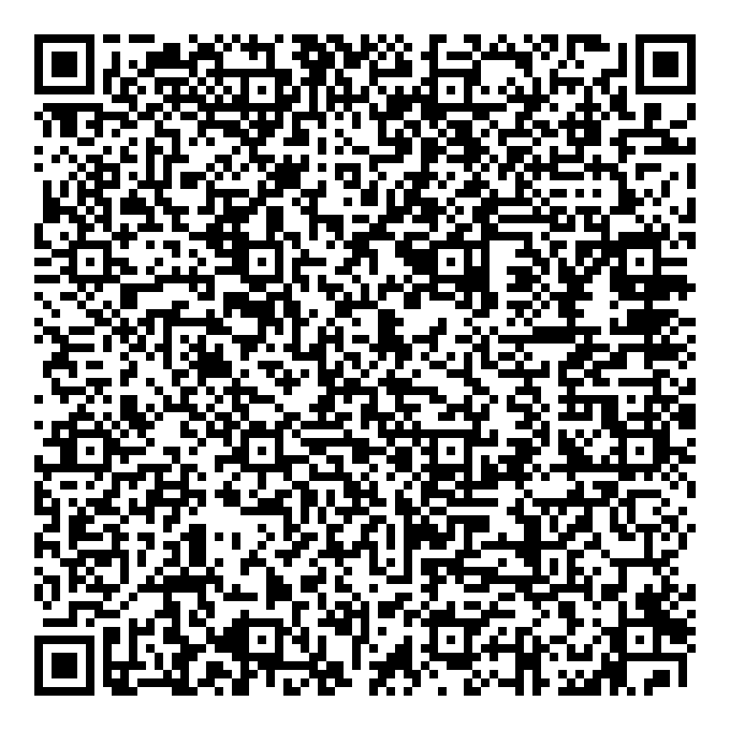
Prayer times for Bothamsall, Nottinghamshire, UK
Thu 1 Jan 2026 - Sat 31 Jan 2026
High Latitude Method: Angle Based Rule
Prayer Calculation Method: Islamic Society of North America
Asar Calculation Method: Hanafi

Date | Day | Fajr | Sunrise | Dhuhr | Asr | Maghrib | Isha
1 | Thu | 6:30 | 8:19 | 12:08 | 2:09 | 3:57 | 5:45
2 | Fri | 6:30 | 8:18 | 12:08 | 2:10 | 3:58 | 5:46
3 | Sat | 6:30 | 8:18 | 12:08 | 2:11 | 3:59 | 5:47
4 | Sun | 6:30 | 8:18 | 12:09 | 2:13 | 4:00 | 5:48
5 | Mon | 6:30 | 8:17 | 12:09 | 2:14 | 4:02 | 5:49
6 | Tue | 6:29 | 8:17 | 12:10 | 2:15 | 4:03 | 5:50
7 | Wed | 6:29 | 8:17 | 12:10 | 2:16 | 4:04 | 5:52
8 | Thu | 6:29 | 8:16 | 12:11 | 2:18 | 4:06 | 5:53
9 | Fri | 6:29 | 8:15 | 12:11 | 2:19 | 4:07 | 5:54
10 | Sat | 6:28 | 8:15 | 12:11 | 2:20 | 4:09 | 5:55
11 | Sun | 6:28 | 8:14 | 12:12 | 2:22 | 4:10 | 5:56
12 | Mon | 6:27 | 8:13 | 12:12 | 2:23 | 4:12 | 5:58
13 | Tue | 6:27 | 8:13 | 12:13 | 2:25 | 4:13 | 5:59
14 | Wed | 6:26 | 8:12 | 12:13 | 2:26 | 4:15 | 6:00
15 | Thu | 6:25 | 8:11 | 12:13 | 2:28 | 4:17 | 6:02
16 | Fri | 6:25 | 8:10 | 12:14 | 2:30 | 4:18 | 6:03
17 | Sat | 6:24 | 8:09 | 12:14 | 2:31 | 4:20 | 6:05
18 | Sun | 6:23 | 8:08 | 12:14 | 2:33 | 4:22 | 6:06
19 | Mon | 6:23 | 8:07 | 12:15 | 2:34 | 4:23 | 6:07
20 | Tue | 6:22 | 8:05 | 12:15 | 2:36 | 4:25 | 6:09
21 | Wed | 6:21 | 8:04 | 12:15 | 2:38 | 4:27 | 6:10
22 | Thu | 6:20 | 8:03 | 12:16 | 2:39 | 4:29 | 6:12
23 | Fri | 6:19 | 8:02 | 12:16 | 2:41 | 4:31 | 6:13
24 | Sat | 6:18 | 8:00 | 12:16 | 2:43 | 4:32 | 6:15
25 | Sun | 6:17 | 7:59 | 12:16 | 2:45 | 4:34 | 6:16
26 | Mon | 6:16 | 7:58 | 12:16 | 2:46 | 4:36 | 6:18
27 | Tue | 6:14 | 7:56 | 12:17 | 2:48 | 4:38 | 6:20
28 | Wed | 6:13 | 7:55 | 12:17 | 2:50 | 4:40 | 6:21
29 | Thu | 6:12 | 7:53 | 12:17 | 2:52 | 4:42 | 6:23
30 | Fri | 6:11 | 7:52 | 12:17 | 2:54 | 4:44 | 6:24
31 | Sat | 6:09 | 7:50 | 12:17 | 2:55 | 4:46 | 6:26
Prayer times provided by https://www.salahtimes.com

