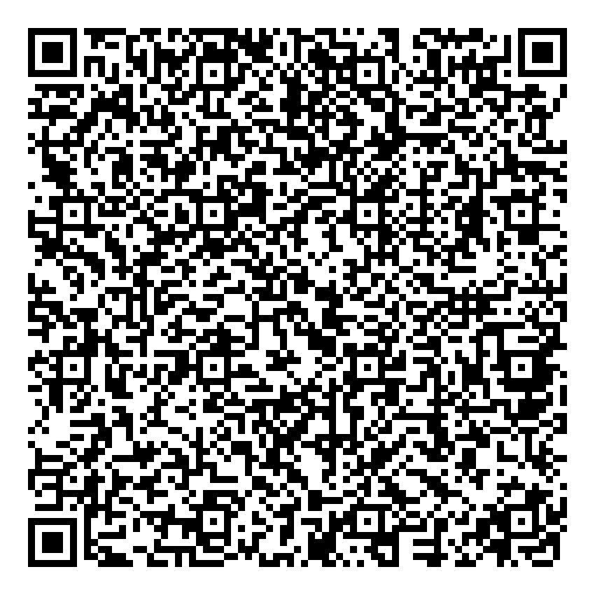
Prayer times for Clarborough, Nottinghamshire, UK
Thu 1 Jan 2026 - Sat 31 Jan 2026
High Latitude Method: Angle Based Rule
Prayer Calculation Method: Islamic Society of North America
Asar Calculation Method: Hanafi

Date | Day | Fajr | Sunrise | Dhuhr | Asr | Maghrib | Isha
1 | Thu | 6:30 | 8:19 | 12:07 | 2:08 | 3:56 | 5:45
2 | Fri | 6:30 | 8:19 | 12:08 | 2:09 | 3:57 | 5:46
3 | Sat | 6:30 | 8:18 | 12:08 | 2:10 | 3:58 | 5:47
4 | Sun | 6:30 | 8:18 | 12:09 | 2:12 | 3:59 | 5:48
5 | Mon | 6:30 | 8:18 | 12:09 | 2:13 | 4:01 | 5:49
6 | Tue | 6:29 | 8:17 | 12:09 | 2:14 | 4:02 | 5:50
7 | Wed | 6:29 | 8:17 | 12:10 | 2:15 | 4:03 | 5:51
8 | Thu | 6:29 | 8:16 | 12:10 | 2:17 | 4:05 | 5:52
9 | Fri | 6:28 | 8:16 | 12:11 | 2:18 | 4:06 | 5:53
10 | Sat | 6:28 | 8:15 | 12:11 | 2:20 | 4:08 | 5:55
11 | Sun | 6:28 | 8:14 | 12:12 | 2:21 | 4:09 | 5:56
12 | Mon | 6:27 | 8:14 | 12:12 | 2:22 | 4:11 | 5:57
13 | Tue | 6:27 | 8:13 | 12:12 | 2:24 | 4:12 | 5:58
14 | Wed | 6:26 | 8:12 | 12:13 | 2:25 | 4:14 | 6:00
15 | Thu | 6:25 | 8:11 | 12:13 | 2:27 | 4:16 | 6:01
16 | Fri | 6:25 | 8:10 | 12:13 | 2:29 | 4:17 | 6:03
17 | Sat | 6:24 | 8:09 | 12:14 | 2:30 | 4:19 | 6:04
18 | Sun | 6:23 | 8:08 | 12:14 | 2:32 | 4:21 | 6:05
19 | Mon | 6:22 | 8:07 | 12:14 | 2:33 | 4:23 | 6:07
20 | Tue | 6:22 | 8:06 | 12:15 | 2:35 | 4:24 | 6:08
21 | Wed | 6:21 | 8:04 | 12:15 | 2:37 | 4:26 | 6:10
22 | Thu | 6:20 | 8:03 | 12:15 | 2:39 | 4:28 | 6:11
23 | Fri | 6:19 | 8:02 | 12:15 | 2:40 | 4:30 | 6:13
24 | Sat | 6:18 | 8:01 | 12:16 | 2:42 | 4:32 | 6:14
25 | Sun | 6:17 | 7:59 | 12:16 | 2:44 | 4:33 | 6:16
26 | Mon | 6:15 | 7:58 | 12:16 | 2:46 | 4:35 | 6:18
27 | Tue | 6:14 | 7:56 | 12:16 | 2:47 | 4:37 | 6:19
28 | Wed | 6:13 | 7:55 | 12:17 | 2:49 | 4:39 | 6:21
29 | Thu | 6:12 | 7:53 | 12:17 | 2:51 | 4:41 | 6:22
30 | Fri | 6:11 | 7:52 | 12:17 | 2:53 | 4:43 | 6:24
31 | Sat | 6:09 | 7:50 | 12:17 | 2:55 | 4:45 | 6:26
Prayer times provided by https://www.salahtimes.com

