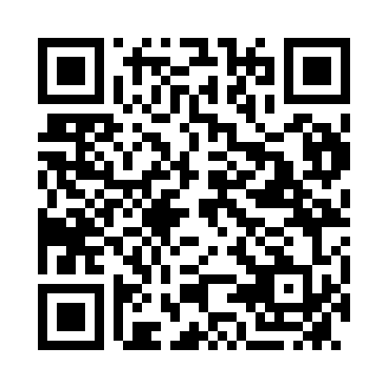
Prayer times for Kimba, Australia
Wed 1 May 2024 - Fri 31 May 2024
High Latitude Method: None
Prayer Calculation Method: Muslim World League
Asar Calculation Method: Shafi

Date | Day | Fajr | Sunrise | Dhuhr | Asr | Maghrib | Isha
1 | Wed | 5:34 | 6:58 | 12:21 | 3:22 | 5:45 | 7:04
2 | Thu | 5:35 | 6:59 | 12:21 | 3:21 | 5:44 | 7:03
3 | Fri | 5:35 | 6:59 | 12:21 | 3:21 | 5:43 | 7:02
4 | Sat | 5:36 | 7:00 | 12:21 | 3:20 | 5:42 | 7:01
5 | Sun | 5:36 | 7:01 | 12:21 | 3:19 | 5:41 | 7:01
6 | Mon | 5:37 | 7:02 | 12:21 | 3:19 | 5:40 | 7:00
7 | Tue | 5:38 | 7:02 | 12:21 | 3:18 | 5:39 | 6:59
8 | Wed | 5:38 | 7:03 | 12:21 | 3:17 | 5:38 | 6:58
9 | Thu | 5:39 | 7:04 | 12:21 | 3:17 | 5:37 | 6:58
10 | Fri | 5:39 | 7:04 | 12:21 | 3:16 | 5:37 | 6:57
11 | Sat | 5:40 | 7:05 | 12:21 | 3:15 | 5:36 | 6:56
12 | Sun | 5:41 | 7:06 | 12:21 | 3:15 | 5:35 | 6:56
13 | Mon | 5:41 | 7:07 | 12:21 | 3:14 | 5:34 | 6:55
14 | Tue | 5:42 | 7:07 | 12:21 | 3:13 | 5:34 | 6:54
15 | Wed | 5:42 | 7:08 | 12:21 | 3:13 | 5:33 | 6:54
16 | Thu | 5:43 | 7:09 | 12:21 | 3:12 | 5:32 | 6:53
17 | Fri | 5:43 | 7:09 | 12:21 | 3:12 | 5:32 | 6:53
18 | Sat | 5:44 | 7:10 | 12:21 | 3:11 | 5:31 | 6:52
19 | Sun | 5:45 | 7:11 | 12:21 | 3:11 | 5:31 | 6:52
20 | Mon | 5:45 | 7:12 | 12:21 | 3:10 | 5:30 | 6:51
21 | Tue | 5:46 | 7:12 | 12:21 | 3:10 | 5:29 | 6:51
22 | Wed | 5:46 | 7:13 | 12:21 | 3:10 | 5:29 | 6:51
23 | Thu | 5:47 | 7:14 | 12:21 | 3:09 | 5:28 | 6:50
24 | Fri | 5:47 | 7:14 | 12:21 | 3:09 | 5:28 | 6:50
25 | Sat | 5:48 | 7:15 | 12:21 | 3:08 | 5:27 | 6:50
26 | Sun | 5:48 | 7:15 | 12:21 | 3:08 | 5:27 | 6:49
27 | Mon | 5:49 | 7:16 | 12:22 | 3:08 | 5:27 | 6:49
28 | Tue | 5:49 | 7:17 | 12:22 | 3:07 | 5:26 | 6:49
29 | Wed | 5:50 | 7:17 | 12:22 | 3:07 | 5:26 | 6:48
30 | Thu | 5:50 | 7:18 | 12:22 | 3:07 | 5:26 | 6:48
31 | Fri | 5:51 | 7:19 | 12:22 | 3:07 | 5:25 | 6:48
Prayer times provided by https://www.salahtimes.com

