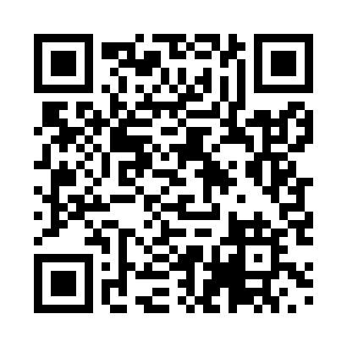
Prayer times for Benokumo, Cameroon
Wed 1 May 2024 - Fri 31 May 2024
High Latitude Method: None
Prayer Calculation Method: Muslim World League
Asar Calculation Method: Shafi

Date | Day | Fajr | Sunrise | Dhuhr | Asr | Maghrib | Isha
1 | Wed | 4:56 | 6:08 | 12:18 | 3:35 | 6:29 | 7:37
2 | Thu | 4:55 | 6:07 | 12:18 | 3:36 | 6:29 | 7:37
3 | Fri | 4:55 | 6:07 | 12:18 | 3:36 | 6:29 | 7:37
4 | Sat | 4:54 | 6:07 | 12:18 | 3:36 | 6:29 | 7:37
5 | Sun | 4:54 | 6:07 | 12:18 | 3:37 | 6:29 | 7:37
6 | Mon | 4:54 | 6:06 | 12:18 | 3:37 | 6:29 | 7:37
7 | Tue | 4:53 | 6:06 | 12:18 | 3:37 | 6:29 | 7:38
8 | Wed | 4:53 | 6:06 | 12:18 | 3:38 | 6:29 | 7:38
9 | Thu | 4:53 | 6:06 | 12:18 | 3:38 | 6:29 | 7:38
10 | Fri | 4:52 | 6:06 | 12:17 | 3:38 | 6:29 | 7:38
11 | Sat | 4:52 | 6:06 | 12:17 | 3:39 | 6:29 | 7:39
12 | Sun | 4:52 | 6:05 | 12:17 | 3:39 | 6:30 | 7:39
13 | Mon | 4:52 | 6:05 | 12:17 | 3:39 | 6:30 | 7:39
14 | Tue | 4:51 | 6:05 | 12:17 | 3:40 | 6:30 | 7:39
15 | Wed | 4:51 | 6:05 | 12:17 | 3:40 | 6:30 | 7:39
16 | Thu | 4:51 | 6:05 | 12:17 | 3:40 | 6:30 | 7:40
17 | Fri | 4:51 | 6:05 | 12:17 | 3:40 | 6:30 | 7:40
18 | Sat | 4:51 | 6:05 | 12:18 | 3:41 | 6:30 | 7:40
19 | Sun | 4:50 | 6:05 | 12:18 | 3:41 | 6:31 | 7:41
20 | Mon | 4:50 | 6:05 | 12:18 | 3:41 | 6:31 | 7:41
21 | Tue | 4:50 | 6:05 | 12:18 | 3:42 | 6:31 | 7:41
22 | Wed | 4:50 | 6:05 | 12:18 | 3:42 | 6:31 | 7:41
23 | Thu | 4:50 | 6:05 | 12:18 | 3:42 | 6:31 | 7:42
24 | Fri | 4:50 | 6:05 | 12:18 | 3:43 | 6:31 | 7:42
25 | Sat | 4:50 | 6:05 | 12:18 | 3:43 | 6:32 | 7:42
26 | Sun | 4:50 | 6:05 | 12:18 | 3:43 | 6:32 | 7:43
27 | Mon | 4:49 | 6:05 | 12:18 | 3:44 | 6:32 | 7:43
28 | Tue | 4:49 | 6:05 | 12:18 | 3:44 | 6:32 | 7:43
29 | Wed | 4:49 | 6:05 | 12:19 | 3:44 | 6:32 | 7:43
30 | Thu | 4:49 | 6:05 | 12:19 | 3:44 | 6:33 | 7:44
31 | Fri | 4:49 | 6:05 | 12:19 | 3:45 | 6:33 | 7:44
Prayer times provided by https://www.salahtimes.com

