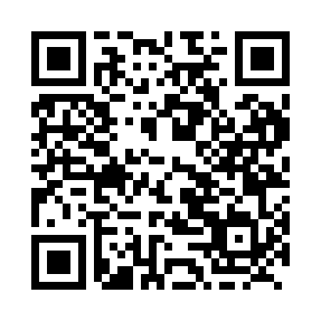
Prayer times for Fort Simpson, Northwest Territories, Canada
Wed 1 May 2024 - Fri 31 May 2024
High Latitude Method: Angle Based Rule
Prayer Calculation Method: Islamic Society of North America
Asar Calculation Method: Hanafi

Date | Day | Fajr | Sunrise | Dhuhr | Asr | Maghrib | Isha
1 | Wed | 3:57 | 5:50 | 2:02 | 7:23 | 10:16 | 12:10
2 | Thu | 3:55 | 5:47 | 2:02 | 7:25 | 10:19 | 12:11
3 | Fri | 3:54 | 5:44 | 2:02 | 7:27 | 10:21 | 12:12
4 | Sat | 3:52 | 5:42 | 2:02 | 7:28 | 10:24 | 12:14
5 | Sun | 3:51 | 5:39 | 2:02 | 7:30 | 10:27 | 12:15
6 | Mon | 3:49 | 5:36 | 2:02 | 7:31 | 10:30 | 12:16
7 | Tue | 3:48 | 5:33 | 2:02 | 7:33 | 10:32 | 12:18
8 | Wed | 3:46 | 5:30 | 2:02 | 7:34 | 10:35 | 12:19
9 | Thu | 3:45 | 5:27 | 2:02 | 7:36 | 10:38 | 12:20
10 | Fri | 3:43 | 5:24 | 2:02 | 7:37 | 10:41 | 12:22
11 | Sat | 3:42 | 5:22 | 2:02 | 7:38 | 10:43 | 12:23
12 | Sun | 3:41 | 5:19 | 2:02 | 7:40 | 10:46 | 12:24
13 | Mon | 3:39 | 5:16 | 2:02 | 7:41 | 10:49 | 12:26
14 | Tue | 3:38 | 5:13 | 2:02 | 7:43 | 10:51 | 12:27
15 | Wed | 3:37 | 5:11 | 2:02 | 7:44 | 10:54 | 12:28
16 | Thu | 3:35 | 5:08 | 2:02 | 7:45 | 10:57 | 12:30
17 | Fri | 3:34 | 5:06 | 2:02 | 7:47 | 10:59 | 12:31
18 | Sat | 3:33 | 5:03 | 2:02 | 7:48 | 11:02 | 12:32
19 | Sun | 3:32 | 5:01 | 2:02 | 7:49 | 11:05 | 12:34
20 | Mon | 3:30 | 4:58 | 2:02 | 7:50 | 11:07 | 12:35
21 | Tue | 3:29 | 4:56 | 2:02 | 7:52 | 11:10 | 12:36
22 | Wed | 3:28 | 4:53 | 2:02 | 7:53 | 11:12 | 12:38
23 | Thu | 3:27 | 4:51 | 2:02 | 7:54 | 11:15 | 12:39
24 | Fri | 3:26 | 4:49 | 2:02 | 7:55 | 11:17 | 12:40
25 | Sat | 3:25 | 4:46 | 2:02 | 7:56 | 11:20 | 12:41
26 | Sun | 3:24 | 4:44 | 2:03 | 7:57 | 11:22 | 12:43
27 | Mon | 3:23 | 4:42 | 2:03 | 7:58 | 11:24 | 12:44
28 | Tue | 3:22 | 4:40 | 2:03 | 8:00 | 11:27 | 12:45
29 | Wed | 3:21 | 4:38 | 2:03 | 8:01 | 11:29 | 12:46
30 | Thu | 3:20 | 4:36 | 2:03 | 8:02 | 11:31 | 12:47
31 | Fri | 3:19 | 4:34 | 2:03 | 8:02 | 11:33 | 12:48
Prayer times provided by https://www.salahtimes.com

