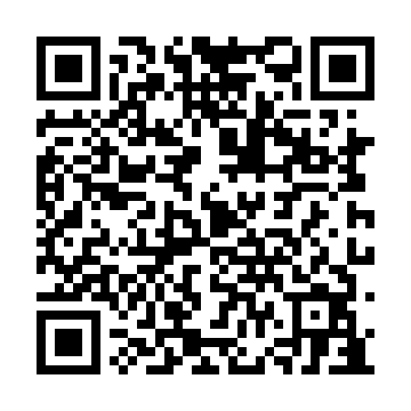
Prayer times for Wetikoweskwattam, Manitoba, Canada
Mon 1 Jul 2024 - Wed 31 Jul 2024
High Latitude Method: Angle Based Rule
Prayer Calculation Method: Islamic Society of North America
Asar Calculation Method: Hanafi

Date | Day | Fajr | Sunrise | Dhuhr | Asr | Maghrib | Isha
1 | Mon | 3:11 | 4:54 | 1:28 | 7:12 | 10:03 | 11:45
2 | Tue | 3:11 | 4:54 | 1:28 | 7:11 | 10:02 | 11:45
3 | Wed | 3:12 | 4:55 | 1:29 | 7:11 | 10:02 | 11:45
4 | Thu | 3:12 | 4:56 | 1:29 | 7:11 | 10:01 | 11:45
5 | Fri | 3:13 | 4:57 | 1:29 | 7:11 | 10:00 | 11:45
6 | Sat | 3:14 | 4:58 | 1:29 | 7:11 | 10:00 | 11:44
7 | Sun | 3:14 | 4:59 | 1:29 | 7:10 | 9:59 | 11:44
8 | Mon | 3:15 | 5:00 | 1:29 | 7:10 | 9:58 | 11:44
9 | Tue | 3:16 | 5:02 | 1:30 | 7:10 | 9:57 | 11:43
10 | Wed | 3:16 | 5:03 | 1:30 | 7:09 | 9:56 | 11:43
11 | Thu | 3:17 | 5:04 | 1:30 | 7:09 | 9:55 | 11:42
12 | Fri | 3:18 | 5:05 | 1:30 | 7:08 | 9:54 | 11:42
13 | Sat | 3:18 | 5:07 | 1:30 | 7:08 | 9:53 | 11:41
14 | Sun | 3:19 | 5:08 | 1:30 | 7:07 | 9:52 | 11:41
15 | Mon | 3:20 | 5:09 | 1:30 | 7:07 | 9:51 | 11:40
16 | Tue | 3:20 | 5:11 | 1:30 | 7:06 | 9:49 | 11:40
17 | Wed | 3:21 | 5:12 | 1:31 | 7:05 | 9:48 | 11:39
18 | Thu | 3:22 | 5:14 | 1:31 | 7:05 | 9:47 | 11:38
19 | Fri | 3:23 | 5:15 | 1:31 | 7:04 | 9:45 | 11:38
20 | Sat | 3:24 | 5:17 | 1:31 | 7:03 | 9:44 | 11:37
21 | Sun | 3:24 | 5:18 | 1:31 | 7:02 | 9:42 | 11:36
22 | Mon | 3:25 | 5:20 | 1:31 | 7:01 | 9:41 | 11:36
23 | Tue | 3:26 | 5:21 | 1:31 | 7:01 | 9:39 | 11:35
24 | Wed | 3:27 | 5:23 | 1:31 | 7:00 | 9:38 | 11:34
25 | Thu | 3:28 | 5:25 | 1:31 | 6:59 | 9:36 | 11:33
26 | Fri | 3:28 | 5:26 | 1:31 | 6:58 | 9:34 | 11:32
27 | Sat | 3:29 | 5:28 | 1:31 | 6:57 | 9:33 | 11:32
28 | Sun | 3:30 | 5:30 | 1:31 | 6:56 | 9:31 | 11:31
29 | Mon | 3:31 | 5:31 | 1:31 | 6:55 | 9:29 | 11:30
30 | Tue | 3:32 | 5:33 | 1:31 | 6:54 | 9:27 | 11:29
31 | Wed | 3:32 | 5:35 | 1:31 | 6:53 | 9:26 | 11:28
Prayer times provided by https://www.salahtimes.com

