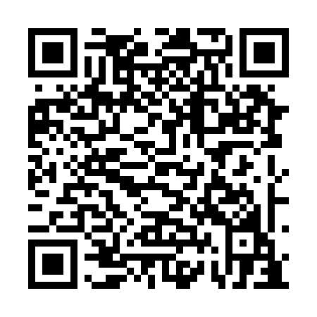
Prayer times for Fort Resolution, Northwest Territories, Canada
Wed 1 May 2024 - Fri 31 May 2024
High Latitude Method: Angle Based Rule
Prayer Calculation Method: Islamic Society of North America
Asar Calculation Method: Hanafi

Date | Day | Fajr | Sunrise | Dhuhr | Asr | Maghrib | Isha
1 | Wed | 3:28 | 5:24 | 1:32 | 6:52 | 9:41 | 11:37
2 | Thu | 3:27 | 5:21 | 1:32 | 6:53 | 9:44 | 11:38
3 | Fri | 3:25 | 5:18 | 1:32 | 6:55 | 9:46 | 11:39
4 | Sat | 3:24 | 5:15 | 1:31 | 6:56 | 9:49 | 11:40
5 | Sun | 3:22 | 5:13 | 1:31 | 6:58 | 9:51 | 11:42
6 | Mon | 3:21 | 5:10 | 1:31 | 6:59 | 9:54 | 11:43
7 | Tue | 3:19 | 5:07 | 1:31 | 7:01 | 9:57 | 11:44
8 | Wed | 3:18 | 5:04 | 1:31 | 7:02 | 9:59 | 11:46
9 | Thu | 3:17 | 5:02 | 1:31 | 7:03 | 10:02 | 11:47
10 | Fri | 3:15 | 4:59 | 1:31 | 7:05 | 10:05 | 11:48
11 | Sat | 3:14 | 4:56 | 1:31 | 7:06 | 10:07 | 11:49
12 | Sun | 3:13 | 4:54 | 1:31 | 7:08 | 10:10 | 11:51
13 | Mon | 3:11 | 4:51 | 1:31 | 7:09 | 10:12 | 11:52
14 | Tue | 3:10 | 4:48 | 1:31 | 7:10 | 10:15 | 11:53
15 | Wed | 3:09 | 4:46 | 1:31 | 7:12 | 10:17 | 11:55
16 | Thu | 3:08 | 4:43 | 1:31 | 7:13 | 10:20 | 11:56
17 | Fri | 3:06 | 4:41 | 1:31 | 7:14 | 10:22 | 11:57
18 | Sat | 3:05 | 4:39 | 1:31 | 7:15 | 10:25 | 11:58
19 | Sun | 3:04 | 4:36 | 1:31 | 7:17 | 10:27 | 12:00
20 | Mon | 3:03 | 4:34 | 1:31 | 7:18 | 10:30 | 12:01
21 | Tue | 3:02 | 4:32 | 1:31 | 7:19 | 10:32 | 12:02
22 | Wed | 3:01 | 4:29 | 1:31 | 7:20 | 10:35 | 12:03
23 | Thu | 3:00 | 4:27 | 1:32 | 7:21 | 10:37 | 12:05
24 | Fri | 2:59 | 4:25 | 1:32 | 7:22 | 10:39 | 12:06
25 | Sat | 2:58 | 4:23 | 1:32 | 7:24 | 10:41 | 12:07
26 | Sun | 2:57 | 4:21 | 1:32 | 7:25 | 10:44 | 12:08
27 | Mon | 2:56 | 4:19 | 1:32 | 7:26 | 10:46 | 12:09
28 | Tue | 2:55 | 4:17 | 1:32 | 7:27 | 10:48 | 12:10
29 | Wed | 2:54 | 4:15 | 1:32 | 7:28 | 10:50 | 12:11
30 | Thu | 2:53 | 4:14 | 1:32 | 7:29 | 10:52 | 12:12
31 | Fri | 2:52 | 4:12 | 1:33 | 7:30 | 10:54 | 12:14
Prayer times provided by https://www.salahtimes.com

