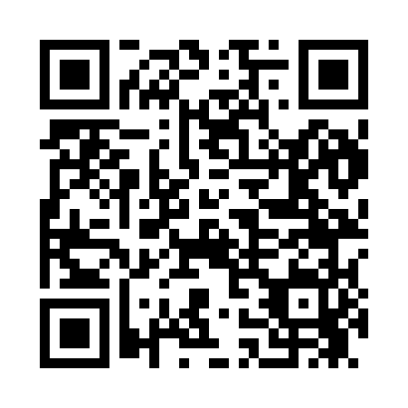
Prayer times for Semmes, Alabama, USA
Mon 1 Jul 2024 - Wed 31 Jul 2024
High Latitude Method: Angle Based Rule
Prayer Calculation Method: Islamic Society of North America
Asar Calculation Method: Shafi

Date | Day | Fajr | Sunrise | Dhuhr | Asr | Maghrib | Isha
1 | Mon | 4:35 | 5:54 | 12:57 | 4:35 | 8:00 | 9:19
2 | Tue | 4:35 | 5:54 | 12:57 | 4:35 | 8:00 | 9:19
3 | Wed | 4:36 | 5:55 | 12:57 | 4:35 | 8:00 | 9:19
4 | Thu | 4:37 | 5:55 | 12:58 | 4:35 | 8:00 | 9:18
5 | Fri | 4:37 | 5:56 | 12:58 | 4:35 | 8:00 | 9:18
6 | Sat | 4:38 | 5:56 | 12:58 | 4:36 | 8:00 | 9:18
7 | Sun | 4:38 | 5:57 | 12:58 | 4:36 | 7:59 | 9:18
8 | Mon | 4:39 | 5:57 | 12:58 | 4:36 | 7:59 | 9:17
9 | Tue | 4:40 | 5:58 | 12:58 | 4:36 | 7:59 | 9:17
10 | Wed | 4:40 | 5:58 | 12:59 | 4:36 | 7:59 | 9:17
11 | Thu | 4:41 | 5:59 | 12:59 | 4:37 | 7:59 | 9:16
12 | Fri | 4:42 | 5:59 | 12:59 | 4:37 | 7:58 | 9:16
13 | Sat | 4:42 | 6:00 | 12:59 | 4:37 | 7:58 | 9:15
14 | Sun | 4:43 | 6:00 | 12:59 | 4:37 | 7:58 | 9:15
15 | Mon | 4:44 | 6:01 | 12:59 | 4:37 | 7:57 | 9:14
16 | Tue | 4:44 | 6:01 | 12:59 | 4:37 | 7:57 | 9:14
17 | Wed | 4:45 | 6:02 | 12:59 | 4:37 | 7:56 | 9:13
18 | Thu | 4:46 | 6:03 | 12:59 | 4:37 | 7:56 | 9:12
19 | Fri | 4:47 | 6:03 | 12:59 | 4:38 | 7:55 | 9:12
20 | Sat | 4:47 | 6:04 | 12:59 | 4:38 | 7:55 | 9:11
21 | Sun | 4:48 | 6:04 | 1:00 | 4:38 | 7:54 | 9:10
22 | Mon | 4:49 | 6:05 | 1:00 | 4:38 | 7:54 | 9:10
23 | Tue | 4:50 | 6:06 | 1:00 | 4:38 | 7:53 | 9:09
24 | Wed | 4:51 | 6:06 | 1:00 | 4:38 | 7:53 | 9:08
25 | Thu | 4:51 | 6:07 | 1:00 | 4:38 | 7:52 | 9:07
26 | Fri | 4:52 | 6:07 | 1:00 | 4:38 | 7:52 | 9:06
27 | Sat | 4:53 | 6:08 | 1:00 | 4:38 | 7:51 | 9:06
28 | Sun | 4:54 | 6:09 | 1:00 | 4:38 | 7:50 | 9:05
29 | Mon | 4:55 | 6:09 | 1:00 | 4:38 | 7:49 | 9:04
30 | Tue | 4:56 | 6:10 | 12:59 | 4:38 | 7:49 | 9:03
31 | Wed | 4:56 | 6:10 | 12:59 | 4:38 | 7:48 | 9:02
Prayer times provided by https://www.salahtimes.com

