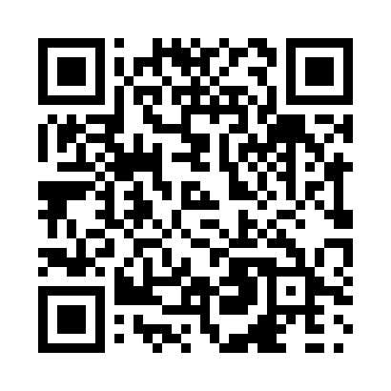
Prayer times for Queens Cove, British Columbia, Canada
Mon 1 Jul 2024 - Wed 31 Jul 2024
High Latitude Method: Angle Based Rule
Prayer Calculation Method: Islamic Society of North America
Asar Calculation Method: Hanafi

Date | Day | Fajr | Sunrise | Dhuhr | Asr | Maghrib | Isha
1 | Mon | 3:28 | 5:24 | 1:32 | 7:04 | 9:40 | 11:36
2 | Tue | 3:28 | 5:25 | 1:32 | 7:04 | 9:39 | 11:36
3 | Wed | 3:29 | 5:26 | 1:32 | 7:04 | 9:39 | 11:36
4 | Thu | 3:29 | 5:26 | 1:33 | 7:04 | 9:38 | 11:35
5 | Fri | 3:30 | 5:27 | 1:33 | 7:04 | 9:38 | 11:35
6 | Sat | 3:30 | 5:28 | 1:33 | 7:04 | 9:37 | 11:35
7 | Sun | 3:31 | 5:29 | 1:33 | 7:03 | 9:37 | 11:35
8 | Mon | 3:31 | 5:30 | 1:33 | 7:03 | 9:36 | 11:35
9 | Tue | 3:32 | 5:31 | 1:33 | 7:03 | 9:36 | 11:34
10 | Wed | 3:32 | 5:32 | 1:33 | 7:02 | 9:35 | 11:34
11 | Thu | 3:33 | 5:33 | 1:34 | 7:02 | 9:34 | 11:34
12 | Fri | 3:34 | 5:34 | 1:34 | 7:02 | 9:33 | 11:33
13 | Sat | 3:34 | 5:35 | 1:34 | 7:01 | 9:32 | 11:33
14 | Sun | 3:35 | 5:36 | 1:34 | 7:01 | 9:32 | 11:33
15 | Mon | 3:35 | 5:37 | 1:34 | 7:00 | 9:31 | 11:32
16 | Tue | 3:36 | 5:38 | 1:34 | 7:00 | 9:30 | 11:32
17 | Wed | 3:37 | 5:39 | 1:34 | 6:59 | 9:29 | 11:31
18 | Thu | 3:37 | 5:40 | 1:34 | 6:59 | 9:28 | 11:31
19 | Fri | 3:38 | 5:42 | 1:34 | 6:58 | 9:26 | 11:30
20 | Sat | 3:38 | 5:43 | 1:34 | 6:58 | 9:25 | 11:30
21 | Sun | 3:39 | 5:44 | 1:34 | 6:57 | 9:24 | 11:29
22 | Mon | 3:40 | 5:45 | 1:34 | 6:56 | 9:23 | 11:29
23 | Tue | 3:40 | 5:47 | 1:34 | 6:56 | 9:22 | 11:28
24 | Wed | 3:41 | 5:48 | 1:34 | 6:55 | 9:20 | 11:26
25 | Thu | 3:44 | 5:49 | 1:34 | 6:54 | 9:19 | 11:24
26 | Fri | 3:46 | 5:51 | 1:34 | 6:53 | 9:18 | 11:22
27 | Sat | 3:49 | 5:52 | 1:34 | 6:53 | 9:16 | 11:19
28 | Sun | 3:51 | 5:53 | 1:34 | 6:52 | 9:15 | 11:17
29 | Mon | 3:53 | 5:55 | 1:34 | 6:51 | 9:13 | 11:14
30 | Tue | 3:56 | 5:56 | 1:34 | 6:50 | 9:12 | 11:12
31 | Wed | 3:58 | 5:57 | 1:34 | 6:49 | 9:10 | 11:09
Prayer times provided by https://www.salahtimes.com

