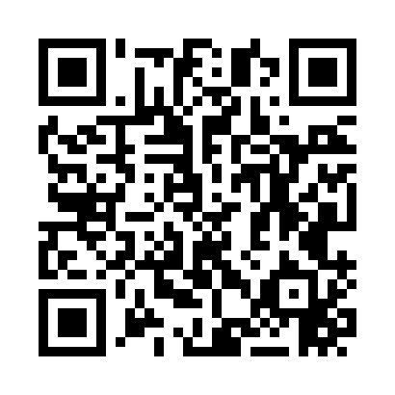
Prayer times for Camp Nashoba, Massachusetts, USA
Mon 1 Jul 2024 - Wed 31 Jul 2024
High Latitude Method: Angle Based Rule
Prayer Calculation Method: Islamic Society of North America
Asar Calculation Method: Shafi

Date | Day | Fajr | Sunrise | Dhuhr | Asr | Maghrib | Isha
1 | Mon | 3:27 | 5:12 | 12:50 | 4:54 | 8:27 | 10:12
2 | Tue | 3:28 | 5:13 | 12:50 | 4:54 | 8:27 | 10:12
3 | Wed | 3:29 | 5:13 | 12:50 | 4:54 | 8:27 | 10:11
4 | Thu | 3:30 | 5:14 | 12:50 | 4:54 | 8:27 | 10:11
5 | Fri | 3:30 | 5:15 | 12:51 | 4:54 | 8:26 | 10:10
6 | Sat | 3:31 | 5:15 | 12:51 | 4:54 | 8:26 | 10:10
7 | Sun | 3:32 | 5:16 | 12:51 | 4:54 | 8:26 | 10:09
8 | Mon | 3:33 | 5:17 | 12:51 | 4:54 | 8:25 | 10:08
9 | Tue | 3:34 | 5:17 | 12:51 | 4:54 | 8:25 | 10:07
10 | Wed | 3:36 | 5:18 | 12:51 | 4:54 | 8:24 | 10:06
11 | Thu | 3:37 | 5:19 | 12:51 | 4:54 | 8:24 | 10:06
12 | Fri | 3:38 | 5:20 | 12:52 | 4:54 | 8:23 | 10:05
13 | Sat | 3:39 | 5:20 | 12:52 | 4:54 | 8:23 | 10:04
14 | Sun | 3:40 | 5:21 | 12:52 | 4:54 | 8:22 | 10:03
15 | Mon | 3:42 | 5:22 | 12:52 | 4:54 | 8:21 | 10:02
16 | Tue | 3:43 | 5:23 | 12:52 | 4:54 | 8:21 | 10:00
17 | Wed | 3:44 | 5:24 | 12:52 | 4:54 | 8:20 | 9:59
18 | Thu | 3:45 | 5:25 | 12:52 | 4:53 | 8:19 | 9:58
19 | Fri | 3:47 | 5:26 | 12:52 | 4:53 | 8:18 | 9:57
20 | Sat | 3:48 | 5:27 | 12:52 | 4:53 | 8:17 | 9:56
21 | Sun | 3:49 | 5:27 | 12:52 | 4:53 | 8:17 | 9:54
22 | Mon | 3:51 | 5:28 | 12:52 | 4:53 | 8:16 | 9:53
23 | Tue | 3:52 | 5:29 | 12:52 | 4:52 | 8:15 | 9:52
24 | Wed | 3:54 | 5:30 | 12:52 | 4:52 | 8:14 | 9:50
25 | Thu | 3:55 | 5:31 | 12:52 | 4:52 | 8:13 | 9:49
26 | Fri | 3:57 | 5:32 | 12:52 | 4:52 | 8:12 | 9:47
27 | Sat | 3:58 | 5:33 | 12:52 | 4:51 | 8:11 | 9:46
28 | Sun | 3:59 | 5:34 | 12:52 | 4:51 | 8:10 | 9:44
29 | Mon | 4:01 | 5:35 | 12:52 | 4:51 | 8:09 | 9:43
30 | Tue | 4:02 | 5:36 | 12:52 | 4:50 | 8:08 | 9:41
31 | Wed | 4:04 | 5:37 | 12:52 | 4:50 | 8:06 | 9:40
Prayer times provided by https://www.salahtimes.com

