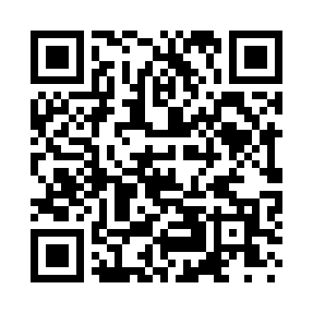
Prayer times for Samish Island, Washington, USA
Mon 1 Jul 2024 - Wed 31 Jul 2024
High Latitude Method: Angle Based Rule
Prayer Calculation Method: Islamic Society of North America
Asar Calculation Method: Shafi

Date | Day | Fajr | Sunrise | Dhuhr | Asr | Maghrib | Isha
1 | Mon | 3:13 | 5:13 | 1:14 | 5:30 | 9:16 | 11:15
2 | Tue | 3:14 | 5:13 | 1:14 | 5:30 | 9:15 | 11:15
3 | Wed | 3:14 | 5:14 | 1:15 | 5:30 | 9:15 | 11:15
4 | Thu | 3:15 | 5:15 | 1:15 | 5:30 | 9:15 | 11:15
5 | Fri | 3:15 | 5:15 | 1:15 | 5:30 | 9:14 | 11:14
6 | Sat | 3:16 | 5:16 | 1:15 | 5:30 | 9:14 | 11:14
7 | Sun | 3:16 | 5:17 | 1:15 | 5:30 | 9:13 | 11:14
8 | Mon | 3:17 | 5:18 | 1:15 | 5:30 | 9:12 | 11:14
9 | Tue | 3:17 | 5:19 | 1:16 | 5:30 | 9:12 | 11:14
10 | Wed | 3:18 | 5:20 | 1:16 | 5:30 | 9:11 | 11:13
11 | Thu | 3:18 | 5:21 | 1:16 | 5:30 | 9:10 | 11:13
12 | Fri | 3:19 | 5:22 | 1:16 | 5:30 | 9:10 | 11:13
13 | Sat | 3:19 | 5:23 | 1:16 | 5:29 | 9:09 | 11:12
14 | Sun | 3:20 | 5:24 | 1:16 | 5:29 | 9:08 | 11:12
15 | Mon | 3:20 | 5:25 | 1:16 | 5:29 | 9:07 | 11:12
16 | Tue | 3:21 | 5:26 | 1:16 | 5:29 | 9:06 | 11:11
17 | Wed | 3:22 | 5:27 | 1:16 | 5:28 | 9:05 | 11:11
18 | Thu | 3:23 | 5:28 | 1:16 | 5:28 | 9:04 | 11:09
19 | Fri | 3:25 | 5:29 | 1:17 | 5:28 | 9:03 | 11:07
20 | Sat | 3:27 | 5:30 | 1:17 | 5:28 | 9:02 | 11:05
21 | Sun | 3:30 | 5:32 | 1:17 | 5:27 | 9:01 | 11:03
22 | Mon | 3:32 | 5:33 | 1:17 | 5:27 | 9:00 | 11:00
23 | Tue | 3:34 | 5:34 | 1:17 | 5:26 | 8:59 | 10:58
24 | Wed | 3:36 | 5:35 | 1:17 | 5:26 | 8:58 | 10:56
25 | Thu | 3:38 | 5:36 | 1:17 | 5:26 | 8:56 | 10:54
26 | Fri | 3:40 | 5:38 | 1:17 | 5:25 | 8:55 | 10:52
27 | Sat | 3:43 | 5:39 | 1:17 | 5:25 | 8:54 | 10:50
28 | Sun | 3:45 | 5:40 | 1:17 | 5:24 | 8:52 | 10:47
29 | Mon | 3:47 | 5:42 | 1:17 | 5:24 | 8:51 | 10:45
30 | Tue | 3:49 | 5:43 | 1:17 | 5:23 | 8:50 | 10:43
31 | Wed | 3:51 | 5:44 | 1:17 | 5:22 | 8:48 | 10:41
Prayer times provided by https://www.salahtimes.com

