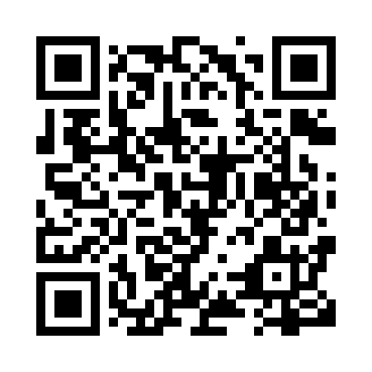
Prayer times for Imirtavik, Quebec, Canada
Mon 1 Jul 2024 - Wed 31 Jul 2024
High Latitude Method: Angle Based Rule
Prayer Calculation Method: Islamic Society of North America
Asar Calculation Method: Hanafi

Date | Day | Fajr | Sunrise | Dhuhr | Asr | Maghrib | Isha
1 | Mon | 2:12 | 3:18 | 1:07 | 7:12 | 10:55 | 12:00
2 | Tue | 2:13 | 3:19 | 1:07 | 7:12 | 10:54 | 12:00
3 | Wed | 2:14 | 3:21 | 1:07 | 7:12 | 10:52 | 11:59
4 | Thu | 2:14 | 3:22 | 1:07 | 7:12 | 10:51 | 11:59
5 | Fri | 2:15 | 3:24 | 1:07 | 7:11 | 10:50 | 11:58
6 | Sat | 2:16 | 3:26 | 1:07 | 7:11 | 10:48 | 11:58
7 | Sun | 2:17 | 3:28 | 1:08 | 7:10 | 10:47 | 11:57
8 | Mon | 2:18 | 3:30 | 1:08 | 7:10 | 10:45 | 11:56
9 | Tue | 2:19 | 3:32 | 1:08 | 7:09 | 10:43 | 11:55
10 | Wed | 2:21 | 3:34 | 1:08 | 7:08 | 10:41 | 11:54
11 | Thu | 2:22 | 3:36 | 1:08 | 7:08 | 10:39 | 11:54
12 | Fri | 2:23 | 3:38 | 1:08 | 7:07 | 10:37 | 11:53
13 | Sat | 2:24 | 3:40 | 1:08 | 7:06 | 10:35 | 11:52
14 | Sun | 2:25 | 3:43 | 1:08 | 7:05 | 10:33 | 11:51
15 | Mon | 2:26 | 3:45 | 1:09 | 7:05 | 10:31 | 11:50
16 | Tue | 2:28 | 3:47 | 1:09 | 7:04 | 10:29 | 11:48
17 | Wed | 2:29 | 3:50 | 1:09 | 7:03 | 10:27 | 11:47
18 | Thu | 2:30 | 3:52 | 1:09 | 7:02 | 10:24 | 11:46
19 | Fri | 2:31 | 3:55 | 1:09 | 7:01 | 10:22 | 11:45
20 | Sat | 2:33 | 3:57 | 1:09 | 7:00 | 10:19 | 11:44
21 | Sun | 2:34 | 4:00 | 1:09 | 6:59 | 10:17 | 11:43
22 | Mon | 2:35 | 4:02 | 1:09 | 6:57 | 10:14 | 11:41
23 | Tue | 2:37 | 4:05 | 1:09 | 6:56 | 10:12 | 11:40
24 | Wed | 2:38 | 4:07 | 1:09 | 6:55 | 10:09 | 11:39
25 | Thu | 2:39 | 4:10 | 1:09 | 6:54 | 10:07 | 11:37
26 | Fri | 2:41 | 4:13 | 1:09 | 6:52 | 10:04 | 11:36
27 | Sat | 2:42 | 4:15 | 1:09 | 6:51 | 10:01 | 11:35
28 | Sun | 2:43 | 4:18 | 1:09 | 6:50 | 9:58 | 11:33
29 | Mon | 2:45 | 4:21 | 1:09 | 6:48 | 9:56 | 11:32
30 | Tue | 2:46 | 4:24 | 1:09 | 6:47 | 9:53 | 11:31
31 | Wed | 2:47 | 4:26 | 1:09 | 6:45 | 9:50 | 11:29
Prayer times provided by https://www.salahtimes.com

