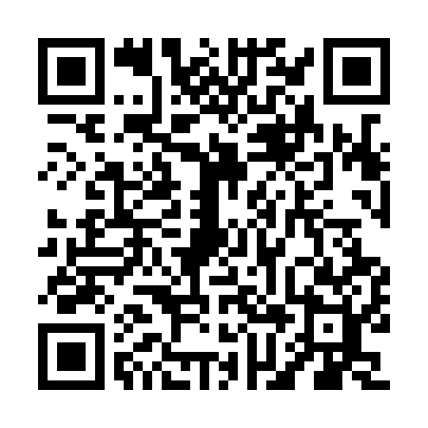
Prayer times for Village-Blanchard, New Brunswick, Canada
Mon 1 Apr 2024 - Tue 30 Apr 2024
High Latitude Method: Angle Based Rule
Prayer Calculation Method: Islamic Society of North America
Asar Calculation Method: Hanafi

Date | Day | Fajr | Sunrise | Dhuhr | Asr | Maghrib | Isha
1 | Mon | 5:29 | 6:57 | 1:23 | 5:52 | 7:50 | 9:19
2 | Tue | 5:27 | 6:55 | 1:23 | 5:53 | 7:52 | 9:20
3 | Wed | 5:24 | 6:53 | 1:23 | 5:54 | 7:53 | 9:22
4 | Thu | 5:22 | 6:51 | 1:22 | 5:55 | 7:55 | 9:24
5 | Fri | 5:20 | 6:49 | 1:22 | 5:56 | 7:56 | 9:26
6 | Sat | 5:17 | 6:47 | 1:22 | 5:57 | 7:57 | 9:27
7 | Sun | 5:15 | 6:45 | 1:22 | 5:58 | 7:59 | 9:29
8 | Mon | 5:13 | 6:43 | 1:21 | 5:59 | 8:00 | 9:31
9 | Tue | 5:10 | 6:41 | 1:21 | 6:00 | 8:02 | 9:33
10 | Wed | 5:08 | 6:39 | 1:21 | 6:01 | 8:03 | 9:34
11 | Thu | 5:06 | 6:37 | 1:20 | 6:02 | 8:05 | 9:36
12 | Fri | 5:03 | 6:35 | 1:20 | 6:03 | 8:06 | 9:38
13 | Sat | 5:01 | 6:33 | 1:20 | 6:04 | 8:07 | 9:40
14 | Sun | 4:59 | 6:31 | 1:20 | 6:05 | 8:09 | 9:42
15 | Mon | 4:56 | 6:30 | 1:19 | 6:06 | 8:10 | 9:44
16 | Tue | 4:54 | 6:28 | 1:19 | 6:07 | 8:12 | 9:46
17 | Wed | 4:52 | 6:26 | 1:19 | 6:08 | 8:13 | 9:48
18 | Thu | 4:49 | 6:24 | 1:19 | 6:08 | 8:14 | 9:49
19 | Fri | 4:47 | 6:22 | 1:19 | 6:09 | 8:16 | 9:51
20 | Sat | 4:45 | 6:20 | 1:18 | 6:10 | 8:17 | 9:53
21 | Sun | 4:42 | 6:18 | 1:18 | 6:11 | 8:19 | 9:55
22 | Mon | 4:40 | 6:17 | 1:18 | 6:12 | 8:20 | 9:57
23 | Tue | 4:38 | 6:15 | 1:18 | 6:13 | 8:22 | 9:59
24 | Wed | 4:35 | 6:13 | 1:18 | 6:14 | 8:23 | 10:01
25 | Thu | 4:33 | 6:11 | 1:17 | 6:15 | 8:24 | 10:03
26 | Fri | 4:31 | 6:10 | 1:17 | 6:16 | 8:26 | 10:05
27 | Sat | 4:28 | 6:08 | 1:17 | 6:17 | 8:27 | 10:07
28 | Sun | 4:26 | 6:06 | 1:17 | 6:17 | 8:29 | 10:09
29 | Mon | 4:24 | 6:05 | 1:17 | 6:18 | 8:30 | 10:11
30 | Tue | 4:21 | 6:03 | 1:17 | 6:19 | 8:31 | 10:13
Prayer times provided by https://www.salahtimes.com

