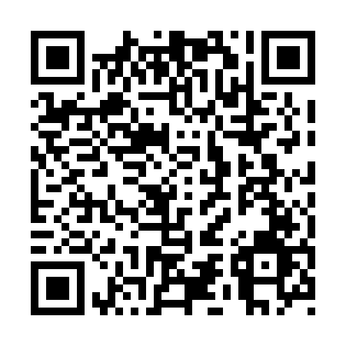
Prayer times for Spillimacheen, British Columbia, Canada
Mon 1 Jul 2024 - Wed 31 Jul 2024
High Latitude Method: Angle Based Rule
Prayer Calculation Method: Islamic Society of North America
Asar Calculation Method: Hanafi

Date | Day | Fajr | Sunrise | Dhuhr | Asr | Maghrib | Isha
1 | Mon | 3:43 | 5:36 | 1:50 | 7:24 | 10:02 | 11:56
2 | Tue | 3:43 | 5:37 | 1:50 | 7:24 | 10:02 | 11:56
3 | Wed | 3:44 | 5:38 | 1:50 | 7:24 | 10:02 | 11:56
4 | Thu | 3:44 | 5:39 | 1:50 | 7:24 | 10:01 | 11:55
5 | Fri | 3:45 | 5:40 | 1:50 | 7:24 | 10:01 | 11:55
6 | Sat | 3:45 | 5:40 | 1:50 | 7:23 | 10:00 | 11:55
7 | Sun | 3:46 | 5:41 | 1:51 | 7:23 | 9:59 | 11:55
8 | Mon | 3:46 | 5:42 | 1:51 | 7:23 | 9:59 | 11:55
9 | Tue | 3:47 | 5:43 | 1:51 | 7:22 | 9:58 | 11:54
10 | Wed | 3:48 | 5:44 | 1:51 | 7:22 | 9:57 | 11:54
11 | Thu | 3:48 | 5:45 | 1:51 | 7:22 | 9:56 | 11:54
12 | Fri | 3:49 | 5:46 | 1:51 | 7:21 | 9:56 | 11:53
13 | Sat | 3:49 | 5:48 | 1:51 | 7:21 | 9:55 | 11:53
14 | Sun | 3:50 | 5:49 | 1:51 | 7:20 | 9:54 | 11:52
15 | Mon | 3:51 | 5:50 | 1:52 | 7:20 | 9:53 | 11:52
16 | Tue | 3:51 | 5:51 | 1:52 | 7:19 | 9:52 | 11:52
17 | Wed | 3:52 | 5:52 | 1:52 | 7:19 | 9:51 | 11:51
18 | Thu | 3:52 | 5:53 | 1:52 | 7:18 | 9:50 | 11:51
19 | Fri | 3:53 | 5:55 | 1:52 | 7:18 | 9:48 | 11:50
20 | Sat | 3:54 | 5:56 | 1:52 | 7:17 | 9:47 | 11:49
21 | Sun | 3:54 | 5:57 | 1:52 | 7:16 | 9:46 | 11:49
22 | Mon | 3:55 | 5:59 | 1:52 | 7:16 | 9:45 | 11:48
23 | Tue | 3:56 | 6:00 | 1:52 | 7:15 | 9:43 | 11:48
24 | Wed | 3:56 | 6:01 | 1:52 | 7:14 | 9:42 | 11:47
25 | Thu | 3:57 | 6:03 | 1:52 | 7:13 | 9:41 | 11:46
26 | Fri | 3:58 | 6:04 | 1:52 | 7:13 | 9:39 | 11:45
27 | Sat | 3:59 | 6:05 | 1:52 | 7:12 | 9:38 | 11:45
28 | Sun | 3:59 | 6:07 | 1:52 | 7:11 | 9:36 | 11:44
29 | Mon | 4:01 | 6:08 | 1:52 | 7:10 | 9:35 | 11:41
30 | Tue | 4:04 | 6:10 | 1:52 | 7:09 | 9:33 | 11:39
31 | Wed | 4:06 | 6:11 | 1:52 | 7:08 | 9:32 | 11:36
Prayer times provided by https://www.salahtimes.com

