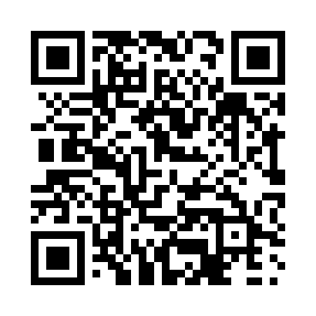

**Prayer times for Stony Rapids, Saskatchewan, Canada**

**Wed 1 Jan 2025 - Fri 31 Jan 2025**

**High Latitude Method: Angle Based Rule**

**Prayer Calculation Method: Islamic Society of North America**

**Asar Calculation Method: Hanafi**

|  |  |  |  |  |  |  |  |
| --- | --- | --- | --- | --- | --- | --- | --- |
| **Date** | **Day** | **Fajr** | **Sunrise** | **Dhuhr** | **Asr** | **Maghrib** | **Isha** |
| 1 | Wed | 7:44 | 9:59 | 1:07 | 2:28 | 4:16 | 6:30 |
| 2 | Thu | 7:44 | 9:58 | 1:08 | 2:29 | 4:18 | 6:31 |
| 3 | Fri | 7:44 | 9:58 | 1:08 | 2:31 | 4:19 | 6:33 |
| 4 | Sat | 7:44 | 9:57 | 1:09 | 2:32 | 4:21 | 6:34 |
| 5 | Sun | 7:43 | 9:56 | 1:09 | 2:33 | 4:22 | 6:35 |
| 6 | Mon | 7:43 | 9:55 | 1:09 | 2:35 | 4:24 | 6:36 |
| 7 | Tue | 7:42 | 9:55 | 1:10 | 2:37 | 4:26 | 6:38 |
| 8 | Wed | 7:42 | 9:54 | 1:10 | 2:38 | 4:28 | 6:39 |
| 9 | Thu | 7:41 | 9:52 | 1:11 | 2:40 | 4:30 | 6:41 |
| 10 | Fri | 7:41 | 9:51 | 1:11 | 2:42 | 4:32 | 6:42 |
| 11 | Sat | 7:40 | 9:50 | 1:11 | 2:43 | 4:34 | 6:44 |
| 12 | Sun | 7:39 | 9:49 | 1:12 | 2:45 | 4:36 | 6:45 |
| 13 | Mon | 7:38 | 9:48 | 1:12 | 2:47 | 4:38 | 6:47 |
| 14 | Tue | 7:38 | 9:46 | 1:13 | 2:49 | 4:40 | 6:48 |
| 15 | Wed | 7:37 | 9:45 | 1:13 | 2:51 | 4:42 | 6:50 |
| 16 | Thu | 7:36 | 9:43 | 1:13 | 2:53 | 4:44 | 6:52 |
| 17 | Fri | 7:35 | 9:42 | 1:14 | 2:55 | 4:47 | 6:53 |
| 18 | Sat | 7:34 | 9:40 | 1:14 | 2:57 | 4:49 | 6:55 |
| 19 | Sun | 7:32 | 9:38 | 1:14 | 2:59 | 4:51 | 6:57 |
| 20 | Mon | 7:31 | 9:37 | 1:15 | 3:01 | 4:53 | 6:59 |
| 21 | Tue | 7:30 | 9:35 | 1:15 | 3:03 | 4:56 | 7:00 |
| 22 | Wed | 7:29 | 9:33 | 1:15 | 3:05 | 4:58 | 7:02 |
| 23 | Thu | 7:27 | 9:31 | 1:15 | 3:07 | 5:01 | 7:04 |
| 24 | Fri | 7:26 | 9:29 | 1:16 | 3:09 | 5:03 | 7:06 |
| 25 | Sat | 7:24 | 9:27 | 1:16 | 3:12 | 5:05 | 7:08 |
| 26 | Sun | 7:23 | 9:25 | 1:16 | 3:14 | 5:08 | 7:10 |
| 27 | Mon | 7:21 | 9:23 | 1:16 | 3:16 | 5:10 | 7:12 |
| 28 | Tue | 7:20 | 9:21 | 1:16 | 3:18 | 5:13 | 7:14 |
| 29 | Wed | 7:18 | 9:19 | 1:17 | 3:20 | 5:15 | 7:16 |
| 30 | Thu | 7:17 | 9:17 | 1:17 | 3:23 | 5:18 | 7:18 |
| 31 | Fri | 7:15 | 9:14 | 1:17 | 3:25 | 5:20 | 7:20 |

**Prayer times provided by https://www.salahtimes.com**