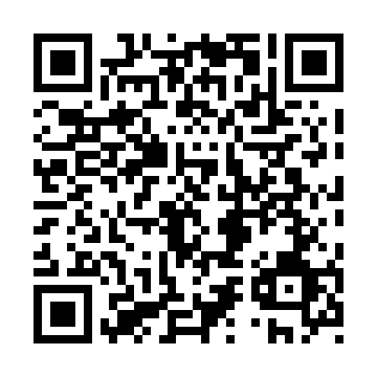

**Prayer times for Tupirvikallak, Quebec, Canada**

**Wed 1 Jan 2025 - Fri 31 Jan 2025**

**High Latitude Method: Angle Based Rule**

**Prayer Calculation Method: Islamic Society of North America**

**Asar Calculation Method: Hanafi**

|  |  |  |  |  |  |  |  |
| --- | --- | --- | --- | --- | --- | --- | --- |
| **Date** | **Day** | **Fajr** | **Sunrise** | **Dhuhr** | **Asr** | **Maghrib** | **Isha** |
| 1 | Wed | 6:35 | 9:04 | 11:51 | 12:52 | 2:37 | 5:07 |
| 2 | Thu | 6:35 | 9:04 | 11:51 | 12:53 | 2:39 | 5:08 |
| 3 | Fri | 6:34 | 9:03 | 11:52 | 12:55 | 2:41 | 5:09 |
| 4 | Sat | 6:34 | 9:02 | 11:52 | 12:56 | 2:43 | 5:11 |
| 5 | Sun | 6:33 | 9:01 | 11:52 | 12:58 | 2:45 | 5:12 |
| 6 | Mon | 6:33 | 9:00 | 11:53 | 12:59 | 2:47 | 5:13 |
| 7 | Tue | 6:32 | 8:59 | 11:53 | 1:01 | 2:49 | 5:15 |
| 8 | Wed | 6:32 | 8:58 | 11:54 | 1:03 | 2:51 | 5:16 |
| 9 | Thu | 6:31 | 8:56 | 11:54 | 1:04 | 2:53 | 5:18 |
| 10 | Fri | 6:30 | 8:55 | 11:55 | 1:06 | 2:55 | 5:19 |
| 11 | Sat | 6:30 | 8:53 | 11:55 | 1:08 | 2:58 | 5:21 |
| 12 | Sun | 6:29 | 8:52 | 11:55 | 1:10 | 3:00 | 5:23 |
| 13 | Mon | 6:28 | 8:50 | 11:56 | 1:12 | 3:02 | 5:24 |
| 14 | Tue | 6:27 | 8:48 | 11:56 | 1:14 | 3:05 | 5:26 |
| 15 | Wed | 6:26 | 8:47 | 11:56 | 1:16 | 3:07 | 5:28 |
| 16 | Thu | 6:25 | 8:45 | 11:57 | 1:18 | 3:10 | 5:30 |
| 17 | Fri | 6:23 | 8:43 | 11:57 | 1:21 | 3:12 | 5:32 |
| 18 | Sat | 6:22 | 8:41 | 11:57 | 1:23 | 3:15 | 5:33 |
| 19 | Sun | 6:21 | 8:39 | 11:58 | 1:25 | 3:18 | 5:35 |
| 20 | Mon | 6:20 | 8:37 | 11:58 | 1:27 | 3:20 | 5:37 |
| 21 | Tue | 6:18 | 8:35 | 11:58 | 1:30 | 3:23 | 5:39 |
| 22 | Wed | 6:17 | 8:33 | 11:59 | 1:32 | 3:26 | 5:41 |
| 23 | Thu | 6:15 | 8:30 | 11:59 | 1:34 | 3:28 | 5:43 |
| 24 | Fri | 6:14 | 8:28 | 11:59 | 1:37 | 3:31 | 5:45 |
| 25 | Sat | 6:12 | 8:26 | 11:59 | 1:39 | 3:34 | 5:47 |
| 26 | Sun | 6:10 | 8:24 | 11:59 | 1:41 | 3:37 | 5:50 |
| 27 | Mon | 6:09 | 8:21 | 12:00 | 1:44 | 3:39 | 5:52 |
| 28 | Tue | 6:07 | 8:19 | 12:00 | 1:46 | 3:42 | 5:54 |
| 29 | Wed | 6:05 | 8:16 | 12:00 | 1:49 | 3:45 | 5:56 |
| 30 | Thu | 6:03 | 8:14 | 12:00 | 1:51 | 3:48 | 5:58 |
| 31 | Fri | 6:01 | 8:11 | 12:00 | 1:54 | 3:51 | 6:01 |

**Prayer times provided by https://www.salahtimes.com**