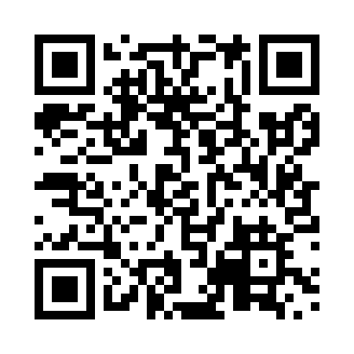

**Prayer times for Kynocks, Yukon, Canada**

**Wed 1 Jan 2025 - Fri 31 Jan 2025**

**High Latitude Method: Angle Based Rule**

**Prayer Calculation Method: Islamic Society of North America**

**Asar Calculation Method: Hanafi**

|  |  |  |  |  |  |  |  |
| --- | --- | --- | --- | --- | --- | --- | --- |
| **Date** | **Day** | **Fajr** | **Sunrise** | **Dhuhr** | **Asr** | **Maghrib** | **Isha** |
| 1 | Wed | 7:51 | 10:18 | 1:08 | 2:12 | 3:58 | 6:25 |
| 2 | Thu | 7:51 | 10:18 | 1:08 | 2:13 | 3:59 | 6:26 |
| 3 | Fri | 7:50 | 10:17 | 1:09 | 2:14 | 4:01 | 6:27 |
| 4 | Sat | 7:50 | 10:16 | 1:09 | 2:16 | 4:03 | 6:29 |
| 5 | Sun | 7:49 | 10:15 | 1:10 | 2:17 | 4:05 | 6:30 |
| 6 | Mon | 7:49 | 10:14 | 1:10 | 2:19 | 4:07 | 6:31 |
| 7 | Tue | 7:48 | 10:13 | 1:10 | 2:21 | 4:09 | 6:33 |
| 8 | Wed | 7:48 | 10:12 | 1:11 | 2:23 | 4:11 | 6:34 |
| 9 | Thu | 7:47 | 10:10 | 1:11 | 2:24 | 4:13 | 6:36 |
| 10 | Fri | 7:46 | 10:09 | 1:12 | 2:26 | 4:15 | 6:38 |
| 11 | Sat | 7:46 | 10:07 | 1:12 | 2:28 | 4:18 | 6:39 |
| 12 | Sun | 7:45 | 10:06 | 1:12 | 2:30 | 4:20 | 6:41 |
| 13 | Mon | 7:44 | 10:04 | 1:13 | 2:32 | 4:22 | 6:42 |
| 14 | Tue | 7:43 | 10:03 | 1:13 | 2:34 | 4:25 | 6:44 |
| 15 | Wed | 7:42 | 10:01 | 1:14 | 2:36 | 4:27 | 6:46 |
| 16 | Thu | 7:41 | 9:59 | 1:14 | 2:38 | 4:30 | 6:48 |
| 17 | Fri | 7:40 | 9:57 | 1:14 | 2:40 | 4:32 | 6:50 |
| 18 | Sat | 7:38 | 9:55 | 1:14 | 2:42 | 4:35 | 6:51 |
| 19 | Sun | 7:37 | 9:53 | 1:15 | 2:45 | 4:37 | 6:53 |
| 20 | Mon | 7:36 | 9:51 | 1:15 | 2:47 | 4:40 | 6:55 |
| 21 | Tue | 7:34 | 9:49 | 1:15 | 2:49 | 4:43 | 6:57 |
| 22 | Wed | 7:33 | 9:47 | 1:16 | 2:51 | 4:45 | 6:59 |
| 23 | Thu | 7:31 | 9:45 | 1:16 | 2:54 | 4:48 | 7:01 |
| 24 | Fri | 7:30 | 9:43 | 1:16 | 2:56 | 4:51 | 7:03 |
| 25 | Sat | 7:28 | 9:41 | 1:16 | 2:59 | 4:53 | 7:05 |
| 26 | Sun | 7:27 | 9:38 | 1:17 | 3:01 | 4:56 | 7:07 |
| 27 | Mon | 7:25 | 9:36 | 1:17 | 3:03 | 4:59 | 7:10 |
| 28 | Tue | 7:23 | 9:33 | 1:17 | 3:06 | 5:02 | 7:12 |
| 29 | Wed | 7:21 | 9:31 | 1:17 | 3:08 | 5:04 | 7:14 |
| 30 | Thu | 7:20 | 9:29 | 1:17 | 3:11 | 5:07 | 7:16 |
| 31 | Fri | 7:18 | 9:26 | 1:17 | 3:13 | 5:10 | 7:18 |

**Prayer times provided by https://www.salahtimes.com**