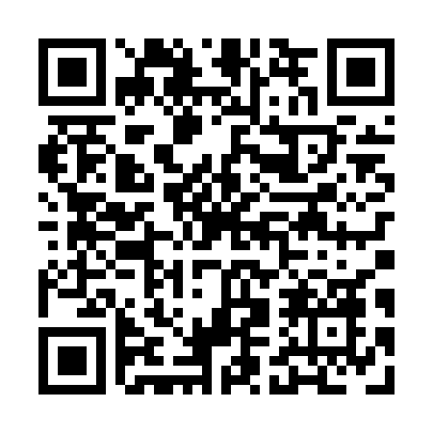
Prayer times for Gros-Mecatina, Quebec, Canada
Wed 1 May 2024 - Fri 31 May 2024
High Latitude Method: Angle Based Rule
Prayer Calculation Method: Islamic Society of North America
Asar Calculation Method: Hanafi

Date | Day | Fajr | Sunrise | Dhuhr | Asr | Maghrib | Isha
1 | Wed | 2:35 | 4:29 | 11:53 | 5:00 | 7:18 | 9:12
2 | Thu | 2:32 | 4:27 | 11:53 | 5:01 | 7:20 | 9:15
3 | Fri | 2:30 | 4:25 | 11:53 | 5:02 | 7:21 | 9:17
4 | Sat | 2:27 | 4:23 | 11:53 | 5:02 | 7:23 | 9:20
5 | Sun | 2:24 | 4:22 | 11:53 | 5:03 | 7:24 | 9:23
6 | Mon | 2:21 | 4:20 | 11:52 | 5:04 | 7:26 | 9:25
7 | Tue | 2:18 | 4:18 | 11:52 | 5:05 | 7:27 | 9:28
8 | Wed | 2:16 | 4:17 | 11:52 | 5:06 | 7:29 | 9:30
9 | Thu | 2:13 | 4:15 | 11:52 | 5:07 | 7:30 | 9:33
10 | Fri | 2:10 | 4:13 | 11:52 | 5:08 | 7:32 | 9:36
11 | Sat | 2:07 | 4:12 | 11:52 | 5:09 | 7:33 | 9:39
12 | Sun | 2:05 | 4:10 | 11:52 | 5:10 | 7:35 | 9:41
13 | Mon | 2:02 | 4:09 | 11:52 | 5:11 | 7:36 | 9:44
14 | Tue | 2:00 | 4:07 | 11:52 | 5:12 | 7:38 | 9:45
15 | Wed | 1:59 | 4:06 | 11:52 | 5:12 | 7:39 | 9:46
16 | Thu | 1:59 | 4:04 | 11:52 | 5:13 | 7:41 | 9:47
17 | Fri | 1:58 | 4:03 | 11:52 | 5:14 | 7:42 | 9:47
18 | Sat | 1:57 | 4:02 | 11:52 | 5:15 | 7:44 | 9:48
19 | Sun | 1:57 | 4:00 | 11:52 | 5:16 | 7:45 | 9:49
20 | Mon | 1:56 | 3:59 | 11:52 | 5:17 | 7:46 | 9:50
21 | Tue | 1:55 | 3:58 | 11:53 | 5:17 | 7:48 | 9:50
22 | Wed | 1:55 | 3:57 | 11:53 | 5:18 | 7:49 | 9:51
23 | Thu | 1:54 | 3:56 | 11:53 | 5:19 | 7:50 | 9:52
24 | Fri | 1:54 | 3:55 | 11:53 | 5:20 | 7:52 | 9:52
25 | Sat | 1:53 | 3:53 | 11:53 | 5:20 | 7:53 | 9:53
26 | Sun | 1:53 | 3:52 | 11:53 | 5:21 | 7:54 | 9:54
27 | Mon | 1:52 | 3:51 | 11:53 | 5:22 | 7:55 | 9:54
28 | Tue | 1:52 | 3:51 | 11:53 | 5:23 | 7:56 | 9:55
29 | Wed | 1:52 | 3:50 | 11:53 | 5:23 | 7:58 | 9:56
30 | Thu | 1:51 | 3:49 | 11:54 | 5:24 | 7:59 | 9:56
31 | Fri | 1:51 | 3:48 | 11:54 | 5:25 | 8:00 | 9:57
Prayer times provided by https://www.salahtimes.com

