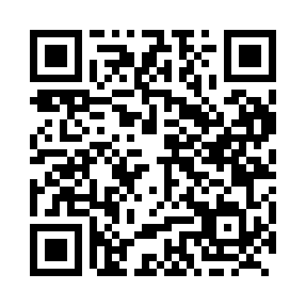

**Prayer times for Carmacks, Yukon, Canada**

**Wed 1 Jan 2025 - Fri 31 Jan 2025**

**High Latitude Method: Angle Based Rule**

**Prayer Calculation Method: Islamic Society of North America**

**Asar Calculation Method: Hanafi**

|  |  |  |  |  |  |  |  |
| --- | --- | --- | --- | --- | --- | --- | --- |
| **Date** | **Day** | **Fajr** | **Sunrise** | **Dhuhr** | **Asr** | **Maghrib** | **Isha** |
| 1 | Wed | 7:55 | 10:29 | 1:09 | 2:05 | 3:50 | 6:24 |
| 2 | Thu | 7:55 | 10:28 | 1:10 | 2:07 | 3:52 | 6:25 |
| 3 | Fri | 7:54 | 10:27 | 1:10 | 2:08 | 3:54 | 6:26 |
| 4 | Sat | 7:54 | 10:26 | 1:10 | 2:10 | 3:56 | 6:28 |
| 5 | Sun | 7:53 | 10:25 | 1:11 | 2:11 | 3:58 | 6:29 |
| 6 | Mon | 7:53 | 10:24 | 1:11 | 2:13 | 4:00 | 6:30 |
| 7 | Tue | 7:52 | 10:23 | 1:12 | 2:15 | 4:02 | 6:32 |
| 8 | Wed | 7:52 | 10:21 | 1:12 | 2:16 | 4:04 | 6:33 |
| 9 | Thu | 7:51 | 10:20 | 1:13 | 2:18 | 4:06 | 6:35 |
| 10 | Fri | 7:50 | 10:18 | 1:13 | 2:20 | 4:09 | 6:37 |
| 11 | Sat | 7:49 | 10:17 | 1:13 | 2:22 | 4:11 | 6:38 |
| 12 | Sun | 7:48 | 10:15 | 1:14 | 2:24 | 4:13 | 6:40 |
| 13 | Mon | 7:47 | 10:13 | 1:14 | 2:26 | 4:16 | 6:42 |
| 14 | Tue | 7:46 | 10:12 | 1:14 | 2:28 | 4:18 | 6:43 |
| 15 | Wed | 7:45 | 10:10 | 1:15 | 2:30 | 4:21 | 6:45 |
| 16 | Thu | 7:44 | 10:08 | 1:15 | 2:33 | 4:24 | 6:47 |
| 17 | Fri | 7:43 | 10:06 | 1:15 | 2:35 | 4:26 | 6:49 |
| 18 | Sat | 7:42 | 10:04 | 1:16 | 2:37 | 4:29 | 6:51 |
| 19 | Sun | 7:40 | 10:02 | 1:16 | 2:39 | 4:32 | 6:53 |
| 20 | Mon | 7:39 | 9:59 | 1:16 | 2:42 | 4:35 | 6:55 |
| 21 | Tue | 7:37 | 9:57 | 1:17 | 2:44 | 4:37 | 6:57 |
| 22 | Wed | 7:36 | 9:55 | 1:17 | 2:46 | 4:40 | 6:59 |
| 23 | Thu | 7:34 | 9:53 | 1:17 | 2:49 | 4:43 | 7:01 |
| 24 | Fri | 7:33 | 9:50 | 1:17 | 2:51 | 4:46 | 7:03 |
| 25 | Sat | 7:31 | 9:48 | 1:18 | 2:54 | 4:49 | 7:05 |
| 26 | Sun | 7:29 | 9:45 | 1:18 | 2:56 | 4:52 | 7:07 |
| 27 | Mon | 7:28 | 9:43 | 1:18 | 2:59 | 4:55 | 7:10 |
| 28 | Tue | 7:26 | 9:40 | 1:18 | 3:01 | 4:57 | 7:12 |
| 29 | Wed | 7:24 | 9:38 | 1:18 | 3:04 | 5:00 | 7:14 |
| 30 | Thu | 7:22 | 9:35 | 1:19 | 3:06 | 5:03 | 7:16 |
| 31 | Fri | 7:20 | 9:33 | 1:19 | 3:09 | 5:06 | 7:19 |

**Prayer times provided by https://www.salahtimes.com**