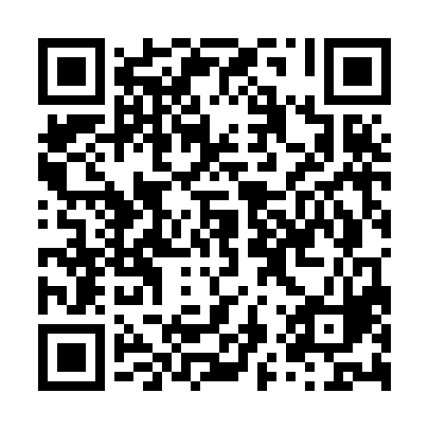
Prayer times for Unterbreizbach, Germany
Wed 1 May 2024 - Fri 31 May 2024
High Latitude Method: Angle Based Rule
Prayer Calculation Method: Muslim World League
Asar Calculation Method: Shafi

Date | Day | Fajr | Sunrise | Dhuhr | Asr | Maghrib | Isha
1 | Wed | 3:28 | 5:53 | 1:17 | 5:19 | 8:42 | 10:56
2 | Thu | 3:25 | 5:51 | 1:17 | 5:20 | 8:43 | 10:59
3 | Fri | 3:22 | 5:50 | 1:17 | 5:21 | 8:45 | 11:02
4 | Sat | 3:18 | 5:48 | 1:17 | 5:21 | 8:47 | 11:05
5 | Sun | 3:15 | 5:46 | 1:17 | 5:22 | 8:48 | 11:08
6 | Mon | 3:11 | 5:44 | 1:17 | 5:23 | 8:50 | 11:11
7 | Tue | 3:08 | 5:43 | 1:17 | 5:23 | 8:51 | 11:14
8 | Wed | 3:04 | 5:41 | 1:17 | 5:24 | 8:53 | 11:18
9 | Thu | 3:02 | 5:40 | 1:17 | 5:24 | 8:54 | 11:21
10 | Fri | 3:01 | 5:38 | 1:16 | 5:25 | 8:56 | 11:24
11 | Sat | 3:01 | 5:36 | 1:16 | 5:26 | 8:57 | 11:24
12 | Sun | 3:00 | 5:35 | 1:16 | 5:26 | 8:59 | 11:25
13 | Mon | 2:59 | 5:33 | 1:16 | 5:27 | 9:00 | 11:26
14 | Tue | 2:59 | 5:32 | 1:16 | 5:27 | 9:02 | 11:26
15 | Wed | 2:58 | 5:30 | 1:16 | 5:28 | 9:03 | 11:27
16 | Thu | 2:58 | 5:29 | 1:16 | 5:28 | 9:05 | 11:28
17 | Fri | 2:57 | 5:28 | 1:16 | 5:29 | 9:06 | 11:28
18 | Sat | 2:57 | 5:26 | 1:17 | 5:30 | 9:07 | 11:29
19 | Sun | 2:56 | 5:25 | 1:17 | 5:30 | 9:09 | 11:29
20 | Mon | 2:56 | 5:24 | 1:17 | 5:31 | 9:10 | 11:30
21 | Tue | 2:55 | 5:22 | 1:17 | 5:31 | 9:12 | 11:31
22 | Wed | 2:55 | 5:21 | 1:17 | 5:32 | 9:13 | 11:31
23 | Thu | 2:54 | 5:20 | 1:17 | 5:32 | 9:14 | 11:32
24 | Fri | 2:54 | 5:19 | 1:17 | 5:33 | 9:15 | 11:32
25 | Sat | 2:54 | 5:18 | 1:17 | 5:33 | 9:17 | 11:33
26 | Sun | 2:53 | 5:17 | 1:17 | 5:34 | 9:18 | 11:34
27 | Mon | 2:53 | 5:16 | 1:17 | 5:34 | 9:19 | 11:34
28 | Tue | 2:53 | 5:15 | 1:17 | 5:35 | 9:20 | 11:35
29 | Wed | 2:52 | 5:14 | 1:18 | 5:35 | 9:22 | 11:35
30 | Thu | 2:52 | 5:13 | 1:18 | 5:36 | 9:23 | 11:36
31 | Fri | 2:52 | 5:12 | 1:18 | 5:36 | 9:24 | 11:37
Prayer times provided by https://www.salahtimes.com

