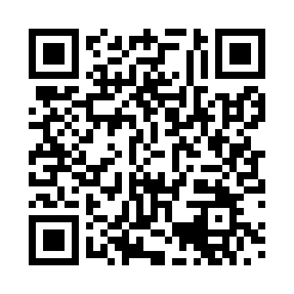

**Prayer times for Kassel, Hesse, Germany**

**Fri 1 Nov 2024 - Sat 30 Nov 2024**

**High Latitude Method: Angle Based Rule**

**Prayer Calculation Method: Muslim World League**

**Asar Calculation Method: Shafi**

|  |  |  |  |  |  |  |  |
| --- | --- | --- | --- | --- | --- | --- | --- |
| **Date** | **Day** | **Fajr** | **Sunrise** | **Dhuhr** | **Asr** | **Maghrib** | **Isha** |
| 1 | Fri | 5:23 | 7:16 | 12:06 | 2:28 | 4:55 | 6:41 |
| 2 | Sat | 5:24 | 7:17 | 12:06 | 2:26 | 4:53 | 6:40 |
| 3 | Sun | 5:26 | 7:19 | 12:06 | 2:25 | 4:51 | 6:38 |
| 4 | Mon | 5:27 | 7:21 | 12:06 | 2:23 | 4:49 | 6:37 |
| 5 | Tue | 5:29 | 7:23 | 12:06 | 2:22 | 4:48 | 6:35 |
| 6 | Wed | 5:30 | 7:24 | 12:06 | 2:21 | 4:46 | 6:34 |
| 7 | Thu | 5:32 | 7:26 | 12:06 | 2:20 | 4:44 | 6:32 |
| 8 | Fri | 5:33 | 7:28 | 12:06 | 2:18 | 4:43 | 6:31 |
| 9 | Sat | 5:35 | 7:30 | 12:06 | 2:17 | 4:41 | 6:30 |
| 10 | Sun | 5:36 | 7:31 | 12:06 | 2:16 | 4:40 | 6:29 |
| 11 | Mon | 5:38 | 7:33 | 12:06 | 2:15 | 4:38 | 6:27 |
| 12 | Tue | 5:39 | 7:35 | 12:06 | 2:14 | 4:37 | 6:26 |
| 13 | Wed | 5:40 | 7:37 | 12:06 | 2:13 | 4:35 | 6:25 |
| 14 | Thu | 5:42 | 7:38 | 12:06 | 2:11 | 4:34 | 6:24 |
| 15 | Fri | 5:43 | 7:40 | 12:07 | 2:10 | 4:33 | 6:23 |
| 16 | Sat | 5:45 | 7:42 | 12:07 | 2:09 | 4:31 | 6:22 |
| 17 | Sun | 5:46 | 7:43 | 12:07 | 2:08 | 4:30 | 6:21 |
| 18 | Mon | 5:47 | 7:45 | 12:07 | 2:08 | 4:29 | 6:20 |
| 19 | Tue | 5:49 | 7:47 | 12:07 | 2:07 | 4:28 | 6:19 |
| 20 | Wed | 5:50 | 7:48 | 12:08 | 2:06 | 4:27 | 6:18 |
| 21 | Thu | 5:52 | 7:50 | 12:08 | 2:05 | 4:25 | 6:17 |
| 22 | Fri | 5:53 | 7:51 | 12:08 | 2:04 | 4:24 | 6:17 |
| 23 | Sat | 5:54 | 7:53 | 12:09 | 2:03 | 4:23 | 6:16 |
| 24 | Sun | 5:55 | 7:55 | 12:09 | 2:03 | 4:22 | 6:15 |
| 25 | Mon | 5:57 | 7:56 | 12:09 | 2:02 | 4:21 | 6:14 |
| 26 | Tue | 5:58 | 7:58 | 12:09 | 2:01 | 4:21 | 6:14 |
| 27 | Wed | 5:59 | 7:59 | 12:10 | 2:01 | 4:20 | 6:13 |
| 28 | Thu | 6:00 | 8:01 | 12:10 | 2:00 | 4:19 | 6:13 |
| 29 | Fri | 6:02 | 8:02 | 12:10 | 2:00 | 4:18 | 6:12 |
| 30 | Sat | 6:03 | 8:03 | 12:11 | 1:59 | 4:18 | 6:12 |

**Prayer times provided by https://www.salahtimes.com**