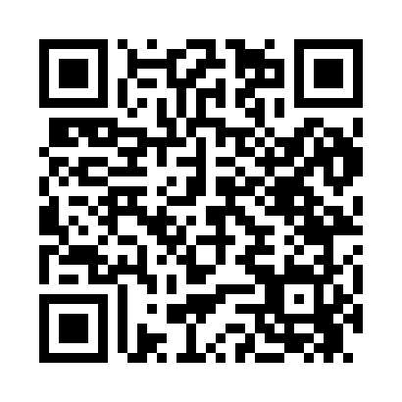
Prayer times for Flora Vista, New Mexico, USA
Mon 1 Jul 2024 - Wed 31 Jul 2024
High Latitude Method: Angle Based Rule
Prayer Calculation Method: Islamic Society of North America
Asar Calculation Method: Shafi

Date | Day | Fajr | Sunrise | Dhuhr | Asr | Maghrib | Isha
1 | Mon | 4:28 | 5:57 | 1:16 | 5:08 | 8:35 | 10:04
2 | Tue | 4:29 | 5:58 | 1:17 | 5:08 | 8:35 | 10:04
3 | Wed | 4:29 | 5:58 | 1:17 | 5:08 | 8:35 | 10:04
4 | Thu | 4:30 | 5:59 | 1:17 | 5:08 | 8:35 | 10:03
5 | Fri | 4:31 | 5:59 | 1:17 | 5:08 | 8:35 | 10:03
6 | Sat | 4:32 | 6:00 | 1:17 | 5:09 | 8:34 | 10:03
7 | Sun | 4:32 | 6:00 | 1:17 | 5:09 | 8:34 | 10:02
8 | Mon | 4:33 | 6:01 | 1:18 | 5:09 | 8:34 | 10:02
9 | Tue | 4:34 | 6:02 | 1:18 | 5:09 | 8:34 | 10:01
10 | Wed | 4:35 | 6:02 | 1:18 | 5:09 | 8:33 | 10:01
11 | Thu | 4:36 | 6:03 | 1:18 | 5:09 | 8:33 | 10:00
12 | Fri | 4:36 | 6:04 | 1:18 | 5:09 | 8:32 | 9:59
13 | Sat | 4:37 | 6:04 | 1:18 | 5:09 | 8:32 | 9:59
14 | Sun | 4:38 | 6:05 | 1:18 | 5:09 | 8:31 | 9:58
15 | Mon | 4:39 | 6:06 | 1:18 | 5:09 | 8:31 | 9:57
16 | Tue | 4:40 | 6:06 | 1:18 | 5:09 | 8:30 | 9:56
17 | Wed | 4:41 | 6:07 | 1:19 | 5:09 | 8:30 | 9:56
18 | Thu | 4:42 | 6:08 | 1:19 | 5:09 | 8:29 | 9:55
19 | Fri | 4:43 | 6:08 | 1:19 | 5:09 | 8:29 | 9:54
20 | Sat | 4:44 | 6:09 | 1:19 | 5:09 | 8:28 | 9:53
21 | Sun | 4:45 | 6:10 | 1:19 | 5:09 | 8:27 | 9:52
22 | Mon | 4:46 | 6:11 | 1:19 | 5:09 | 8:27 | 9:51
23 | Tue | 4:47 | 6:11 | 1:19 | 5:09 | 8:26 | 9:50
24 | Wed | 4:48 | 6:12 | 1:19 | 5:09 | 8:25 | 9:49
25 | Thu | 4:49 | 6:13 | 1:19 | 5:09 | 8:24 | 9:48
26 | Fri | 4:50 | 6:14 | 1:19 | 5:08 | 8:24 | 9:47
27 | Sat | 4:51 | 6:15 | 1:19 | 5:08 | 8:23 | 9:46
28 | Sun | 4:53 | 6:15 | 1:19 | 5:08 | 8:22 | 9:45
29 | Mon | 4:54 | 6:16 | 1:19 | 5:08 | 8:21 | 9:43
30 | Tue | 4:55 | 6:17 | 1:19 | 5:08 | 8:20 | 9:42
31 | Wed | 4:56 | 6:18 | 1:19 | 5:07 | 8:19 | 9:41
Prayer times provided by https://www.salahtimes.com

