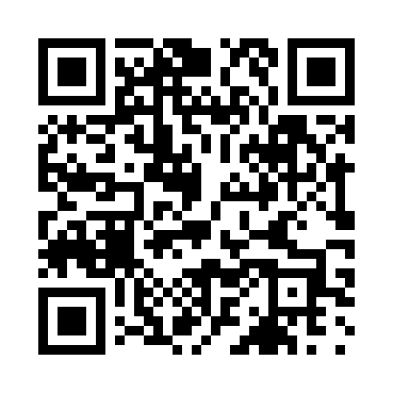

**Prayer times for Malmo, Skane, Sweden**

**Fri 1 Nov 2024 - Sat 30 Nov 2024**

**High Latitude Method: Angle Based Rule**

**Prayer Calculation Method: Muslim World League**

**Asar Calculation Method: Hanafi**

|  |  |  |  |  |  |  |  |
| --- | --- | --- | --- | --- | --- | --- | --- |
| **Date** | **Day** | **Fajr** | **Sunrise** | **Dhuhr** | **Asr** | **Maghrib** | **Isha** |
| 1 | Fri | 5:09 | 7:14 | 11:51 | 2:35 | 4:28 | 6:26 |
| 2 | Sat | 5:10 | 7:16 | 11:51 | 2:33 | 4:26 | 6:24 |
| 3 | Sun | 5:12 | 7:18 | 11:51 | 2:31 | 4:23 | 6:23 |
| 4 | Mon | 5:14 | 7:20 | 11:51 | 2:29 | 4:21 | 6:21 |
| 5 | Tue | 5:16 | 7:23 | 11:51 | 2:27 | 4:19 | 6:19 |
| 6 | Wed | 5:18 | 7:25 | 11:52 | 2:25 | 4:17 | 6:17 |
| 7 | Thu | 5:19 | 7:27 | 11:52 | 2:24 | 4:15 | 6:16 |
| 8 | Fri | 5:21 | 7:29 | 11:52 | 2:22 | 4:14 | 6:14 |
| 9 | Sat | 5:23 | 7:31 | 11:52 | 2:20 | 4:12 | 6:13 |
| 10 | Sun | 5:24 | 7:33 | 11:52 | 2:18 | 4:10 | 6:11 |
| 11 | Mon | 5:26 | 7:35 | 11:52 | 2:17 | 4:08 | 6:10 |
| 12 | Tue | 5:28 | 7:37 | 11:52 | 2:15 | 4:06 | 6:08 |
| 13 | Wed | 5:29 | 7:39 | 11:52 | 2:13 | 4:04 | 6:07 |
| 14 | Thu | 5:31 | 7:41 | 11:52 | 2:12 | 4:03 | 6:06 |
| 15 | Fri | 5:33 | 7:43 | 11:53 | 2:10 | 4:01 | 6:04 |
| 16 | Sat | 5:34 | 7:45 | 11:53 | 2:09 | 3:59 | 6:03 |
| 17 | Sun | 5:36 | 7:47 | 11:53 | 2:07 | 3:58 | 6:02 |
| 18 | Mon | 5:38 | 7:49 | 11:53 | 2:06 | 3:56 | 6:01 |
| 19 | Tue | 5:39 | 7:51 | 11:53 | 2:05 | 3:55 | 6:00 |
| 20 | Wed | 5:41 | 7:53 | 11:54 | 2:03 | 3:53 | 5:59 |
| 21 | Thu | 5:42 | 7:55 | 11:54 | 2:02 | 3:52 | 5:58 |
| 22 | Fri | 5:44 | 7:57 | 11:54 | 2:01 | 3:51 | 5:57 |
| 23 | Sat | 5:45 | 7:59 | 11:54 | 2:00 | 3:49 | 5:56 |
| 24 | Sun | 5:47 | 8:01 | 11:55 | 1:58 | 3:48 | 5:55 |
| 25 | Mon | 5:48 | 8:02 | 11:55 | 1:57 | 3:47 | 5:54 |
| 26 | Tue | 5:49 | 8:04 | 11:55 | 1:56 | 3:46 | 5:53 |
| 27 | Wed | 5:51 | 8:06 | 11:56 | 1:55 | 3:45 | 5:53 |
| 28 | Thu | 5:52 | 8:08 | 11:56 | 1:54 | 3:44 | 5:52 |
| 29 | Fri | 5:54 | 8:09 | 11:56 | 1:54 | 3:43 | 5:51 |
| 30 | Sat | 5:55 | 8:11 | 11:57 | 1:53 | 3:42 | 5:51 |

**Prayer times provided by https://www.salahtimes.com**