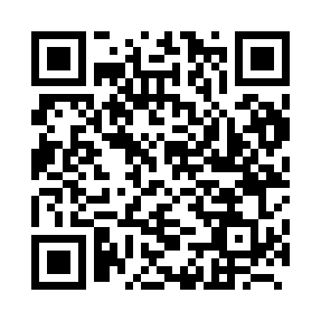

**Prayer times for Pinsk, Belarus**

**Fri 1 Nov 2024 - Sat 30 Nov 2024**

**High Latitude Method: Angle Based Rule**

**Prayer Calculation Method: Muslim World League**

**Asar Calculation Method: Shafi**

|  |  |  |  |  |  |  |  |
| --- | --- | --- | --- | --- | --- | --- | --- |
| **Date** | **Day** | **Fajr** | **Sunrise** | **Dhuhr** | **Asr** | **Maghrib** | **Isha** |
| 1 | Fri | 6:16 | 8:11 | 12:59 | 3:19 | 5:46 | 7:35 |
| 2 | Sat | 6:18 | 8:13 | 12:59 | 3:17 | 5:44 | 7:33 |
| 3 | Sun | 6:19 | 8:15 | 12:59 | 3:16 | 5:42 | 7:32 |
| 4 | Mon | 6:21 | 8:17 | 12:59 | 3:14 | 5:41 | 7:30 |
| 5 | Tue | 6:23 | 8:19 | 12:59 | 3:13 | 5:39 | 7:29 |
| 6 | Wed | 6:24 | 8:20 | 12:59 | 3:12 | 5:37 | 7:27 |
| 7 | Thu | 6:26 | 8:22 | 12:59 | 3:10 | 5:36 | 7:26 |
| 8 | Fri | 6:27 | 8:24 | 12:59 | 3:09 | 5:34 | 7:24 |
| 9 | Sat | 6:29 | 8:26 | 12:59 | 3:08 | 5:32 | 7:23 |
| 10 | Sun | 6:30 | 8:28 | 1:00 | 3:07 | 5:31 | 7:22 |
| 11 | Mon | 6:32 | 8:29 | 1:00 | 3:05 | 5:29 | 7:20 |
| 12 | Tue | 6:33 | 8:31 | 1:00 | 3:04 | 5:28 | 7:19 |
| 13 | Wed | 6:35 | 8:33 | 1:00 | 3:03 | 5:26 | 7:18 |
| 14 | Thu | 6:36 | 8:35 | 1:00 | 3:02 | 5:25 | 7:17 |
| 15 | Fri | 6:38 | 8:36 | 1:00 | 3:01 | 5:23 | 7:16 |
| 16 | Sat | 6:39 | 8:38 | 1:00 | 3:00 | 5:22 | 7:15 |
| 17 | Sun | 6:40 | 8:40 | 1:01 | 2:59 | 5:21 | 7:14 |
| 18 | Mon | 6:42 | 8:42 | 1:01 | 2:58 | 5:19 | 7:13 |
| 19 | Tue | 6:43 | 8:43 | 1:01 | 2:57 | 5:18 | 7:12 |
| 20 | Wed | 6:45 | 8:45 | 1:01 | 2:56 | 5:17 | 7:11 |
| 21 | Thu | 6:46 | 8:47 | 1:02 | 2:55 | 5:16 | 7:10 |
| 22 | Fri | 6:47 | 8:48 | 1:02 | 2:55 | 5:15 | 7:09 |
| 23 | Sat | 6:49 | 8:50 | 1:02 | 2:54 | 5:14 | 7:08 |
| 24 | Sun | 6:50 | 8:52 | 1:02 | 2:53 | 5:13 | 7:08 |
| 25 | Mon | 6:51 | 8:53 | 1:03 | 2:52 | 5:12 | 7:07 |
| 26 | Tue | 6:53 | 8:55 | 1:03 | 2:52 | 5:11 | 7:06 |
| 27 | Wed | 6:54 | 8:56 | 1:03 | 2:51 | 5:10 | 7:06 |
| 28 | Thu | 6:55 | 8:58 | 1:04 | 2:51 | 5:09 | 7:05 |
| 29 | Fri | 6:56 | 8:59 | 1:04 | 2:50 | 5:08 | 7:05 |
| 30 | Sat | 6:57 | 9:01 | 1:04 | 2:50 | 5:08 | 7:04 |

**Prayer times provided by https://www.salahtimes.com**