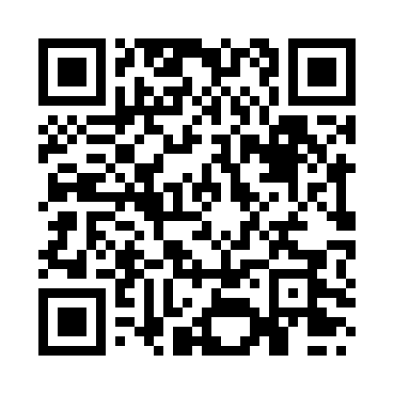

**Prayer times for Plymouth, Montserrat**

**Fri 1 Nov 2024 - Sat 30 Nov 2024**

**High Latitude Method: None**

**Prayer Calculation Method: Muslim World League**

**Asar Calculation Method: Shafi**

|  |  |  |  |  |  |  |  |
| --- | --- | --- | --- | --- | --- | --- | --- |
| **Date** | **Day** | **Fajr** | **Sunrise** | **Dhuhr** | **Asr** | **Maghrib** | **Isha** |
| 1 | Fri | 4:53 | 6:07 | 11:52 | 3:11 | 5:38 | 6:47 |
| 2 | Sat | 4:54 | 6:07 | 11:52 | 3:11 | 5:37 | 6:47 |
| 3 | Sun | 4:54 | 6:08 | 11:52 | 3:10 | 5:37 | 6:46 |
| 4 | Mon | 4:54 | 6:08 | 11:52 | 3:10 | 5:37 | 6:46 |
| 5 | Tue | 4:54 | 6:08 | 11:52 | 3:10 | 5:36 | 6:46 |
| 6 | Wed | 4:55 | 6:09 | 11:52 | 3:10 | 5:36 | 6:46 |
| 7 | Thu | 4:55 | 6:09 | 11:53 | 3:10 | 5:36 | 6:45 |
| 8 | Fri | 4:55 | 6:10 | 11:53 | 3:10 | 5:35 | 6:45 |
| 9 | Sat | 4:56 | 6:10 | 11:53 | 3:09 | 5:35 | 6:45 |
| 10 | Sun | 4:56 | 6:11 | 11:53 | 3:09 | 5:35 | 6:45 |
| 11 | Mon | 4:57 | 6:11 | 11:53 | 3:09 | 5:35 | 6:45 |
| 12 | Tue | 4:57 | 6:12 | 11:53 | 3:09 | 5:34 | 6:45 |
| 13 | Wed | 4:57 | 6:12 | 11:53 | 3:09 | 5:34 | 6:45 |
| 14 | Thu | 4:58 | 6:13 | 11:53 | 3:09 | 5:34 | 6:45 |
| 15 | Fri | 4:58 | 6:13 | 11:53 | 3:09 | 5:34 | 6:44 |
| 16 | Sat | 4:58 | 6:14 | 11:54 | 3:09 | 5:34 | 6:44 |
| 17 | Sun | 4:59 | 6:14 | 11:54 | 3:09 | 5:34 | 6:44 |
| 18 | Mon | 4:59 | 6:15 | 11:54 | 3:09 | 5:33 | 6:44 |
| 19 | Tue | 5:00 | 6:15 | 11:54 | 3:09 | 5:33 | 6:44 |
| 20 | Wed | 5:00 | 6:16 | 11:55 | 3:09 | 5:33 | 6:44 |
| 21 | Thu | 5:01 | 6:16 | 11:55 | 3:09 | 5:33 | 6:45 |
| 22 | Fri | 5:01 | 6:17 | 11:55 | 3:09 | 5:33 | 6:45 |
| 23 | Sat | 5:02 | 6:17 | 11:55 | 3:09 | 5:33 | 6:45 |
| 24 | Sun | 5:02 | 6:18 | 11:56 | 3:09 | 5:33 | 6:45 |
| 25 | Mon | 5:02 | 6:18 | 11:56 | 3:09 | 5:33 | 6:45 |
| 26 | Tue | 5:03 | 6:19 | 11:56 | 3:10 | 5:33 | 6:45 |
| 27 | Wed | 5:03 | 6:20 | 11:57 | 3:10 | 5:34 | 6:45 |
| 28 | Thu | 5:04 | 6:20 | 11:57 | 3:10 | 5:34 | 6:46 |
| 29 | Fri | 5:04 | 6:21 | 11:57 | 3:10 | 5:34 | 6:46 |
| 30 | Sat | 5:05 | 6:21 | 11:58 | 3:10 | 5:34 | 6:46 |

**Prayer times provided by https://www.salahtimes.com**