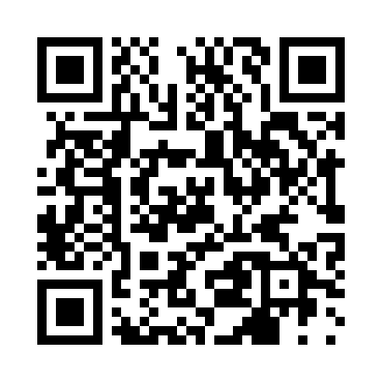

**Prayer times for Mongarigou, France**

**Sun 1 Sep 2024 - Mon 30 Sep 2024**

**High Latitude Method: Angle Based Rule**

**Prayer Calculation Method: Islamic Organisations Union of France**

**Asar Calculation Method: Shafi**

|  |  |  |  |  |  |  |  |
| --- | --- | --- | --- | --- | --- | --- | --- |
| **Date** | **Day** | **Fajr** | **Sunrise** | **Dhuhr** | **Asr** | **Maghrib** | **Isha** |
| 1 | Sun | 6:21 | 7:33 | 2:14 | 5:56 | 8:54 | 10:05 |
| 2 | Mon | 6:23 | 7:34 | 2:13 | 5:55 | 8:52 | 10:03 |
| 3 | Tue | 6:25 | 7:35 | 2:13 | 5:54 | 8:50 | 10:00 |
| 4 | Wed | 6:26 | 7:37 | 2:13 | 5:52 | 8:48 | 9:58 |
| 5 | Thu | 6:28 | 7:38 | 2:12 | 5:51 | 8:46 | 9:56 |
| 6 | Fri | 6:29 | 7:39 | 2:12 | 5:50 | 8:44 | 9:54 |
| 7 | Sat | 6:31 | 7:41 | 2:12 | 5:48 | 8:42 | 9:51 |
| 8 | Sun | 6:33 | 7:42 | 2:11 | 5:47 | 8:40 | 9:49 |
| 9 | Mon | 6:34 | 7:43 | 2:11 | 5:46 | 8:38 | 9:47 |
| 10 | Tue | 6:36 | 7:45 | 2:11 | 5:44 | 8:36 | 9:45 |
| 11 | Wed | 6:37 | 7:46 | 2:10 | 5:43 | 8:34 | 9:42 |
| 12 | Thu | 6:39 | 7:47 | 2:10 | 5:42 | 8:32 | 9:40 |
| 13 | Fri | 6:40 | 7:49 | 2:10 | 5:40 | 8:30 | 9:38 |
| 14 | Sat | 6:42 | 7:50 | 2:09 | 5:39 | 8:28 | 9:36 |
| 15 | Sun | 6:43 | 7:52 | 2:09 | 5:37 | 8:25 | 9:34 |
| 16 | Mon | 6:45 | 7:53 | 2:09 | 5:36 | 8:23 | 9:31 |
| 17 | Tue | 6:46 | 7:54 | 2:08 | 5:35 | 8:21 | 9:29 |
| 18 | Wed | 6:48 | 7:56 | 2:08 | 5:33 | 8:19 | 9:27 |
| 19 | Thu | 6:49 | 7:57 | 2:07 | 5:32 | 8:17 | 9:25 |
| 20 | Fri | 6:51 | 7:58 | 2:07 | 5:30 | 8:15 | 9:23 |
| 21 | Sat | 6:52 | 8:00 | 2:07 | 5:29 | 8:13 | 9:20 |
| 22 | Sun | 6:54 | 8:01 | 2:06 | 5:27 | 8:11 | 9:18 |
| 23 | Mon | 6:55 | 8:02 | 2:06 | 5:26 | 8:09 | 9:16 |
| 24 | Tue | 6:57 | 8:04 | 2:06 | 5:24 | 8:07 | 9:14 |
| 25 | Wed | 6:58 | 8:05 | 2:05 | 5:23 | 8:05 | 9:12 |
| 26 | Thu | 6:59 | 8:07 | 2:05 | 5:21 | 8:03 | 9:10 |
| 27 | Fri | 7:01 | 8:08 | 2:05 | 5:20 | 8:01 | 9:08 |
| 28 | Sat | 7:02 | 8:09 | 2:04 | 5:18 | 7:59 | 9:05 |
| 29 | Sun | 7:04 | 8:11 | 2:04 | 5:17 | 7:56 | 9:03 |
| 30 | Mon | 7:05 | 8:12 | 2:04 | 5:15 | 7:54 | 9:01 |

**Prayer times provided by https://www.salahtimes.com**