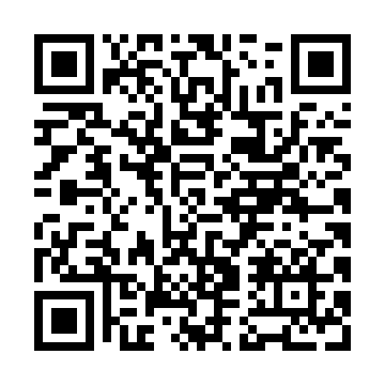
Prayer times for Char Palana, Bangladesh
Wed 1 May 2024 - Fri 31 May 2024
High Latitude Method: None
Prayer Calculation Method: University of Islamic Sciences
Asar Calculation Method: Shafi

Date | Day | Fajr | Sunrise | Dhuhr | Asr | Maghrib | Isha
1 | Wed | 4:02 | 5:24 | 11:58 | 3:28 | 6:32 | 7:55
2 | Thu | 4:01 | 5:24 | 11:58 | 3:27 | 6:33 | 7:56
3 | Fri | 4:00 | 5:23 | 11:58 | 3:27 | 6:33 | 7:56
4 | Sat | 3:59 | 5:22 | 11:58 | 3:27 | 6:34 | 7:57
5 | Sun | 3:58 | 5:21 | 11:58 | 3:27 | 6:35 | 7:58
6 | Mon | 3:57 | 5:21 | 11:58 | 3:27 | 6:35 | 7:59
7 | Tue | 3:56 | 5:20 | 11:58 | 3:26 | 6:36 | 7:59
8 | Wed | 3:56 | 5:19 | 11:58 | 3:26 | 6:36 | 8:00
9 | Thu | 3:55 | 5:19 | 11:58 | 3:26 | 6:37 | 8:01
10 | Fri | 3:54 | 5:18 | 11:58 | 3:26 | 6:37 | 8:02
11 | Sat | 3:53 | 5:18 | 11:58 | 3:26 | 6:38 | 8:02
12 | Sun | 3:52 | 5:17 | 11:57 | 3:26 | 6:38 | 8:03
13 | Mon | 3:51 | 5:16 | 11:57 | 3:26 | 6:39 | 8:04
14 | Tue | 3:51 | 5:16 | 11:57 | 3:25 | 6:39 | 8:05
15 | Wed | 3:50 | 5:15 | 11:57 | 3:25 | 6:40 | 8:05
16 | Thu | 3:49 | 5:15 | 11:58 | 3:25 | 6:40 | 8:06
17 | Fri | 3:49 | 5:14 | 11:58 | 3:25 | 6:41 | 8:07
18 | Sat | 3:48 | 5:14 | 11:58 | 3:25 | 6:41 | 8:08
19 | Sun | 3:47 | 5:14 | 11:58 | 3:25 | 6:42 | 8:08
20 | Mon | 3:47 | 5:13 | 11:58 | 3:25 | 6:42 | 8:09
21 | Tue | 3:46 | 5:13 | 11:58 | 3:25 | 6:43 | 8:10
22 | Wed | 3:45 | 5:12 | 11:58 | 3:25 | 6:44 | 8:11
23 | Thu | 3:45 | 5:12 | 11:58 | 3:24 | 6:44 | 8:11
24 | Fri | 3:44 | 5:12 | 11:58 | 3:24 | 6:45 | 8:12
25 | Sat | 3:44 | 5:11 | 11:58 | 3:24 | 6:45 | 8:13
26 | Sun | 3:43 | 5:11 | 11:58 | 3:24 | 6:46 | 8:13
27 | Mon | 3:43 | 5:11 | 11:58 | 3:24 | 6:46 | 8:14
28 | Tue | 3:43 | 5:11 | 11:58 | 3:24 | 6:47 | 8:15
29 | Wed | 3:42 | 5:10 | 11:59 | 3:24 | 6:47 | 8:15
30 | Thu | 3:42 | 5:10 | 11:59 | 3:24 | 6:48 | 8:16
31 | Fri | 3:41 | 5:10 | 11:59 | 3:24 | 6:48 | 8:17
Prayer times provided by https://www.salahtimes.com

