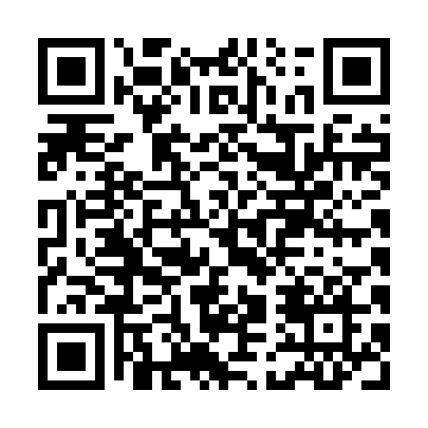

**Prayer times for Antsiranana, Madagascar**

**Fri 1 Nov 2024 - Sat 30 Nov 2024**

**High Latitude Method: None**

**Prayer Calculation Method: Muslim World League**

**Asar Calculation Method: Shafi**

|  |  |  |  |  |  |  |  |
| --- | --- | --- | --- | --- | --- | --- | --- |
| **Date** | **Day** | **Fajr** | **Sunrise** | **Dhuhr** | **Asr** | **Maghrib** | **Isha** |
| 1 | Fri | 3:56 | 5:10 | 11:26 | 2:36 | 5:43 | 6:52 |
| 2 | Sat | 3:56 | 5:10 | 11:26 | 2:37 | 5:43 | 6:53 |
| 3 | Sun | 3:55 | 5:09 | 11:26 | 2:38 | 5:44 | 6:53 |
| 4 | Mon | 3:55 | 5:09 | 11:26 | 2:38 | 5:44 | 6:54 |
| 5 | Tue | 3:55 | 5:09 | 11:26 | 2:39 | 5:44 | 6:54 |
| 6 | Wed | 3:54 | 5:09 | 11:27 | 2:40 | 5:45 | 6:55 |
| 7 | Thu | 3:54 | 5:08 | 11:27 | 2:40 | 5:45 | 6:55 |
| 8 | Fri | 3:53 | 5:08 | 11:27 | 2:41 | 5:45 | 6:56 |
| 9 | Sat | 3:53 | 5:08 | 11:27 | 2:42 | 5:46 | 6:56 |
| 10 | Sun | 3:53 | 5:08 | 11:27 | 2:42 | 5:46 | 6:57 |
| 11 | Mon | 3:53 | 5:08 | 11:27 | 2:43 | 5:46 | 6:57 |
| 12 | Tue | 3:52 | 5:07 | 11:27 | 2:44 | 5:47 | 6:58 |
| 13 | Wed | 3:52 | 5:07 | 11:27 | 2:44 | 5:47 | 6:58 |
| 14 | Thu | 3:52 | 5:07 | 11:27 | 2:45 | 5:48 | 6:59 |
| 15 | Fri | 3:51 | 5:07 | 11:28 | 2:46 | 5:48 | 6:59 |
| 16 | Sat | 3:51 | 5:07 | 11:28 | 2:46 | 5:48 | 7:00 |
| 17 | Sun | 3:51 | 5:07 | 11:28 | 2:47 | 5:49 | 7:00 |
| 18 | Mon | 3:51 | 5:07 | 11:28 | 2:48 | 5:49 | 7:01 |
| 19 | Tue | 3:51 | 5:07 | 11:28 | 2:48 | 5:50 | 7:02 |
| 20 | Wed | 3:51 | 5:07 | 11:29 | 2:49 | 5:50 | 7:02 |
| 21 | Thu | 3:51 | 5:07 | 11:29 | 2:50 | 5:51 | 7:03 |
| 22 | Fri | 3:50 | 5:07 | 11:29 | 2:50 | 5:51 | 7:03 |
| 23 | Sat | 3:50 | 5:07 | 11:29 | 2:51 | 5:52 | 7:04 |
| 24 | Sun | 3:50 | 5:07 | 11:30 | 2:52 | 5:52 | 7:05 |
| 25 | Mon | 3:50 | 5:07 | 11:30 | 2:52 | 5:53 | 7:05 |
| 26 | Tue | 3:50 | 5:07 | 11:30 | 2:53 | 5:53 | 7:06 |
| 27 | Wed | 3:50 | 5:07 | 11:31 | 2:53 | 5:54 | 7:06 |
| 28 | Thu | 3:50 | 5:08 | 11:31 | 2:54 | 5:54 | 7:07 |
| 29 | Fri | 3:50 | 5:08 | 11:31 | 2:55 | 5:55 | 7:08 |
| 30 | Sat | 3:50 | 5:08 | 11:32 | 2:55 | 5:55 | 7:08 |

**Prayer times provided by https://www.salahtimes.com**