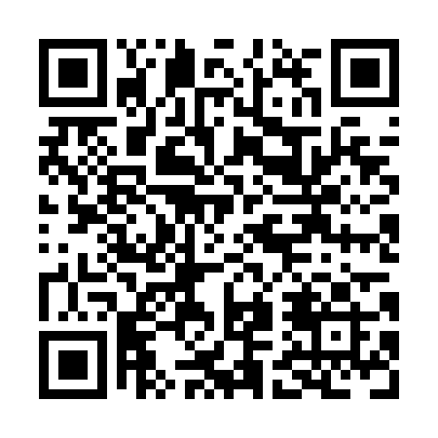
Prayer times for Castle Mountain, Alberta, Canada
Mon 1 Jul 2024 - Wed 31 Jul 2024
High Latitude Method: Angle Based Rule
Prayer Calculation Method: Islamic Society of North America
Asar Calculation Method: Hanafi

Date | Day | Fajr | Sunrise | Dhuhr | Asr | Maghrib | Isha
1 | Mon | 3:40 | 5:33 | 1:48 | 7:23 | 10:02 | 11:55
2 | Tue | 3:41 | 5:33 | 1:48 | 7:23 | 10:02 | 11:55
3 | Wed | 3:41 | 5:34 | 1:48 | 7:23 | 10:02 | 11:55
4 | Thu | 3:42 | 5:35 | 1:48 | 7:23 | 10:01 | 11:55
5 | Fri | 3:42 | 5:36 | 1:48 | 7:22 | 10:01 | 11:54
6 | Sat | 3:43 | 5:37 | 1:49 | 7:22 | 10:00 | 11:54
7 | Sun | 3:43 | 5:38 | 1:49 | 7:22 | 9:59 | 11:54
8 | Mon | 3:44 | 5:39 | 1:49 | 7:22 | 9:59 | 11:54
9 | Tue | 3:44 | 5:40 | 1:49 | 7:21 | 9:58 | 11:53
10 | Wed | 3:45 | 5:41 | 1:49 | 7:21 | 9:57 | 11:53
11 | Thu | 3:45 | 5:42 | 1:49 | 7:21 | 9:56 | 11:53
12 | Fri | 3:46 | 5:43 | 1:49 | 7:20 | 9:55 | 11:52
13 | Sat | 3:47 | 5:44 | 1:49 | 7:20 | 9:55 | 11:52
14 | Sun | 3:47 | 5:45 | 1:50 | 7:19 | 9:54 | 11:51
15 | Mon | 3:48 | 5:46 | 1:50 | 7:19 | 9:53 | 11:51
16 | Tue | 3:48 | 5:47 | 1:50 | 7:18 | 9:52 | 11:51
17 | Wed | 3:49 | 5:49 | 1:50 | 7:18 | 9:50 | 11:50
18 | Thu | 3:50 | 5:50 | 1:50 | 7:17 | 9:49 | 11:49
19 | Fri | 3:50 | 5:51 | 1:50 | 7:17 | 9:48 | 11:49
20 | Sat | 3:51 | 5:53 | 1:50 | 7:16 | 9:47 | 11:48
21 | Sun | 3:52 | 5:54 | 1:50 | 7:15 | 9:46 | 11:48
22 | Mon | 3:52 | 5:55 | 1:50 | 7:15 | 9:44 | 11:47
23 | Tue | 3:53 | 5:57 | 1:50 | 7:14 | 9:43 | 11:46
24 | Wed | 3:54 | 5:58 | 1:50 | 7:13 | 9:42 | 11:46
25 | Thu | 3:55 | 5:59 | 1:50 | 7:12 | 9:40 | 11:45
26 | Fri | 3:55 | 6:01 | 1:50 | 7:11 | 9:39 | 11:44
27 | Sat | 3:56 | 6:02 | 1:50 | 7:10 | 9:37 | 11:44
28 | Sun | 3:57 | 6:04 | 1:50 | 7:10 | 9:36 | 11:43
29 | Mon | 3:57 | 6:05 | 1:50 | 7:09 | 9:34 | 11:42
30 | Tue | 3:58 | 6:07 | 1:50 | 7:08 | 9:33 | 11:40
31 | Wed | 4:01 | 6:08 | 1:50 | 7:07 | 9:31 | 11:38
Prayer times provided by https://www.salahtimes.com

