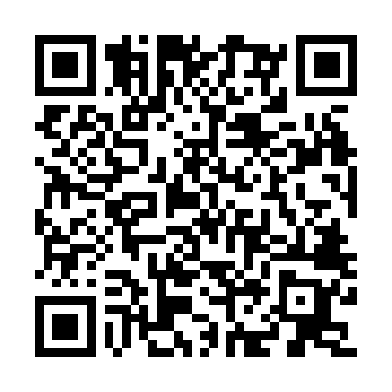

**Prayer times for Bukavu, Democratic Republic Congo**

**Fri 1 Nov 2024 - Sat 30 Nov 2024**

**High Latitude Method: None**

**Prayer Calculation Method: Muslim World League**

**Asar Calculation Method: Shafi**

|  |  |  |  |  |  |  |  |
| --- | --- | --- | --- | --- | --- | --- | --- |
| **Date** | **Day** | **Fajr** | **Sunrise** | **Dhuhr** | **Asr** | **Maghrib** | **Isha** |
| 1 | Fri | 3:31 | 4:42 | 10:48 | 2:07 | 4:54 | 6:01 |
| 2 | Sat | 3:31 | 4:42 | 10:48 | 2:08 | 4:54 | 6:02 |
| 3 | Sun | 3:31 | 4:42 | 10:48 | 2:08 | 4:54 | 6:02 |
| 4 | Mon | 3:30 | 4:42 | 10:48 | 2:08 | 4:55 | 6:02 |
| 5 | Tue | 3:30 | 4:42 | 10:48 | 2:09 | 4:55 | 6:02 |
| 6 | Wed | 3:30 | 4:42 | 10:48 | 2:09 | 4:55 | 6:02 |
| 7 | Thu | 3:30 | 4:42 | 10:48 | 2:09 | 4:55 | 6:03 |
| 8 | Fri | 3:30 | 4:42 | 10:48 | 2:10 | 4:55 | 6:03 |
| 9 | Sat | 3:30 | 4:42 | 10:49 | 2:10 | 4:55 | 6:03 |
| 10 | Sun | 3:30 | 4:42 | 10:49 | 2:10 | 4:55 | 6:03 |
| 11 | Mon | 3:30 | 4:42 | 10:49 | 2:11 | 4:55 | 6:04 |
| 12 | Tue | 3:30 | 4:42 | 10:49 | 2:11 | 4:56 | 6:04 |
| 13 | Wed | 3:30 | 4:42 | 10:49 | 2:12 | 4:56 | 6:04 |
| 14 | Thu | 3:30 | 4:42 | 10:49 | 2:12 | 4:56 | 6:05 |
| 15 | Fri | 3:30 | 4:42 | 10:49 | 2:12 | 4:56 | 6:05 |
| 16 | Sat | 3:30 | 4:43 | 10:50 | 2:13 | 4:57 | 6:05 |
| 17 | Sun | 3:30 | 4:43 | 10:50 | 2:13 | 4:57 | 6:06 |
| 18 | Mon | 3:30 | 4:43 | 10:50 | 2:14 | 4:57 | 6:06 |
| 19 | Tue | 3:30 | 4:43 | 10:50 | 2:14 | 4:57 | 6:06 |
| 20 | Wed | 3:30 | 4:43 | 10:50 | 2:14 | 4:58 | 6:07 |
| 21 | Thu | 3:30 | 4:43 | 10:51 | 2:15 | 4:58 | 6:07 |
| 22 | Fri | 3:30 | 4:44 | 10:51 | 2:15 | 4:58 | 6:08 |
| 23 | Sat | 3:30 | 4:44 | 10:51 | 2:16 | 4:59 | 6:08 |
| 24 | Sun | 3:30 | 4:44 | 10:51 | 2:16 | 4:59 | 6:08 |
| 25 | Mon | 3:30 | 4:44 | 10:52 | 2:17 | 4:59 | 6:09 |
| 26 | Tue | 3:31 | 4:45 | 10:52 | 2:17 | 5:00 | 6:09 |
| 27 | Wed | 3:31 | 4:45 | 10:52 | 2:18 | 5:00 | 6:10 |
| 28 | Thu | 3:31 | 4:45 | 10:53 | 2:18 | 5:00 | 6:10 |
| 29 | Fri | 3:31 | 4:45 | 10:53 | 2:18 | 5:01 | 6:11 |
| 30 | Sat | 3:31 | 4:46 | 10:53 | 2:19 | 5:01 | 6:11 |

**Prayer times provided by https://www.salahtimes.com**