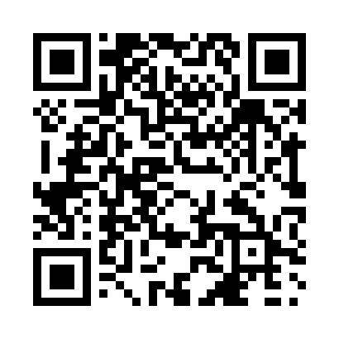
Prayer times for Gull Harbour, Manitoba, Canada
Mon 1 Apr 2024 - Tue 30 Apr 2024
High Latitude Method: Angle Based Rule
Prayer Calculation Method: Islamic Society of North America
Asar Calculation Method: Hanafi

Date | Day | Fajr | Sunrise | Dhuhr | Asr | Maghrib | Isha
1 | Mon | 5:25 | 7:01 | 1:30 | 5:58 | 8:01 | 9:37
2 | Tue | 5:22 | 6:58 | 1:30 | 5:59 | 8:02 | 9:39
3 | Wed | 5:20 | 6:56 | 1:30 | 6:00 | 8:04 | 9:41
4 | Thu | 5:17 | 6:54 | 1:29 | 6:01 | 8:06 | 9:43
5 | Fri | 5:14 | 6:52 | 1:29 | 6:03 | 8:07 | 9:45
6 | Sat | 5:12 | 6:49 | 1:29 | 6:04 | 8:09 | 9:47
7 | Sun | 5:09 | 6:47 | 1:28 | 6:05 | 8:11 | 9:49
8 | Mon | 5:06 | 6:45 | 1:28 | 6:06 | 8:12 | 9:51
9 | Tue | 5:04 | 6:43 | 1:28 | 6:07 | 8:14 | 9:53
10 | Wed | 5:01 | 6:41 | 1:28 | 6:08 | 8:15 | 9:56
11 | Thu | 4:58 | 6:38 | 1:27 | 6:09 | 8:17 | 9:58
12 | Fri | 4:56 | 6:36 | 1:27 | 6:11 | 8:19 | 10:00
13 | Sat | 4:53 | 6:34 | 1:27 | 6:12 | 8:20 | 10:02
14 | Sun | 4:50 | 6:32 | 1:27 | 6:13 | 8:22 | 10:04
15 | Mon | 4:47 | 6:30 | 1:26 | 6:14 | 8:24 | 10:07
16 | Tue | 4:45 | 6:28 | 1:26 | 6:15 | 8:25 | 10:09
17 | Wed | 4:42 | 6:26 | 1:26 | 6:16 | 8:27 | 10:11
18 | Thu | 4:39 | 6:24 | 1:26 | 6:17 | 8:29 | 10:14
19 | Fri | 4:36 | 6:22 | 1:25 | 6:18 | 8:30 | 10:16
20 | Sat | 4:34 | 6:19 | 1:25 | 6:19 | 8:32 | 10:18
21 | Sun | 4:31 | 6:17 | 1:25 | 6:20 | 8:34 | 10:21
22 | Mon | 4:28 | 6:15 | 1:25 | 6:22 | 8:35 | 10:23
23 | Tue | 4:25 | 6:13 | 1:25 | 6:23 | 8:37 | 10:26
24 | Wed | 4:22 | 6:11 | 1:24 | 6:24 | 8:39 | 10:28
25 | Thu | 4:20 | 6:09 | 1:24 | 6:25 | 8:40 | 10:31
26 | Fri | 4:17 | 6:07 | 1:24 | 6:26 | 8:42 | 10:33
27 | Sat | 4:14 | 6:06 | 1:24 | 6:27 | 8:43 | 10:36
28 | Sun | 4:11 | 6:04 | 1:24 | 6:28 | 8:45 | 10:38
29 | Mon | 4:08 | 6:02 | 1:24 | 6:29 | 8:47 | 10:41
30 | Tue | 4:05 | 6:00 | 1:24 | 6:30 | 8:48 | 10:43
Prayer times provided by https://www.salahtimes.com

