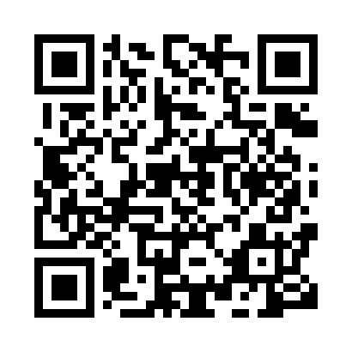
Prayer times for Barkeno, Cameroon
Wed 1 May 2024 - Fri 31 May 2024
High Latitude Method: None
Prayer Calculation Method: Muslim World League
Asar Calculation Method: Shafi

Date | Day | Fajr | Sunrise | Dhuhr | Asr | Maghrib | Isha
1 | Wed | 4:43 | 5:56 | 12:07 | 3:24 | 6:19 | 7:27
2 | Thu | 4:43 | 5:56 | 12:07 | 3:24 | 6:19 | 7:28
3 | Fri | 4:43 | 5:55 | 12:07 | 3:25 | 6:19 | 7:28
4 | Sat | 4:42 | 5:55 | 12:07 | 3:25 | 6:19 | 7:28
5 | Sun | 4:42 | 5:55 | 12:07 | 3:25 | 6:20 | 7:28
6 | Mon | 4:41 | 5:54 | 12:07 | 3:26 | 6:20 | 7:28
7 | Tue | 4:41 | 5:54 | 12:07 | 3:26 | 6:20 | 7:29
8 | Wed | 4:41 | 5:54 | 12:07 | 3:26 | 6:20 | 7:29
9 | Thu | 4:40 | 5:54 | 12:07 | 3:27 | 6:20 | 7:29
10 | Fri | 4:40 | 5:54 | 12:07 | 3:27 | 6:20 | 7:29
11 | Sat | 4:40 | 5:53 | 12:07 | 3:27 | 6:20 | 7:30
12 | Sun | 4:40 | 5:53 | 12:07 | 3:28 | 6:20 | 7:30
13 | Mon | 4:39 | 5:53 | 12:07 | 3:28 | 6:20 | 7:30
14 | Tue | 4:39 | 5:53 | 12:07 | 3:28 | 6:21 | 7:30
15 | Wed | 4:39 | 5:53 | 12:07 | 3:29 | 6:21 | 7:31
16 | Thu | 4:38 | 5:53 | 12:07 | 3:29 | 6:21 | 7:31
17 | Fri | 4:38 | 5:53 | 12:07 | 3:29 | 6:21 | 7:31
18 | Sat | 4:38 | 5:53 | 12:07 | 3:30 | 6:21 | 7:31
19 | Sun | 4:38 | 5:52 | 12:07 | 3:30 | 6:21 | 7:32
20 | Mon | 4:38 | 5:52 | 12:07 | 3:30 | 6:22 | 7:32
21 | Tue | 4:37 | 5:52 | 12:07 | 3:31 | 6:22 | 7:32
22 | Wed | 4:37 | 5:52 | 12:07 | 3:31 | 6:22 | 7:33
23 | Thu | 4:37 | 5:52 | 12:07 | 3:31 | 6:22 | 7:33
24 | Fri | 4:37 | 5:52 | 12:07 | 3:32 | 6:22 | 7:33
25 | Sat | 4:37 | 5:52 | 12:07 | 3:32 | 6:23 | 7:34
26 | Sun | 4:37 | 5:52 | 12:08 | 3:32 | 6:23 | 7:34
27 | Mon | 4:37 | 5:52 | 12:08 | 3:33 | 6:23 | 7:34
28 | Tue | 4:37 | 5:52 | 12:08 | 3:33 | 6:23 | 7:34
29 | Wed | 4:37 | 5:52 | 12:08 | 3:33 | 6:24 | 7:35
30 | Thu | 4:37 | 5:52 | 12:08 | 3:34 | 6:24 | 7:35
31 | Fri | 4:37 | 5:52 | 12:08 | 3:34 | 6:24 | 7:35
Prayer times provided by https://www.salahtimes.com

