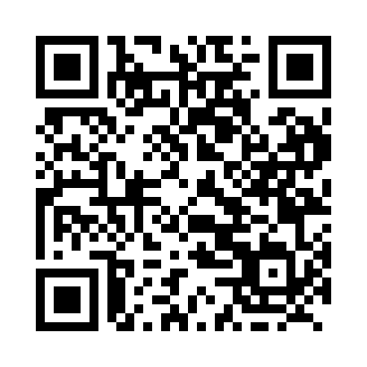

**Prayer times for Fort St. John, British Columbia, Canada**

**Wed 1 Jan 2025 - Fri 31 Jan 2025**

**High Latitude Method: Angle Based Rule**

**Prayer Calculation Method: Islamic Society of North America**

**Asar Calculation Method: Hanafi**

|  |  |  |  |  |  |  |  |
| --- | --- | --- | --- | --- | --- | --- | --- |
| **Date** | **Day** | **Fajr** | **Sunrise** | **Dhuhr** | **Asr** | **Maghrib** | **Isha** |
| 1 | Wed | 7:36 | 9:36 | 1:07 | 2:50 | 4:39 | 6:38 |
| 2 | Thu | 7:36 | 9:36 | 1:08 | 2:51 | 4:40 | 6:39 |
| 3 | Fri | 7:36 | 9:35 | 1:08 | 2:53 | 4:41 | 6:40 |
| 4 | Sat | 7:36 | 9:35 | 1:09 | 2:54 | 4:43 | 6:42 |
| 5 | Sun | 7:36 | 9:34 | 1:09 | 2:55 | 4:44 | 6:43 |
| 6 | Mon | 7:35 | 9:34 | 1:09 | 2:57 | 4:46 | 6:44 |
| 7 | Tue | 7:35 | 9:33 | 1:10 | 2:58 | 4:47 | 6:45 |
| 8 | Wed | 7:35 | 9:32 | 1:10 | 3:00 | 4:49 | 6:46 |
| 9 | Thu | 7:34 | 9:32 | 1:11 | 3:01 | 4:51 | 6:48 |
| 10 | Fri | 7:34 | 9:31 | 1:11 | 3:03 | 4:52 | 6:49 |
| 11 | Sat | 7:33 | 9:30 | 1:12 | 3:04 | 4:54 | 6:50 |
| 12 | Sun | 7:32 | 9:29 | 1:12 | 3:06 | 4:56 | 6:52 |
| 13 | Mon | 7:32 | 9:28 | 1:12 | 3:08 | 4:58 | 6:53 |
| 14 | Tue | 7:31 | 9:27 | 1:13 | 3:09 | 4:59 | 6:55 |
| 15 | Wed | 7:30 | 9:25 | 1:13 | 3:11 | 5:01 | 6:56 |
| 16 | Thu | 7:29 | 9:24 | 1:13 | 3:13 | 5:03 | 6:58 |
| 17 | Fri | 7:29 | 9:23 | 1:14 | 3:14 | 5:05 | 6:59 |
| 18 | Sat | 7:28 | 9:22 | 1:14 | 3:16 | 5:07 | 7:01 |
| 19 | Sun | 7:27 | 9:20 | 1:14 | 3:18 | 5:09 | 7:03 |
| 20 | Mon | 7:26 | 9:19 | 1:15 | 3:20 | 5:11 | 7:04 |
| 21 | Tue | 7:25 | 9:17 | 1:15 | 3:22 | 5:13 | 7:06 |
| 22 | Wed | 7:23 | 9:16 | 1:15 | 3:24 | 5:15 | 7:07 |
| 23 | Thu | 7:22 | 9:14 | 1:15 | 3:26 | 5:17 | 7:09 |
| 24 | Fri | 7:21 | 9:13 | 1:16 | 3:28 | 5:19 | 7:11 |
| 25 | Sat | 7:20 | 9:11 | 1:16 | 3:30 | 5:22 | 7:13 |
| 26 | Sun | 7:19 | 9:09 | 1:16 | 3:32 | 5:24 | 7:14 |
| 27 | Mon | 7:17 | 9:08 | 1:16 | 3:34 | 5:26 | 7:16 |
| 28 | Tue | 7:16 | 9:06 | 1:16 | 3:36 | 5:28 | 7:18 |
| 29 | Wed | 7:14 | 9:04 | 1:17 | 3:38 | 5:30 | 7:20 |
| 30 | Thu | 7:13 | 9:02 | 1:17 | 3:40 | 5:32 | 7:22 |
| 31 | Fri | 7:11 | 9:00 | 1:17 | 3:42 | 5:35 | 7:23 |

**Prayer times provided by https://www.salahtimes.com**