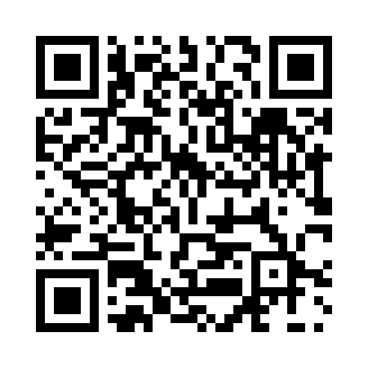
Prayer times for Coco Cay, Bahamas
Mon 1 Apr 2024 - Tue 30 Apr 2024
High Latitude Method: None
Prayer Calculation Method: Muslim World League
Asar Calculation Method: Shafi

Date | Day | Fajr | Sunrise | Dhuhr | Asr | Maghrib | Isha
1 | Mon | 5:45 | 7:02 | 1:15 | 4:44 | 7:29 | 8:42
2 | Tue | 5:44 | 7:01 | 1:15 | 4:44 | 7:29 | 8:42
3 | Wed | 5:43 | 7:00 | 1:15 | 4:44 | 7:30 | 8:43
4 | Thu | 5:41 | 6:59 | 1:15 | 4:44 | 7:30 | 8:44
5 | Fri | 5:40 | 6:58 | 1:14 | 4:44 | 7:31 | 8:44
6 | Sat | 5:39 | 6:57 | 1:14 | 4:44 | 7:31 | 8:45
7 | Sun | 5:38 | 6:56 | 1:14 | 4:43 | 7:32 | 8:45
8 | Mon | 5:37 | 6:55 | 1:13 | 4:43 | 7:32 | 8:46
9 | Tue | 5:36 | 6:54 | 1:13 | 4:43 | 7:32 | 8:46
10 | Wed | 5:34 | 6:53 | 1:13 | 4:43 | 7:33 | 8:47
11 | Thu | 5:33 | 6:52 | 1:13 | 4:43 | 7:33 | 8:48
12 | Fri | 5:32 | 6:51 | 1:12 | 4:42 | 7:34 | 8:48
13 | Sat | 5:31 | 6:50 | 1:12 | 4:42 | 7:34 | 8:49
14 | Sun | 5:30 | 6:49 | 1:12 | 4:42 | 7:35 | 8:50
15 | Mon | 5:29 | 6:48 | 1:12 | 4:42 | 7:35 | 8:50
16 | Tue | 5:28 | 6:47 | 1:11 | 4:42 | 7:36 | 8:51
17 | Wed | 5:27 | 6:46 | 1:11 | 4:41 | 7:36 | 8:51
18 | Thu | 5:25 | 6:45 | 1:11 | 4:41 | 7:37 | 8:52
19 | Fri | 5:24 | 6:45 | 1:11 | 4:41 | 7:37 | 8:53
20 | Sat | 5:23 | 6:44 | 1:11 | 4:41 | 7:38 | 8:53
21 | Sun | 5:22 | 6:43 | 1:10 | 4:40 | 7:38 | 8:54
22 | Mon | 5:21 | 6:42 | 1:10 | 4:40 | 7:39 | 8:55
23 | Tue | 5:20 | 6:41 | 1:10 | 4:40 | 7:39 | 8:55
24 | Wed | 5:19 | 6:40 | 1:10 | 4:40 | 7:40 | 8:56
25 | Thu | 5:18 | 6:39 | 1:10 | 4:40 | 7:40 | 8:57
26 | Fri | 5:17 | 6:38 | 1:09 | 4:39 | 7:41 | 8:58
27 | Sat | 5:16 | 6:38 | 1:09 | 4:39 | 7:41 | 8:58
28 | Sun | 5:15 | 6:37 | 1:09 | 4:39 | 7:42 | 8:59
29 | Mon | 5:14 | 6:36 | 1:09 | 4:39 | 7:42 | 9:00
30 | Tue | 5:13 | 6:35 | 1:09 | 4:39 | 7:43 | 9:00
Prayer times provided by https://www.salahtimes.com

