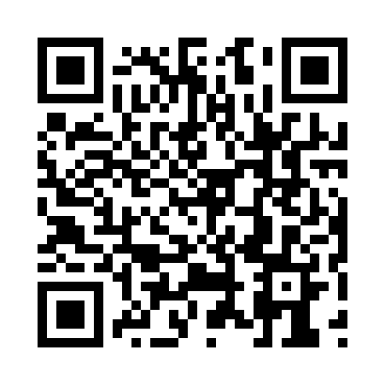

**Prayer times for Deception, Quebec, Canada**

**Wed 1 Jan 2025 - Fri 31 Jan 2025**

**High Latitude Method: Angle Based Rule**

**Prayer Calculation Method: Islamic Society of North America**

**Asar Calculation Method: Hanafi**

|  |  |  |  |  |  |  |  |
| --- | --- | --- | --- | --- | --- | --- | --- |
| **Date** | **Day** | **Fajr** | **Sunrise** | **Dhuhr** | **Asr** | **Maghrib** | **Isha** |
| 1 | Wed | 6:48 | 9:22 | 12:02 | 12:58 | 2:43 | 5:17 |
| 2 | Thu | 6:48 | 9:22 | 12:03 | 12:59 | 2:44 | 5:18 |
| 3 | Fri | 6:48 | 9:21 | 12:03 | 1:01 | 2:46 | 5:19 |
| 4 | Sat | 6:47 | 9:20 | 12:04 | 1:02 | 2:48 | 5:21 |
| 5 | Sun | 6:47 | 9:19 | 12:04 | 1:04 | 2:50 | 5:22 |
| 6 | Mon | 6:46 | 9:18 | 12:05 | 1:06 | 2:52 | 5:23 |
| 7 | Tue | 6:46 | 9:16 | 12:05 | 1:07 | 2:54 | 5:25 |
| 8 | Wed | 6:45 | 9:15 | 12:05 | 1:09 | 2:57 | 5:26 |
| 9 | Thu | 6:44 | 9:14 | 12:06 | 1:11 | 2:59 | 5:28 |
| 10 | Fri | 6:44 | 9:12 | 12:06 | 1:13 | 3:01 | 5:29 |
| 11 | Sat | 6:43 | 9:11 | 12:07 | 1:15 | 3:04 | 5:31 |
| 12 | Sun | 6:42 | 9:09 | 12:07 | 1:17 | 3:06 | 5:33 |
| 13 | Mon | 6:41 | 9:07 | 12:07 | 1:19 | 3:09 | 5:35 |
| 14 | Tue | 6:40 | 9:05 | 12:08 | 1:21 | 3:11 | 5:36 |
| 15 | Wed | 6:39 | 9:04 | 12:08 | 1:23 | 3:14 | 5:38 |
| 16 | Thu | 6:38 | 9:02 | 12:08 | 1:25 | 3:16 | 5:40 |
| 17 | Fri | 6:36 | 9:00 | 12:09 | 1:28 | 3:19 | 5:42 |
| 18 | Sat | 6:35 | 8:58 | 12:09 | 1:30 | 3:22 | 5:44 |
| 19 | Sun | 6:34 | 8:55 | 12:09 | 1:32 | 3:24 | 5:46 |
| 20 | Mon | 6:32 | 8:53 | 12:10 | 1:34 | 3:27 | 5:48 |
| 21 | Tue | 6:31 | 8:51 | 12:10 | 1:37 | 3:30 | 5:50 |
| 22 | Wed | 6:29 | 8:49 | 12:10 | 1:39 | 3:33 | 5:52 |
| 23 | Thu | 6:28 | 8:47 | 12:10 | 1:42 | 3:36 | 5:54 |
| 24 | Fri | 6:26 | 8:44 | 12:11 | 1:44 | 3:39 | 5:56 |
| 25 | Sat | 6:25 | 8:42 | 12:11 | 1:46 | 3:41 | 5:58 |
| 26 | Sun | 6:23 | 8:39 | 12:11 | 1:49 | 3:44 | 6:00 |
| 27 | Mon | 6:21 | 8:37 | 12:11 | 1:51 | 3:47 | 6:02 |
| 28 | Tue | 6:19 | 8:34 | 12:12 | 1:54 | 3:50 | 6:05 |
| 29 | Wed | 6:18 | 8:32 | 12:12 | 1:56 | 3:53 | 6:07 |
| 30 | Thu | 6:16 | 8:29 | 12:12 | 1:59 | 3:56 | 6:09 |
| 31 | Fri | 6:14 | 8:27 | 12:12 | 2:01 | 3:59 | 6:11 |

**Prayer times provided by https://www.salahtimes.com**