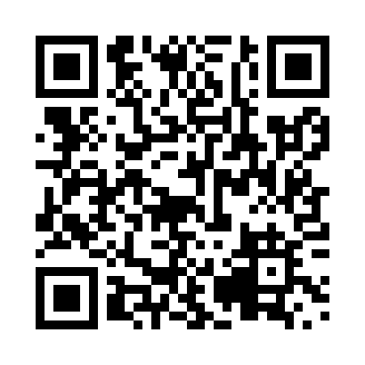

**Prayer times for Charrington, Quebec, Canada**

**Wed 1 Jan 2025 - Fri 31 Jan 2025**

**High Latitude Method: Angle Based Rule**

**Prayer Calculation Method: Islamic Society of North America**

**Asar Calculation Method: Hanafi**

|  |  |  |  |  |  |  |  |
| --- | --- | --- | --- | --- | --- | --- | --- |
| **Date** | **Day** | **Fajr** | **Sunrise** | **Dhuhr** | **Asr** | **Maghrib** | **Isha** |
| 1 | Wed | 5:56 | 7:25 | 11:50 | 2:32 | 4:15 | 5:44 |
| 2 | Thu | 5:56 | 7:25 | 11:51 | 2:33 | 4:16 | 5:45 |
| 3 | Fri | 5:56 | 7:25 | 11:51 | 2:34 | 4:17 | 5:46 |
| 4 | Sat | 5:56 | 7:25 | 11:51 | 2:35 | 4:18 | 5:47 |
| 5 | Sun | 5:56 | 7:25 | 11:52 | 2:36 | 4:19 | 5:48 |
| 6 | Mon | 5:56 | 7:25 | 11:52 | 2:37 | 4:20 | 5:48 |
| 7 | Tue | 5:56 | 7:25 | 11:53 | 2:38 | 4:21 | 5:49 |
| 8 | Wed | 5:56 | 7:24 | 11:53 | 2:39 | 4:22 | 5:50 |
| 9 | Thu | 5:56 | 7:24 | 11:54 | 2:40 | 4:23 | 5:51 |
| 10 | Fri | 5:56 | 7:24 | 11:54 | 2:41 | 4:25 | 5:52 |
| 11 | Sat | 5:56 | 7:23 | 11:54 | 2:42 | 4:26 | 5:53 |
| 12 | Sun | 5:55 | 7:23 | 11:55 | 2:44 | 4:27 | 5:55 |
| 13 | Mon | 5:55 | 7:22 | 11:55 | 2:45 | 4:28 | 5:56 |
| 14 | Tue | 5:55 | 7:22 | 11:55 | 2:46 | 4:30 | 5:57 |
| 15 | Wed | 5:54 | 7:21 | 11:56 | 2:47 | 4:31 | 5:58 |
| 16 | Thu | 5:54 | 7:21 | 11:56 | 2:49 | 4:32 | 5:59 |
| 17 | Fri | 5:53 | 7:20 | 11:57 | 2:50 | 4:33 | 6:00 |
| 18 | Sat | 5:53 | 7:19 | 11:57 | 2:51 | 4:35 | 6:01 |
| 19 | Sun | 5:52 | 7:19 | 11:57 | 2:52 | 4:36 | 6:02 |
| 20 | Mon | 5:52 | 7:18 | 11:57 | 2:54 | 4:37 | 6:03 |
| 21 | Tue | 5:51 | 7:17 | 11:58 | 2:55 | 4:39 | 6:05 |
| 22 | Wed | 5:51 | 7:16 | 11:58 | 2:56 | 4:40 | 6:06 |
| 23 | Thu | 5:50 | 7:16 | 11:58 | 2:58 | 4:41 | 6:07 |
| 24 | Fri | 5:49 | 7:15 | 11:58 | 2:59 | 4:43 | 6:08 |
| 25 | Sat | 5:48 | 7:14 | 11:59 | 3:00 | 4:44 | 6:09 |
| 26 | Sun | 5:48 | 7:13 | 11:59 | 3:02 | 4:46 | 6:11 |
| 27 | Mon | 5:47 | 7:12 | 11:59 | 3:03 | 4:47 | 6:12 |
| 28 | Tue | 5:46 | 7:11 | 11:59 | 3:05 | 4:49 | 6:13 |
| 29 | Wed | 5:45 | 7:10 | 11:59 | 3:06 | 4:50 | 6:14 |
| 30 | Thu | 5:44 | 7:08 | 12:00 | 3:07 | 4:51 | 6:16 |
| 31 | Fri | 5:43 | 7:07 | 12:00 | 3:09 | 4:53 | 6:17 |

**Prayer times provided by https://www.salahtimes.com**