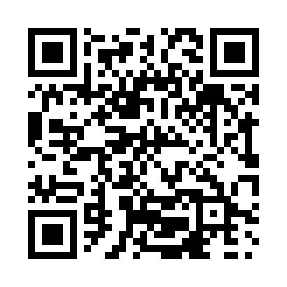
Prayer times for St. Elmo, Ontario, Canada
Mon 1 Jul 2024 - Wed 31 Jul 2024
High Latitude Method: Angle Based Rule
Prayer Calculation Method: Islamic Society of North America
Asar Calculation Method: Hanafi

Date | Day | Fajr | Sunrise | Dhuhr | Asr | Maghrib | Isha
1 | Mon | 3:19 | 5:16 | 1:04 | 6:26 | 8:51 | 10:48
2 | Tue | 3:20 | 5:16 | 1:04 | 6:26 | 8:51 | 10:47
3 | Wed | 3:21 | 5:17 | 1:04 | 6:26 | 8:51 | 10:46
4 | Thu | 3:22 | 5:18 | 1:04 | 6:26 | 8:50 | 10:46
5 | Fri | 3:23 | 5:18 | 1:04 | 6:26 | 8:50 | 10:45
6 | Sat | 3:24 | 5:19 | 1:04 | 6:26 | 8:49 | 10:44
7 | Sun | 3:25 | 5:20 | 1:05 | 6:26 | 8:49 | 10:43
8 | Mon | 3:27 | 5:21 | 1:05 | 6:25 | 8:49 | 10:42
9 | Tue | 3:28 | 5:21 | 1:05 | 6:25 | 8:48 | 10:41
10 | Wed | 3:29 | 5:22 | 1:05 | 6:25 | 8:47 | 10:40
11 | Thu | 3:30 | 5:23 | 1:05 | 6:25 | 8:47 | 10:39
12 | Fri | 3:32 | 5:24 | 1:05 | 6:24 | 8:46 | 10:38
13 | Sat | 3:33 | 5:25 | 1:05 | 6:24 | 8:46 | 10:37
14 | Sun | 3:35 | 5:26 | 1:05 | 6:24 | 8:45 | 10:35
15 | Mon | 3:36 | 5:27 | 1:06 | 6:23 | 8:44 | 10:34
16 | Tue | 3:38 | 5:28 | 1:06 | 6:23 | 8:43 | 10:33
17 | Wed | 3:39 | 5:29 | 1:06 | 6:23 | 8:43 | 10:31
18 | Thu | 3:41 | 5:30 | 1:06 | 6:22 | 8:42 | 10:30
19 | Fri | 3:42 | 5:31 | 1:06 | 6:22 | 8:41 | 10:29
20 | Sat | 3:44 | 5:32 | 1:06 | 6:21 | 8:40 | 10:27
21 | Sun | 3:46 | 5:33 | 1:06 | 6:21 | 8:39 | 10:25
22 | Mon | 3:47 | 5:34 | 1:06 | 6:20 | 8:38 | 10:24
23 | Tue | 3:49 | 5:35 | 1:06 | 6:20 | 8:37 | 10:22
24 | Wed | 3:51 | 5:36 | 1:06 | 6:19 | 8:36 | 10:21
25 | Thu | 3:52 | 5:37 | 1:06 | 6:18 | 8:35 | 10:19
26 | Fri | 3:54 | 5:38 | 1:06 | 6:18 | 8:34 | 10:17
27 | Sat | 3:56 | 5:39 | 1:06 | 6:17 | 8:32 | 10:15
28 | Sun | 3:57 | 5:40 | 1:06 | 6:16 | 8:31 | 10:14
29 | Mon | 3:59 | 5:41 | 1:06 | 6:16 | 8:30 | 10:12
30 | Tue | 4:01 | 5:42 | 1:06 | 6:15 | 8:29 | 10:10
31 | Wed | 4:03 | 5:44 | 1:06 | 6:14 | 8:28 | 10:08
Prayer times provided by https://www.salahtimes.com

