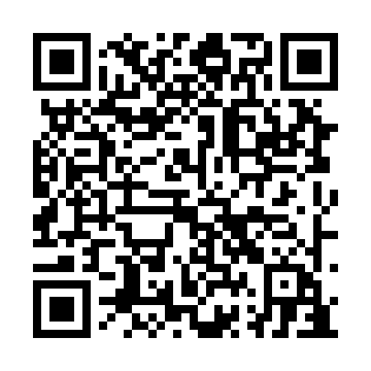
Prayer times for Barriere-Bethanie, Quebec, Canada
Mon 1 Apr 2024 - Tue 30 Apr 2024
High Latitude Method: Angle Based Rule
Prayer Calculation Method: Islamic Society of North America
Asar Calculation Method: Hanafi

Date | Day | Fajr | Sunrise | Dhuhr | Asr | Maghrib | Isha
1 | Mon | 4:52 | 6:21 | 12:48 | 5:17 | 7:16 | 8:45
2 | Tue | 4:50 | 6:19 | 12:48 | 5:18 | 7:17 | 8:47
3 | Wed | 4:48 | 6:17 | 12:48 | 5:19 | 7:19 | 8:49
4 | Thu | 4:45 | 6:15 | 12:47 | 5:20 | 7:20 | 8:51
5 | Fri | 4:43 | 6:13 | 12:47 | 5:21 | 7:22 | 8:52
6 | Sat | 4:40 | 6:11 | 12:47 | 5:22 | 7:23 | 8:54
7 | Sun | 4:38 | 6:09 | 12:46 | 5:23 | 7:25 | 8:56
8 | Mon | 4:36 | 6:07 | 12:46 | 5:24 | 7:26 | 8:58
9 | Tue | 4:33 | 6:05 | 12:46 | 5:25 | 7:27 | 9:00
10 | Wed | 4:31 | 6:03 | 12:46 | 5:26 | 7:29 | 9:02
11 | Thu | 4:29 | 6:01 | 12:45 | 5:27 | 7:30 | 9:03
12 | Fri | 4:26 | 5:59 | 12:45 | 5:28 | 7:32 | 9:05
13 | Sat | 4:24 | 5:57 | 12:45 | 5:29 | 7:33 | 9:07
14 | Sun | 4:21 | 5:55 | 12:45 | 5:30 | 7:35 | 9:09
15 | Mon | 4:19 | 5:53 | 12:44 | 5:31 | 7:36 | 9:11
16 | Tue | 4:17 | 5:52 | 12:44 | 5:32 | 7:38 | 9:13
17 | Wed | 4:14 | 5:50 | 12:44 | 5:33 | 7:39 | 9:15
18 | Thu | 4:12 | 5:48 | 12:44 | 5:34 | 7:41 | 9:17
19 | Fri | 4:09 | 5:46 | 12:44 | 5:35 | 7:42 | 9:19
20 | Sat | 4:07 | 5:44 | 12:43 | 5:36 | 7:43 | 9:21
21 | Sun | 4:05 | 5:42 | 12:43 | 5:37 | 7:45 | 9:23
22 | Mon | 4:02 | 5:40 | 12:43 | 5:37 | 7:46 | 9:25
23 | Tue | 4:00 | 5:38 | 12:43 | 5:38 | 7:48 | 9:27
24 | Wed | 3:57 | 5:37 | 12:43 | 5:39 | 7:49 | 9:29
25 | Thu | 3:55 | 5:35 | 12:42 | 5:40 | 7:51 | 9:31
26 | Fri | 3:53 | 5:33 | 12:42 | 5:41 | 7:52 | 9:33
27 | Sat | 3:50 | 5:31 | 12:42 | 5:42 | 7:54 | 9:35
28 | Sun | 3:48 | 5:30 | 12:42 | 5:43 | 7:55 | 9:37
29 | Mon | 3:45 | 5:28 | 12:42 | 5:44 | 7:56 | 9:39
30 | Tue | 3:43 | 5:26 | 12:42 | 5:45 | 7:58 | 9:42
Prayer times provided by https://www.salahtimes.com

