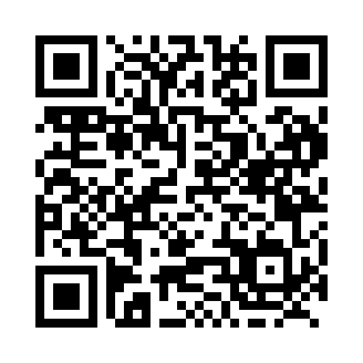
Prayer times for Brossard, Quebec, Canada
Wed 1 May 2024 - Fri 31 May 2024
High Latitude Method: Angle Based Rule
Prayer Calculation Method: Islamic Society of North America
Asar Calculation Method: Hanafi

Date | Day | Fajr | Sunrise | Dhuhr | Asr | Maghrib | Isha
1 | Wed | 4:06 | 5:41 | 12:51 | 5:52 | 8:01 | 9:37
2 | Thu | 4:04 | 5:40 | 12:51 | 5:53 | 8:02 | 9:39
3 | Fri | 4:02 | 5:38 | 12:51 | 5:53 | 8:04 | 9:41
4 | Sat | 4:00 | 5:37 | 12:51 | 5:54 | 8:05 | 9:43
5 | Sun | 3:58 | 5:35 | 12:50 | 5:55 | 8:06 | 9:44
6 | Mon | 3:56 | 5:34 | 12:50 | 5:55 | 8:07 | 9:46
7 | Tue | 3:54 | 5:33 | 12:50 | 5:56 | 8:09 | 9:48
8 | Wed | 3:52 | 5:31 | 12:50 | 5:57 | 8:10 | 9:50
9 | Thu | 3:50 | 5:30 | 12:50 | 5:58 | 8:11 | 9:52
10 | Fri | 3:48 | 5:29 | 12:50 | 5:58 | 8:12 | 9:53
11 | Sat | 3:46 | 5:27 | 12:50 | 5:59 | 8:14 | 9:55
12 | Sun | 3:44 | 5:26 | 12:50 | 6:00 | 8:15 | 9:57
13 | Mon | 3:42 | 5:25 | 12:50 | 6:00 | 8:16 | 9:59
14 | Tue | 3:41 | 5:24 | 12:50 | 6:01 | 8:17 | 10:01
15 | Wed | 3:39 | 5:23 | 12:50 | 6:02 | 8:18 | 10:02
16 | Thu | 3:37 | 5:22 | 12:50 | 6:03 | 8:19 | 10:04
17 | Fri | 3:36 | 5:20 | 12:50 | 6:03 | 8:21 | 10:06
18 | Sat | 3:34 | 5:19 | 12:50 | 6:04 | 8:22 | 10:08
19 | Sun | 3:32 | 5:18 | 12:50 | 6:05 | 8:23 | 10:09
20 | Mon | 3:31 | 5:17 | 12:50 | 6:05 | 8:24 | 10:11
21 | Tue | 3:29 | 5:16 | 12:50 | 6:06 | 8:25 | 10:13
22 | Wed | 3:27 | 5:16 | 12:51 | 6:06 | 8:26 | 10:14
23 | Thu | 3:26 | 5:15 | 12:51 | 6:07 | 8:27 | 10:16
24 | Fri | 3:25 | 5:14 | 12:51 | 6:08 | 8:28 | 10:18
25 | Sat | 3:23 | 5:13 | 12:51 | 6:08 | 8:29 | 10:19
26 | Sun | 3:22 | 5:12 | 12:51 | 6:09 | 8:30 | 10:21
27 | Mon | 3:20 | 5:11 | 12:51 | 6:10 | 8:31 | 10:22
28 | Tue | 3:19 | 5:11 | 12:51 | 6:10 | 8:32 | 10:24
29 | Wed | 3:18 | 5:10 | 12:51 | 6:11 | 8:33 | 10:25
30 | Thu | 3:17 | 5:09 | 12:51 | 6:11 | 8:34 | 10:27
31 | Fri | 3:16 | 5:09 | 12:52 | 6:12 | 8:35 | 10:28
Prayer times provided by https://www.salahtimes.com

