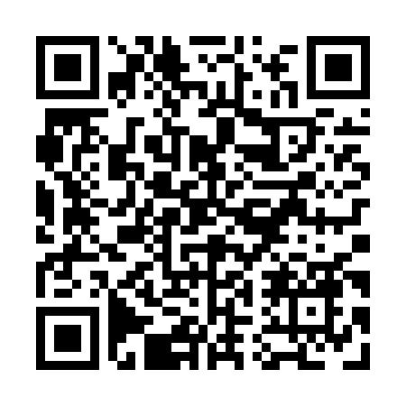
Prayer times for Grassy Plains, British Columbia, Canada
Wed 1 May 2024 - Fri 31 May 2024
High Latitude Method: Angle Based Rule
Prayer Calculation Method: Islamic Society of North America
Asar Calculation Method: Hanafi

Date | Day | Fajr | Sunrise | Dhuhr | Asr | Maghrib | Isha
1 | Wed | 3:35 | 5:46 | 1:21 | 6:31 | 8:56 | 11:08
2 | Thu | 3:32 | 5:44 | 1:20 | 6:32 | 8:58 | 11:10
3 | Fri | 3:31 | 5:42 | 1:20 | 6:33 | 9:00 | 11:10
4 | Sat | 3:30 | 5:40 | 1:20 | 6:34 | 9:02 | 11:11
5 | Sun | 3:29 | 5:38 | 1:20 | 6:35 | 9:04 | 11:12
6 | Mon | 3:28 | 5:36 | 1:20 | 6:36 | 9:06 | 11:13
7 | Tue | 3:27 | 5:34 | 1:20 | 6:38 | 9:07 | 11:14
8 | Wed | 3:26 | 5:32 | 1:20 | 6:39 | 9:09 | 11:15
9 | Thu | 3:25 | 5:30 | 1:20 | 6:40 | 9:11 | 11:16
10 | Fri | 3:24 | 5:28 | 1:20 | 6:41 | 9:13 | 11:16
11 | Sat | 3:23 | 5:26 | 1:20 | 6:42 | 9:14 | 11:17
12 | Sun | 3:22 | 5:25 | 1:20 | 6:43 | 9:16 | 11:18
13 | Mon | 3:22 | 5:23 | 1:20 | 6:44 | 9:18 | 11:19
14 | Tue | 3:21 | 5:21 | 1:20 | 6:45 | 9:19 | 11:20
15 | Wed | 3:20 | 5:20 | 1:20 | 6:46 | 9:21 | 11:21
16 | Thu | 3:19 | 5:18 | 1:20 | 6:47 | 9:23 | 11:22
17 | Fri | 3:18 | 5:16 | 1:20 | 6:48 | 9:24 | 11:22
18 | Sat | 3:18 | 5:15 | 1:20 | 6:49 | 9:26 | 11:23
19 | Sun | 3:17 | 5:13 | 1:20 | 6:49 | 9:28 | 11:24
20 | Mon | 3:16 | 5:12 | 1:20 | 6:50 | 9:29 | 11:25
21 | Tue | 3:15 | 5:10 | 1:20 | 6:51 | 9:31 | 11:26
22 | Wed | 3:15 | 5:09 | 1:20 | 6:52 | 9:32 | 11:26
23 | Thu | 3:14 | 5:08 | 1:20 | 6:53 | 9:34 | 11:27
24 | Fri | 3:14 | 5:06 | 1:20 | 6:54 | 9:35 | 11:28
25 | Sat | 3:13 | 5:05 | 1:21 | 6:55 | 9:37 | 11:29
26 | Sun | 3:12 | 5:04 | 1:21 | 6:56 | 9:38 | 11:30
27 | Mon | 3:12 | 5:03 | 1:21 | 6:56 | 9:39 | 11:30
28 | Tue | 3:11 | 5:02 | 1:21 | 6:57 | 9:41 | 11:31
29 | Wed | 3:11 | 5:01 | 1:21 | 6:58 | 9:42 | 11:32
30 | Thu | 3:11 | 5:00 | 1:21 | 6:59 | 9:43 | 11:32
31 | Fri | 3:10 | 4:59 | 1:21 | 6:59 | 9:45 | 11:33
Prayer times provided by https://www.salahtimes.com

