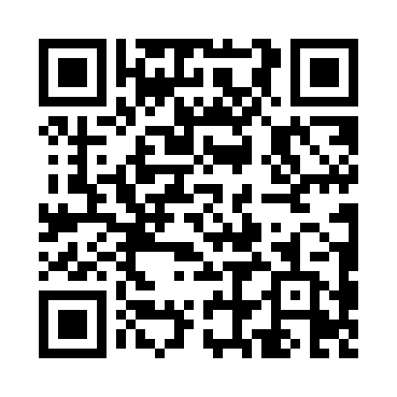
Prayer times for Azzano Decimo, Italy
Wed 1 May 2024 - Fri 31 May 2024
High Latitude Method: Angle Based Rule
Prayer Calculation Method: Muslim World League
Asar Calculation Method: Hanafi

Date | Day | Fajr | Sunrise | Dhuhr | Asr | Maghrib | Isha
1 | Wed | 3:55 | 5:56 | 1:06 | 6:07 | 8:17 | 10:10
2 | Thu | 3:53 | 5:54 | 1:06 | 6:08 | 8:19 | 10:12
3 | Fri | 3:51 | 5:53 | 1:06 | 6:09 | 8:20 | 10:14
4 | Sat | 3:48 | 5:51 | 1:06 | 6:10 | 8:21 | 10:16
5 | Sun | 3:46 | 5:50 | 1:06 | 6:10 | 8:22 | 10:18
6 | Mon | 3:44 | 5:49 | 1:06 | 6:11 | 8:24 | 10:20
7 | Tue | 3:41 | 5:47 | 1:06 | 6:12 | 8:25 | 10:22
8 | Wed | 3:39 | 5:46 | 1:06 | 6:13 | 8:26 | 10:24
9 | Thu | 3:37 | 5:44 | 1:06 | 6:13 | 8:27 | 10:26
10 | Fri | 3:35 | 5:43 | 1:06 | 6:14 | 8:29 | 10:28
11 | Sat | 3:32 | 5:42 | 1:06 | 6:15 | 8:30 | 10:30
12 | Sun | 3:30 | 5:41 | 1:06 | 6:16 | 8:31 | 10:33
13 | Mon | 3:28 | 5:39 | 1:06 | 6:16 | 8:32 | 10:35
14 | Tue | 3:26 | 5:38 | 1:06 | 6:17 | 8:33 | 10:37
15 | Wed | 3:24 | 5:37 | 1:06 | 6:18 | 8:35 | 10:39
16 | Thu | 3:21 | 5:36 | 1:06 | 6:18 | 8:36 | 10:41
17 | Fri | 3:19 | 5:35 | 1:06 | 6:19 | 8:37 | 10:43
18 | Sat | 3:17 | 5:34 | 1:06 | 6:20 | 8:38 | 10:45
19 | Sun | 3:15 | 5:33 | 1:06 | 6:20 | 8:39 | 10:47
20 | Mon | 3:13 | 5:32 | 1:06 | 6:21 | 8:40 | 10:49
21 | Tue | 3:11 | 5:31 | 1:06 | 6:22 | 8:41 | 10:51
22 | Wed | 3:09 | 5:30 | 1:06 | 6:22 | 8:43 | 10:53
23 | Thu | 3:07 | 5:29 | 1:06 | 6:23 | 8:44 | 10:55
24 | Fri | 3:05 | 5:28 | 1:06 | 6:24 | 8:45 | 10:57
25 | Sat | 3:03 | 5:27 | 1:06 | 6:24 | 8:46 | 10:58
26 | Sun | 3:01 | 5:26 | 1:06 | 6:25 | 8:47 | 11:00
27 | Mon | 3:00 | 5:25 | 1:06 | 6:25 | 8:48 | 11:02
28 | Tue | 2:58 | 5:25 | 1:07 | 6:26 | 8:49 | 11:04
29 | Wed | 2:56 | 5:24 | 1:07 | 6:27 | 8:50 | 11:06
30 | Thu | 2:55 | 5:23 | 1:07 | 6:27 | 8:51 | 11:08
31 | Fri | 2:53 | 5:23 | 1:07 | 6:28 | 8:51 | 11:09
Prayer times provided by https://www.salahtimes.com

