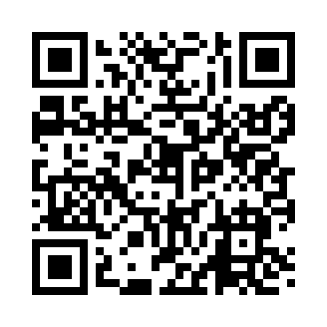
Prayer times for Tonasket, Washington, USA
Mon 1 Jul 2024 - Wed 31 Jul 2024
High Latitude Method: Angle Based Rule
Prayer Calculation Method: Islamic Society of North America
Asar Calculation Method: Shafi

Date | Day | Fajr | Sunrise | Dhuhr | Asr | Maghrib | Isha
1 | Mon | 3:01 | 5:00 | 1:02 | 5:18 | 9:04 | 11:03
2 | Tue | 3:01 | 5:00 | 1:02 | 5:18 | 9:03 | 11:03
3 | Wed | 3:02 | 5:01 | 1:02 | 5:18 | 9:03 | 11:03
4 | Thu | 3:02 | 5:02 | 1:02 | 5:18 | 9:03 | 11:02
5 | Fri | 3:02 | 5:02 | 1:03 | 5:18 | 9:02 | 11:02
6 | Sat | 3:03 | 5:03 | 1:03 | 5:18 | 9:02 | 11:02
7 | Sun | 3:03 | 5:04 | 1:03 | 5:18 | 9:01 | 11:02
8 | Mon | 3:04 | 5:05 | 1:03 | 5:18 | 9:01 | 11:02
9 | Tue | 3:04 | 5:06 | 1:03 | 5:18 | 9:00 | 11:01
10 | Wed | 3:05 | 5:07 | 1:03 | 5:18 | 8:59 | 11:01
11 | Thu | 3:05 | 5:08 | 1:03 | 5:18 | 8:59 | 11:01
12 | Fri | 3:06 | 5:09 | 1:04 | 5:17 | 8:58 | 11:01
13 | Sat | 3:07 | 5:10 | 1:04 | 5:17 | 8:57 | 11:00
14 | Sun | 3:07 | 5:11 | 1:04 | 5:17 | 8:56 | 11:00
15 | Mon | 3:08 | 5:12 | 1:04 | 5:17 | 8:55 | 10:59
16 | Tue | 3:08 | 5:13 | 1:04 | 5:17 | 8:54 | 10:59
17 | Wed | 3:09 | 5:14 | 1:04 | 5:16 | 8:53 | 10:59
18 | Thu | 3:10 | 5:15 | 1:04 | 5:16 | 8:52 | 10:58
19 | Fri | 3:12 | 5:16 | 1:04 | 5:16 | 8:51 | 10:56
20 | Sat | 3:14 | 5:17 | 1:04 | 5:15 | 8:50 | 10:53
21 | Sun | 3:16 | 5:19 | 1:04 | 5:15 | 8:49 | 10:51
22 | Mon | 3:18 | 5:20 | 1:04 | 5:15 | 8:48 | 10:49
23 | Tue | 3:20 | 5:21 | 1:04 | 5:14 | 8:47 | 10:47
24 | Wed | 3:22 | 5:22 | 1:04 | 5:14 | 8:46 | 10:45
25 | Thu | 3:25 | 5:24 | 1:04 | 5:13 | 8:44 | 10:43
26 | Fri | 3:27 | 5:25 | 1:04 | 5:13 | 8:43 | 10:41
27 | Sat | 3:29 | 5:26 | 1:04 | 5:12 | 8:42 | 10:38
28 | Sun | 3:31 | 5:27 | 1:04 | 5:12 | 8:40 | 10:36
29 | Mon | 3:33 | 5:29 | 1:04 | 5:11 | 8:39 | 10:34
30 | Tue | 3:36 | 5:30 | 1:04 | 5:11 | 8:38 | 10:32
31 | Wed | 3:38 | 5:31 | 1:04 | 5:10 | 8:36 | 10:29
Prayer times provided by https://www.salahtimes.com

