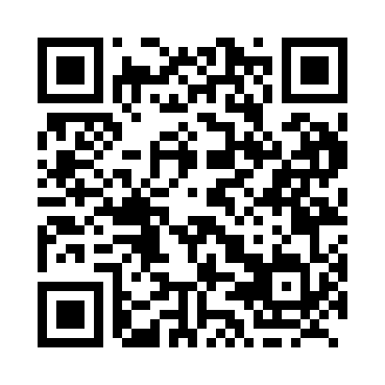
Prayer times for Union Centre, Nova Scotia, Canada
Wed 1 May 2024 - Fri 31 May 2024
High Latitude Method: Angle Based Rule
Prayer Calculation Method: Islamic Society of North America
Asar Calculation Method: Hanafi

Date | Day | Fajr | Sunrise | Dhuhr | Asr | Maghrib | Isha
1 | Wed | 4:23 | 5:58 | 1:08 | 6:09 | 8:19 | 9:55
2 | Thu | 4:21 | 5:57 | 1:08 | 6:10 | 8:20 | 9:56
3 | Fri | 4:18 | 5:55 | 1:08 | 6:11 | 8:21 | 9:58
4 | Sat | 4:17 | 5:54 | 1:08 | 6:11 | 8:22 | 10:00
5 | Sun | 4:15 | 5:52 | 1:08 | 6:12 | 8:24 | 10:02
6 | Mon | 4:13 | 5:51 | 1:08 | 6:13 | 8:25 | 10:04
7 | Tue | 4:11 | 5:50 | 1:08 | 6:14 | 8:26 | 10:06
8 | Wed | 4:09 | 5:48 | 1:08 | 6:14 | 8:27 | 10:07
9 | Thu | 4:07 | 5:47 | 1:07 | 6:15 | 8:29 | 10:09
10 | Fri | 4:05 | 5:46 | 1:07 | 6:16 | 8:30 | 10:11
11 | Sat | 4:03 | 5:44 | 1:07 | 6:16 | 8:31 | 10:13
12 | Sun | 4:01 | 5:43 | 1:07 | 6:17 | 8:32 | 10:15
13 | Mon | 3:59 | 5:42 | 1:07 | 6:18 | 8:33 | 10:16
14 | Tue | 3:58 | 5:41 | 1:07 | 6:19 | 8:35 | 10:18
15 | Wed | 3:56 | 5:40 | 1:07 | 6:19 | 8:36 | 10:20
16 | Thu | 3:54 | 5:39 | 1:07 | 6:20 | 8:37 | 10:22
17 | Fri | 3:52 | 5:38 | 1:07 | 6:21 | 8:38 | 10:24
18 | Sat | 3:51 | 5:36 | 1:08 | 6:21 | 8:39 | 10:25
19 | Sun | 3:49 | 5:35 | 1:08 | 6:22 | 8:40 | 10:27
20 | Mon | 3:47 | 5:34 | 1:08 | 6:23 | 8:41 | 10:29
21 | Tue | 3:46 | 5:34 | 1:08 | 6:23 | 8:42 | 10:30
22 | Wed | 3:44 | 5:33 | 1:08 | 6:24 | 8:43 | 10:32
23 | Thu | 3:43 | 5:32 | 1:08 | 6:24 | 8:45 | 10:34
24 | Fri | 3:41 | 5:31 | 1:08 | 6:25 | 8:46 | 10:35
25 | Sat | 3:40 | 5:30 | 1:08 | 6:26 | 8:47 | 10:37
26 | Sun | 3:39 | 5:29 | 1:08 | 6:26 | 8:48 | 10:39
27 | Mon | 3:37 | 5:28 | 1:08 | 6:27 | 8:49 | 10:40
28 | Tue | 3:36 | 5:28 | 1:08 | 6:27 | 8:49 | 10:42
29 | Wed | 3:35 | 5:27 | 1:09 | 6:28 | 8:50 | 10:43
30 | Thu | 3:33 | 5:26 | 1:09 | 6:29 | 8:51 | 10:45
31 | Fri | 3:32 | 5:26 | 1:09 | 6:29 | 8:52 | 10:46
Prayer times provided by https://www.salahtimes.com

