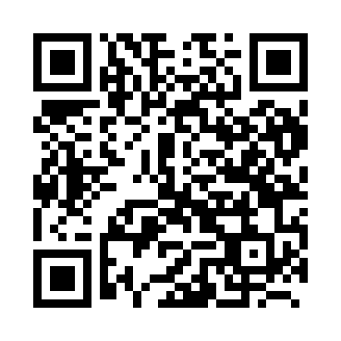
Prayer times for Brocsous, Belgium
Wed 1 May 2024 - Fri 31 May 2024
High Latitude Method: Angle Based Rule
Prayer Calculation Method: Muslim World League
Asar Calculation Method: Shafi

Date | Day | Fajr | Sunrise | Dhuhr | Asr | Maghrib | Isha
1 | Wed | 3:51 | 6:15 | 1:38 | 5:41 | 9:03 | 11:17
2 | Thu | 3:48 | 6:13 | 1:38 | 5:41 | 9:04 | 11:20
3 | Fri | 3:44 | 6:11 | 1:38 | 5:42 | 9:06 | 11:22
4 | Sat | 3:41 | 6:10 | 1:38 | 5:43 | 9:08 | 11:25
5 | Sun | 3:37 | 6:08 | 1:38 | 5:43 | 9:09 | 11:28
6 | Mon | 3:34 | 6:06 | 1:38 | 5:44 | 9:11 | 11:31
7 | Tue | 3:30 | 6:05 | 1:38 | 5:44 | 9:12 | 11:35
8 | Wed | 3:27 | 6:03 | 1:38 | 5:45 | 9:14 | 11:38
9 | Thu | 3:23 | 6:01 | 1:38 | 5:46 | 9:15 | 11:41
10 | Fri | 3:23 | 6:00 | 1:38 | 5:46 | 9:17 | 11:44
11 | Sat | 3:22 | 5:58 | 1:38 | 5:47 | 9:18 | 11:46
12 | Sun | 3:22 | 5:57 | 1:38 | 5:47 | 9:20 | 11:46
13 | Mon | 3:21 | 5:55 | 1:38 | 5:48 | 9:21 | 11:47
14 | Tue | 3:20 | 5:54 | 1:38 | 5:49 | 9:23 | 11:47
15 | Wed | 3:20 | 5:52 | 1:38 | 5:49 | 9:24 | 11:48
16 | Thu | 3:19 | 5:51 | 1:38 | 5:50 | 9:26 | 11:49
17 | Fri | 3:19 | 5:49 | 1:38 | 5:50 | 9:27 | 11:49
18 | Sat | 3:18 | 5:48 | 1:38 | 5:51 | 9:28 | 11:50
19 | Sun | 3:18 | 5:47 | 1:38 | 5:51 | 9:30 | 11:51
20 | Mon | 3:17 | 5:46 | 1:38 | 5:52 | 9:31 | 11:51
21 | Tue | 3:17 | 5:44 | 1:38 | 5:52 | 9:32 | 11:52
22 | Wed | 3:16 | 5:43 | 1:38 | 5:53 | 9:34 | 11:52
23 | Thu | 3:16 | 5:42 | 1:38 | 5:53 | 9:35 | 11:53
24 | Fri | 3:16 | 5:41 | 1:38 | 5:54 | 9:36 | 11:54
25 | Sat | 3:15 | 5:40 | 1:38 | 5:54 | 9:38 | 11:54
26 | Sun | 3:15 | 5:39 | 1:39 | 5:55 | 9:39 | 11:55
27 | Mon | 3:15 | 5:38 | 1:39 | 5:55 | 9:40 | 11:55
28 | Tue | 3:14 | 5:37 | 1:39 | 5:56 | 9:41 | 11:56
29 | Wed | 3:14 | 5:36 | 1:39 | 5:56 | 9:42 | 11:57
30 | Thu | 3:14 | 5:35 | 1:39 | 5:57 | 9:43 | 11:57
31 | Fri | 3:13 | 5:34 | 1:39 | 5:57 | 9:44 | 11:58
Prayer times provided by https://www.salahtimes.com

