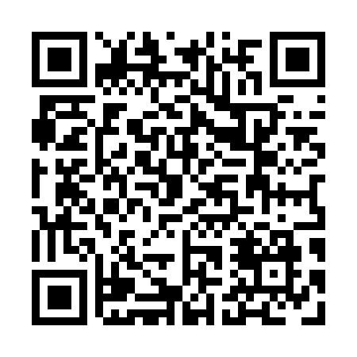
Prayer times for Tour-Chicotte, Quebec, Canada
Wed 1 May 2024 - Fri 31 May 2024
High Latitude Method: Angle Based Rule
Prayer Calculation Method: Islamic Society of North America
Asar Calculation Method: Hanafi

Date | Day | Fajr | Sunrise | Dhuhr | Asr | Maghrib | Isha
1 | Wed | 3:01 | 4:49 | 12:09 | 5:15 | 7:30 | 9:19
2 | Thu | 2:59 | 4:48 | 12:09 | 5:16 | 7:32 | 9:21
3 | Fri | 2:56 | 4:46 | 12:09 | 5:16 | 7:33 | 9:23
4 | Sat | 2:54 | 4:44 | 12:09 | 5:17 | 7:35 | 9:26
5 | Sun | 2:51 | 4:43 | 12:09 | 5:18 | 7:36 | 9:28
6 | Mon | 2:49 | 4:41 | 12:09 | 5:19 | 7:38 | 9:31
7 | Tue | 2:46 | 4:39 | 12:09 | 5:20 | 7:39 | 9:33
8 | Wed | 2:44 | 4:38 | 12:09 | 5:21 | 7:41 | 9:35
9 | Thu | 2:41 | 4:36 | 12:09 | 5:22 | 7:42 | 9:38
10 | Fri | 2:39 | 4:35 | 12:09 | 5:23 | 7:44 | 9:40
11 | Sat | 2:37 | 4:33 | 12:09 | 5:23 | 7:45 | 9:42
12 | Sun | 2:34 | 4:32 | 12:09 | 5:24 | 7:46 | 9:45
13 | Mon | 2:32 | 4:31 | 12:09 | 5:25 | 7:48 | 9:47
14 | Tue | 2:29 | 4:29 | 12:09 | 5:26 | 7:49 | 9:50
15 | Wed | 2:27 | 4:28 | 12:09 | 5:27 | 7:51 | 9:52
16 | Thu | 2:25 | 4:26 | 12:09 | 5:28 | 7:52 | 9:54
17 | Fri | 2:22 | 4:25 | 12:09 | 5:28 | 7:53 | 9:57
18 | Sat | 2:20 | 4:24 | 12:09 | 5:29 | 7:55 | 9:59
19 | Sun | 2:18 | 4:23 | 12:09 | 5:30 | 7:56 | 10:02
20 | Mon | 2:15 | 4:22 | 12:09 | 5:31 | 7:57 | 10:03
21 | Tue | 2:15 | 4:20 | 12:09 | 5:31 | 7:58 | 10:04
22 | Wed | 2:14 | 4:19 | 12:09 | 5:32 | 8:00 | 10:05
23 | Thu | 2:14 | 4:18 | 12:09 | 5:33 | 8:01 | 10:05
24 | Fri | 2:13 | 4:17 | 12:09 | 5:34 | 8:02 | 10:06
25 | Sat | 2:13 | 4:16 | 12:09 | 5:34 | 8:03 | 10:06
26 | Sun | 2:13 | 4:15 | 12:10 | 5:35 | 8:04 | 10:07
27 | Mon | 2:12 | 4:14 | 12:10 | 5:36 | 8:06 | 10:08
28 | Tue | 2:12 | 4:13 | 12:10 | 5:36 | 8:07 | 10:08
29 | Wed | 2:11 | 4:13 | 12:10 | 5:37 | 8:08 | 10:09
30 | Thu | 2:11 | 4:12 | 12:10 | 5:38 | 8:09 | 10:10
31 | Fri | 2:11 | 4:11 | 12:10 | 5:38 | 8:10 | 10:10
Prayer times provided by https://www.salahtimes.com

