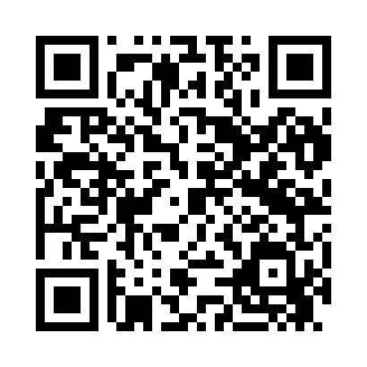

**Prayer times for Aberoti, Estonia**

**Sun 1 Sep 2024 - Mon 30 Sep 2024**

**High Latitude Method: Angle Based Rule**

**Prayer Calculation Method: Muslim World League**

**Asar Calculation Method: Hanafi**

|  |  |  |  |  |  |  |  |
| --- | --- | --- | --- | --- | --- | --- | --- |
| **Date** | **Day** | **Fajr** | **Sunrise** | **Dhuhr** | **Asr** | **Maghrib** | **Isha** |
| 1 | Sun | 3:17 | 6:08 | 1:10 | 5:50 | 8:11 | 10:48 |
| 2 | Mon | 3:21 | 6:10 | 1:10 | 5:47 | 8:09 | 10:43 |
| 3 | Tue | 3:26 | 6:13 | 1:10 | 5:45 | 8:06 | 10:39 |
| 4 | Wed | 3:30 | 6:15 | 1:09 | 5:43 | 8:03 | 10:34 |
| 5 | Thu | 3:34 | 6:17 | 1:09 | 5:41 | 8:00 | 10:29 |
| 6 | Fri | 3:38 | 6:19 | 1:09 | 5:38 | 7:57 | 10:25 |
| 7 | Sat | 3:42 | 6:22 | 1:08 | 5:36 | 7:54 | 10:21 |
| 8 | Sun | 3:46 | 6:24 | 1:08 | 5:34 | 7:51 | 10:16 |
| 9 | Mon | 3:50 | 6:26 | 1:08 | 5:31 | 7:48 | 10:12 |
| 10 | Tue | 3:54 | 6:29 | 1:07 | 5:29 | 7:45 | 10:08 |
| 11 | Wed | 3:57 | 6:31 | 1:07 | 5:27 | 7:42 | 10:04 |
| 12 | Thu | 4:01 | 6:33 | 1:07 | 5:24 | 7:39 | 10:00 |
| 13 | Fri | 4:04 | 6:35 | 1:06 | 5:22 | 7:36 | 9:56 |
| 14 | Sat | 4:08 | 6:38 | 1:06 | 5:19 | 7:33 | 9:52 |
| 15 | Sun | 4:11 | 6:40 | 1:06 | 5:17 | 7:30 | 9:48 |
| 16 | Mon | 4:14 | 6:42 | 1:05 | 5:15 | 7:27 | 9:44 |
| 17 | Tue | 4:17 | 6:44 | 1:05 | 5:12 | 7:24 | 9:41 |
| 18 | Wed | 4:21 | 6:47 | 1:05 | 5:10 | 7:21 | 9:37 |
| 19 | Thu | 4:24 | 6:49 | 1:04 | 5:07 | 7:18 | 9:33 |
| 20 | Fri | 4:27 | 6:51 | 1:04 | 5:05 | 7:15 | 9:30 |
| 21 | Sat | 4:30 | 6:53 | 1:03 | 5:02 | 7:12 | 9:26 |
| 22 | Sun | 4:33 | 6:56 | 1:03 | 5:00 | 7:09 | 9:22 |
| 23 | Mon | 4:36 | 6:58 | 1:03 | 4:57 | 7:06 | 9:19 |
| 24 | Tue | 4:39 | 7:00 | 1:02 | 4:55 | 7:03 | 9:15 |
| 25 | Wed | 4:42 | 7:03 | 1:02 | 4:52 | 7:00 | 9:12 |
| 26 | Thu | 4:44 | 7:05 | 1:02 | 4:50 | 6:57 | 9:09 |
| 27 | Fri | 4:47 | 7:07 | 1:01 | 4:47 | 6:54 | 9:05 |
| 28 | Sat | 4:50 | 7:09 | 1:01 | 4:45 | 6:51 | 9:02 |
| 29 | Sun | 4:53 | 7:12 | 1:01 | 4:42 | 6:48 | 8:58 |
| 30 | Mon | 4:55 | 7:14 | 1:00 | 4:39 | 6:45 | 8:55 |

**Prayer times provided by https://www.salahtimes.com**