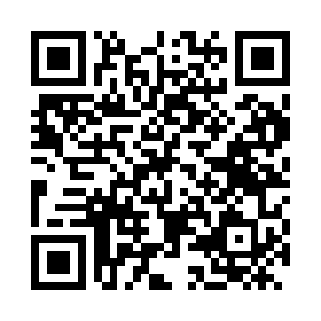
Prayer times for La Coloma, Cuba
Wed 1 May 2024 - Fri 31 May 2024
High Latitude Method: None
Prayer Calculation Method: Muslim World League
Asar Calculation Method: Shafi

Date | Day | Fajr | Sunrise | Dhuhr | Asr | Maghrib | Isha
1 | Wed | 5:42 | 7:02 | 1:32 | 4:54 | 8:01 | 9:16
2 | Thu | 5:42 | 7:01 | 1:31 | 4:54 | 8:02 | 9:17
3 | Fri | 5:41 | 7:01 | 1:31 | 4:54 | 8:02 | 9:17
4 | Sat | 5:40 | 7:00 | 1:31 | 4:53 | 8:03 | 9:18
5 | Sun | 5:39 | 7:00 | 1:31 | 4:53 | 8:03 | 9:19
6 | Mon | 5:38 | 6:59 | 1:31 | 4:53 | 8:04 | 9:19
7 | Tue | 5:38 | 6:58 | 1:31 | 4:53 | 8:04 | 9:20
8 | Wed | 5:37 | 6:58 | 1:31 | 4:52 | 8:04 | 9:21
9 | Thu | 5:36 | 6:57 | 1:31 | 4:52 | 8:05 | 9:21
10 | Fri | 5:36 | 6:57 | 1:31 | 4:52 | 8:05 | 9:22
11 | Sat | 5:35 | 6:56 | 1:31 | 4:51 | 8:06 | 9:22
12 | Sun | 5:34 | 6:56 | 1:31 | 4:51 | 8:06 | 9:23
13 | Mon | 5:34 | 6:55 | 1:31 | 4:51 | 8:07 | 9:24
14 | Tue | 5:33 | 6:55 | 1:31 | 4:51 | 8:07 | 9:24
15 | Wed | 5:32 | 6:54 | 1:31 | 4:50 | 8:08 | 9:25
16 | Thu | 5:32 | 6:54 | 1:31 | 4:50 | 8:08 | 9:26
17 | Fri | 5:31 | 6:54 | 1:31 | 4:50 | 8:08 | 9:26
18 | Sat | 5:31 | 6:53 | 1:31 | 4:50 | 8:09 | 9:27
19 | Sun | 5:30 | 6:53 | 1:31 | 4:50 | 8:09 | 9:27
20 | Mon | 5:30 | 6:53 | 1:31 | 4:49 | 8:10 | 9:28
21 | Tue | 5:29 | 6:52 | 1:31 | 4:49 | 8:10 | 9:29
22 | Wed | 5:29 | 6:52 | 1:31 | 4:49 | 8:11 | 9:29
23 | Thu | 5:28 | 6:52 | 1:31 | 4:49 | 8:11 | 9:30
24 | Fri | 5:28 | 6:51 | 1:31 | 4:49 | 8:12 | 9:30
25 | Sat | 5:27 | 6:51 | 1:32 | 4:49 | 8:12 | 9:31
26 | Sun | 5:27 | 6:51 | 1:32 | 4:49 | 8:13 | 9:32
27 | Mon | 5:27 | 6:51 | 1:32 | 4:48 | 8:13 | 9:32
28 | Tue | 5:26 | 6:51 | 1:32 | 4:48 | 8:13 | 9:33
29 | Wed | 5:26 | 6:50 | 1:32 | 4:48 | 8:14 | 9:33
30 | Thu | 5:26 | 6:50 | 1:32 | 4:48 | 8:14 | 9:34
31 | Fri | 5:25 | 6:50 | 1:32 | 4:48 | 8:15 | 9:34
Prayer times provided by https://www.salahtimes.com

