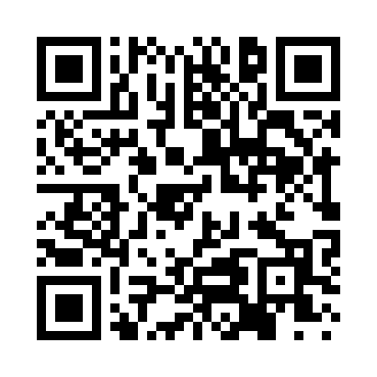
Prayer times for Bechers Brook, Delaware, USA
Wed 1 May 2024 - Fri 31 May 2024
High Latitude Method: Angle Based Rule
Prayer Calculation Method: Islamic Society of North America
Asar Calculation Method: Shafi

Date | Day | Fajr | Sunrise | Dhuhr | Asr | Maghrib | Isha
1 | Wed | 4:41 | 6:03 | 1:00 | 4:49 | 7:56 | 9:19
2 | Thu | 4:39 | 6:02 | 12:59 | 4:49 | 7:57 | 9:20
3 | Fri | 4:38 | 6:01 | 12:59 | 4:50 | 7:58 | 9:22
4 | Sat | 4:36 | 6:00 | 12:59 | 4:50 | 7:59 | 9:23
5 | Sun | 4:35 | 5:59 | 12:59 | 4:50 | 8:00 | 9:24
6 | Mon | 4:33 | 5:58 | 12:59 | 4:50 | 8:01 | 9:26
7 | Tue | 4:32 | 5:57 | 12:59 | 4:51 | 8:02 | 9:27
8 | Wed | 4:30 | 5:55 | 12:59 | 4:51 | 8:03 | 9:28
9 | Thu | 4:29 | 5:54 | 12:59 | 4:51 | 8:04 | 9:30
10 | Fri | 4:28 | 5:53 | 12:59 | 4:51 | 8:05 | 9:31
11 | Sat | 4:26 | 5:52 | 12:59 | 4:52 | 8:06 | 9:32
12 | Sun | 4:25 | 5:51 | 12:59 | 4:52 | 8:07 | 9:33
13 | Mon | 4:24 | 5:50 | 12:59 | 4:52 | 8:08 | 9:35
14 | Tue | 4:22 | 5:50 | 12:59 | 4:52 | 8:09 | 9:36
15 | Wed | 4:21 | 5:49 | 12:59 | 4:52 | 8:10 | 9:37
16 | Thu | 4:20 | 5:48 | 12:59 | 4:53 | 8:10 | 9:39
17 | Fri | 4:19 | 5:47 | 12:59 | 4:53 | 8:11 | 9:40
18 | Sat | 4:18 | 5:46 | 12:59 | 4:53 | 8:12 | 9:41
19 | Sun | 4:17 | 5:45 | 12:59 | 4:53 | 8:13 | 9:42
20 | Mon | 4:15 | 5:45 | 12:59 | 4:54 | 8:14 | 9:43
21 | Tue | 4:14 | 5:44 | 12:59 | 4:54 | 8:15 | 9:45
22 | Wed | 4:13 | 5:43 | 12:59 | 4:54 | 8:16 | 9:46
23 | Thu | 4:12 | 5:43 | 12:59 | 4:54 | 8:17 | 9:47
24 | Fri | 4:11 | 5:42 | 12:59 | 4:55 | 8:17 | 9:48
25 | Sat | 4:10 | 5:41 | 1:00 | 4:55 | 8:18 | 9:49
26 | Sun | 4:10 | 5:41 | 1:00 | 4:55 | 8:19 | 9:50
27 | Mon | 4:09 | 5:40 | 1:00 | 4:55 | 8:20 | 9:51
28 | Tue | 4:08 | 5:40 | 1:00 | 4:56 | 8:20 | 9:52
29 | Wed | 4:07 | 5:39 | 1:00 | 4:56 | 8:21 | 9:53
30 | Thu | 4:06 | 5:39 | 1:00 | 4:56 | 8:22 | 9:54
31 | Fri | 4:06 | 5:38 | 1:00 | 4:56 | 8:23 | 9:55
Prayer times provided by https://www.salahtimes.com

