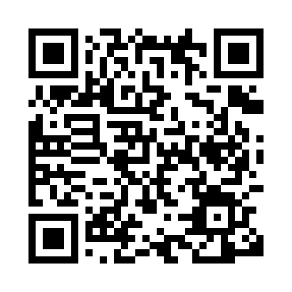
Prayer times for Unshausen, Germany
Mon 1 Apr 2024 - Tue 30 Apr 2024
High Latitude Method: Angle Based Rule
Prayer Calculation Method: Muslim World League
Asar Calculation Method: Shafi

Date | Day | Fajr | Sunrise | Dhuhr | Asr | Maghrib | Isha
1 | Mon | 5:00 | 6:57 | 1:26 | 5:00 | 7:56 | 9:46
2 | Tue | 4:57 | 6:55 | 1:26 | 5:00 | 7:58 | 9:48
3 | Wed | 4:54 | 6:53 | 1:26 | 5:01 | 7:59 | 9:51
4 | Thu | 4:52 | 6:51 | 1:25 | 5:02 | 8:01 | 9:53
5 | Fri | 4:49 | 6:48 | 1:25 | 5:03 | 8:03 | 9:55
6 | Sat | 4:46 | 6:46 | 1:25 | 5:04 | 8:04 | 9:57
7 | Sun | 4:43 | 6:44 | 1:25 | 5:05 | 8:06 | 9:59
8 | Mon | 4:40 | 6:42 | 1:24 | 5:05 | 8:08 | 10:02
9 | Tue | 4:37 | 6:40 | 1:24 | 5:06 | 8:09 | 10:04
10 | Wed | 4:34 | 6:38 | 1:24 | 5:07 | 8:11 | 10:06
11 | Thu | 4:31 | 6:35 | 1:23 | 5:08 | 8:12 | 10:09
12 | Fri | 4:29 | 6:33 | 1:23 | 5:09 | 8:14 | 10:11
13 | Sat | 4:26 | 6:31 | 1:23 | 5:09 | 8:16 | 10:13
14 | Sun | 4:23 | 6:29 | 1:23 | 5:10 | 8:17 | 10:16
15 | Mon | 4:20 | 6:27 | 1:22 | 5:11 | 8:19 | 10:18
16 | Tue | 4:16 | 6:25 | 1:22 | 5:12 | 8:21 | 10:21
17 | Wed | 4:13 | 6:23 | 1:22 | 5:12 | 8:22 | 10:23
18 | Thu | 4:10 | 6:20 | 1:22 | 5:13 | 8:24 | 10:26
19 | Fri | 4:07 | 6:18 | 1:22 | 5:14 | 8:26 | 10:28
20 | Sat | 4:04 | 6:16 | 1:21 | 5:15 | 8:27 | 10:31
21 | Sun | 4:01 | 6:14 | 1:21 | 5:15 | 8:29 | 10:33
22 | Mon | 3:58 | 6:12 | 1:21 | 5:16 | 8:30 | 10:36
23 | Tue | 3:55 | 6:10 | 1:21 | 5:17 | 8:32 | 10:39
24 | Wed | 3:51 | 6:08 | 1:21 | 5:17 | 8:34 | 10:41
25 | Thu | 3:48 | 6:06 | 1:20 | 5:18 | 8:35 | 10:44
26 | Fri | 3:45 | 6:04 | 1:20 | 5:19 | 8:37 | 10:47
27 | Sat | 3:42 | 6:02 | 1:20 | 5:19 | 8:39 | 10:50
28 | Sun | 3:38 | 6:01 | 1:20 | 5:20 | 8:40 | 10:52
29 | Mon | 3:35 | 5:59 | 1:20 | 5:21 | 8:42 | 10:55
30 | Tue | 3:32 | 5:57 | 1:20 | 5:21 | 8:43 | 10:58
Prayer times provided by https://www.salahtimes.com

