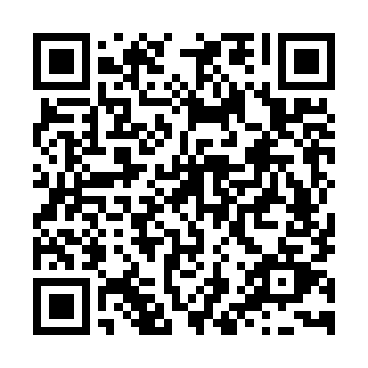
Prayer times for Kimchaek, North Korea
Wed 1 May 2024 - Fri 31 May 2024
High Latitude Method: None
Prayer Calculation Method: Muslim World League
Asar Calculation Method: Shafi

Date | Day | Fajr | Sunrise | Dhuhr | Asr | Maghrib | Isha
1 | Wed | 3:37 | 5:22 | 12:20 | 4:12 | 7:19 | 8:58
2 | Thu | 3:35 | 5:21 | 12:20 | 4:12 | 7:20 | 8:59
3 | Fri | 3:33 | 5:19 | 12:20 | 4:12 | 7:21 | 9:01
4 | Sat | 3:32 | 5:18 | 12:20 | 4:12 | 7:22 | 9:02
5 | Sun | 3:30 | 5:17 | 12:20 | 4:13 | 7:23 | 9:04
6 | Mon | 3:28 | 5:16 | 12:20 | 4:13 | 7:24 | 9:05
7 | Tue | 3:27 | 5:15 | 12:20 | 4:13 | 7:25 | 9:07
8 | Wed | 3:25 | 5:13 | 12:20 | 4:13 | 7:26 | 9:08
9 | Thu | 3:23 | 5:12 | 12:20 | 4:14 | 7:27 | 9:10
10 | Fri | 3:22 | 5:11 | 12:20 | 4:14 | 7:28 | 9:11
11 | Sat | 3:20 | 5:10 | 12:20 | 4:14 | 7:29 | 9:13
12 | Sun | 3:18 | 5:09 | 12:20 | 4:15 | 7:30 | 9:14
13 | Mon | 3:17 | 5:08 | 12:20 | 4:15 | 7:31 | 9:16
14 | Tue | 3:15 | 5:07 | 12:20 | 4:15 | 7:32 | 9:17
15 | Wed | 3:14 | 5:06 | 12:20 | 4:15 | 7:33 | 9:19
16 | Thu | 3:12 | 5:05 | 12:20 | 4:16 | 7:34 | 9:20
17 | Fri | 3:11 | 5:04 | 12:20 | 4:16 | 7:35 | 9:21
18 | Sat | 3:09 | 5:04 | 12:20 | 4:16 | 7:36 | 9:23
19 | Sun | 3:08 | 5:03 | 12:20 | 4:16 | 7:37 | 9:24
20 | Mon | 3:07 | 5:02 | 12:20 | 4:17 | 7:38 | 9:26
21 | Tue | 3:05 | 5:01 | 12:20 | 4:17 | 7:39 | 9:27
22 | Wed | 3:04 | 5:00 | 12:20 | 4:17 | 7:40 | 9:28
23 | Thu | 3:03 | 5:00 | 12:20 | 4:18 | 7:41 | 9:30
24 | Fri | 3:01 | 4:59 | 12:20 | 4:18 | 7:42 | 9:31
25 | Sat | 3:00 | 4:58 | 12:20 | 4:18 | 7:43 | 9:32
26 | Sun | 2:59 | 4:58 | 12:20 | 4:18 | 7:43 | 9:34
27 | Mon | 2:58 | 4:57 | 12:20 | 4:19 | 7:44 | 9:35
28 | Tue | 2:57 | 4:56 | 12:21 | 4:19 | 7:45 | 9:36
29 | Wed | 2:56 | 4:56 | 12:21 | 4:19 | 7:46 | 9:38
30 | Thu | 2:55 | 4:55 | 12:21 | 4:20 | 7:47 | 9:39
31 | Fri | 2:54 | 4:55 | 12:21 | 4:20 | 7:47 | 9:40
Prayer times provided by https://www.salahtimes.com

